**ADF – Azure Data Factory**

It’s cloud-based ETL and data integration service provided by Microsoft azure.

**What is Azure Data Factory?**

Azure Data Factory is a cloud-based data integration service designed to orchestrate (arrange or order) and automate data workflows.

It is used to collect, transform, and deliver data, ensuring that insights are readily accessible for analytics and decision-making.

With its scalable and serverless architecture, ADF can handle workflows of any size—from simple data migrations to complex data transformation pipelines.

ADF stands out for its user-friendly, no-code interface, which allows both technical and non-technical users to build data pipeline easily

(Data integration is the process of combining data from different sources and providing a unified view of it.)

Features of ADF:

**1. Data integration**

Azure Data Factory supports integration with over 90 data sources, including cloud-based and on-premises systems. It includes support for SQL databases, NoSQL systems, REST APIs, and file-based data sources, allowing you to unify data workflows regardless of the source or format.

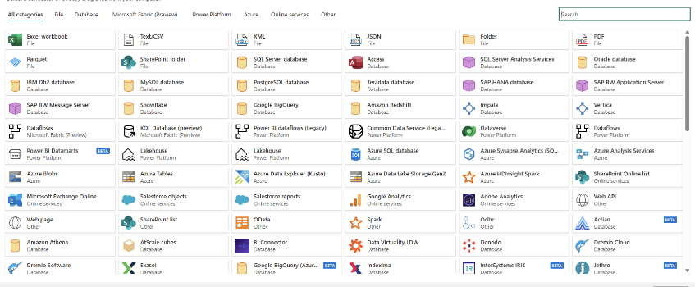

**2. No-code pipeline authoring**

ADF’s drag-and-drop interface simplifies how users create data pipelines. With prebuilt templates, guided configuration wizards, and an intuitive visual editor, even users with no coding expertise can design comprehensive end-to-end workflows.

**3. Scheduling**

Azure Data Factory’s scheduling tools offer workflow automation. Users can set up triggers based on specific conditions, such as a file’s arrival in cloud storage or scheduled time intervals. These scheduling options eliminate the need for manual interventions and ensure workflows are executed consistently and reliably.

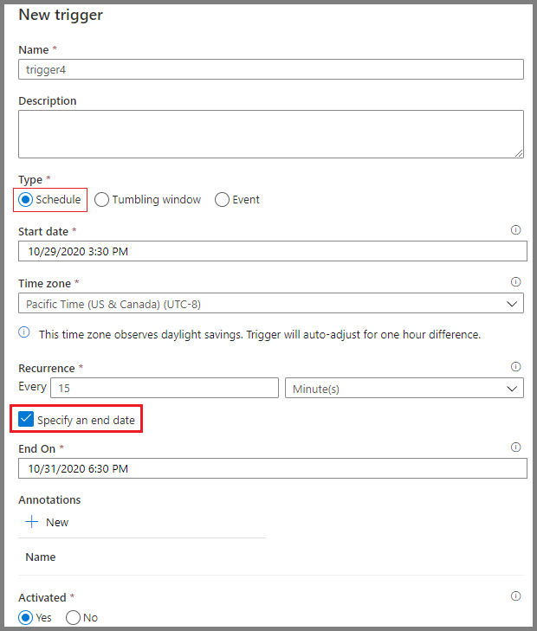

[Azure Data Factory: A Complete Guide for Beginners | DataCamp](https://www.datacamp.com/tutorial/azure-data-factory)

Features:

1. Data movement – copy data from on-premises system, SaaS apps, and cloud storages (e.g., SQL server, Oracle, Blob Storage, Data Lake).
2. Data transformation – supports:

Build-in transformation with Mapping Data Flows (low-code / no-code)

Running compute service like databricks, synapse or custom code.

1. Orchestration (order) & Monitoring – manage workflows, schedule pipelines, and monitor execution visually.
2. Integration runtime (IR) – provides the compute infrastructure for data movement and transformation.
3. Serverless – you don’t need to manage servers; you pay only for the pipelines and runtime you use.

Common use cases:

* Migrating data from on-premises databases to the cloud.
* Building ETL/ELT pipelines for data warehousing.
* Moving data into azure data lake or synapse analytics for reporting.
* Automating data workflows for AI/ML model training.
* Real-time data ingestion with event triggers.

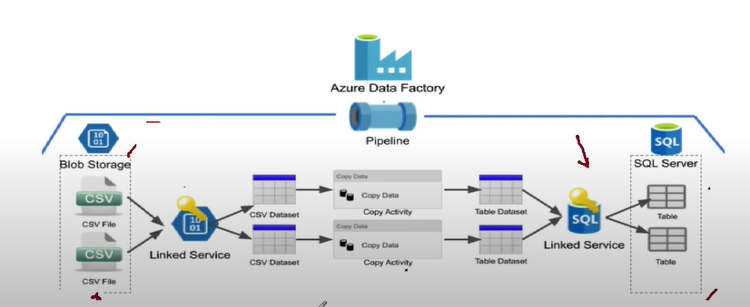

**Functions in Azure Data Factory (ADF)**

**1. String Functions**

Used to work with text.

|  |  |  |
| --- | --- | --- |
| **Function** | **Description** | **Example** |
| concat(a,b,...) | Joins multiple strings. | @concat('file_', pipeline().RunId, '.csv') → "file_1234.csv" |
| substring(string, start, length) | Extracts part of a string. | @substring('DataFactory', 0, 4) → "Data" |
| length(string) | Returns length of string. | @length('ADF') → 3 |
| toLower(string) | Lowercase. | @toLower('ADF') → "adf" |
| toUpper(string) | Uppercase. | @toUpper('adf') → "ADF" |
| trim(string) | Removes spaces. | @trim(' hello ') → "hello" |
| replace(string, old, new) | Replaces text. | @replace('data_factory','_','') → "datafactory" |
| split(string, delimiter) | Splits into array. | @split('a,b,c',',') → ['a','b','c'] |
| guid() | Generates unique ID. | @guid() → "7e8d...a2b" |

**2. Collection Functions (Arrays & Objects)**

**Work with arrays, objects, JSON.**

|  |  |  |
| --- | --- | --- |
| **Function** | **Description** | **Example** |
| contains(collection, value) | Checks if value exists. | @contains(['a','b'],'b') → true |
| empty(collection) | Checks if empty. | @empty([]) → true |
| first(array) | First element. | @first(['x','y']) → "x" |
| last(array) | Last element. | @last(['x','y']) → "y" |
| intersection(arr1,arr2) | Common values. | @intersection([1,2],[2,3]) → [2] |
| union(arr1,arr2) | Combine unique values. | @union([1,2],[2,3]) → [1,2,3] |
| join(array, delimiter) | Join into string. | @join(['a','b'], '-') → "a-b" |
| length(array) | Array length. | @length([1,2,3]) → 3 |
| addProperty(obj,key,value) | Adds property. | @addProperty(variables('obj'),'newKey','val') |
| removeProperty(obj,key) | Removes property. | @removeProperty(obj,'key') |

**3.Logical Functions**

**Used in conditions (If, Switch, Filter, etc.).**

|  |  |  |
| --- | --- | --- |
| Function | Description | Example |
| and(a,b,...) | True if all true. | @and(equals(1,1),greater(2,1)) → true |
| or(a,b,...) | True if at least one true. | @or(equals(1,2),equals(2,2)) → true |
| not(expr) | Negates. | @not(equals(1,1)) → false |
| equals(a,b) | Checks equality. | @equals(5,5) → true |
| greater(a,b) | Greater than. | @greater(5,3) → true |
| less(a,b) | Less than. | @less(2,3) → true |
| if(cond, trueVal, falseVal) | Inline if. | @if(equals(2,2),'Yes','No') → "Yes" |
| coalesce(a,b,...) | First non-null value. | @coalesce(null,'ADF','DF') → "ADF" |

**4. Conversion Functions**

**Convert between data types.**

|  |  |  |
| --- | --- | --- |
| **Function** | **Description** | **Example** |
| string(value) | Convert to string. | @string(123) → "123" |
| int(value) | Convert to integer. | @int('25') → 25 |
| float(value) | Convert to float. | @float('12.34') → 12.34 |
| bool(value) | Convert to boolean. | @bool('true') → true |
| json(string) | Convert to JSON. | @json('{"name":"abc"}') → object |
| base64(string) | Encode base64. | @base64('ADF') → "QURG" |
| base64ToString(string) | Decode base64. | @base64ToString('QURG') → "ADF" |

**5.Date & Time Functions**

**Handle datetime.**

|  |  |  |  |
| --- | --- | --- | --- |
| **Function** | **Description** | | **Example** |
| **utcNow()** | **Current UTC datetime.** | | **@utcNow() → "2025-09-02T06:30:00Z"** |
| **addDays(datetime,n)** | **Add days.** | | **@addDays(utcNow(),5)** |
| **addHours(datetime,n)** | **Add hours.** | | **@addHours(utcNow(),2)** |
| **addMinutes(datetime,n)** | **Add minutes.** | | **@addMinutes(utcNow(),30)** |
| **addMonths(datetime,n)** | **Add months.** | | **@addMonths('2025-01-01',1) → Feb 1** |
| **addSeconds(datetime,n)** | **Add seconds.** | | **@addSeconds(utcNow(),10)** |
| **subtractFromTime(datetime,n,unit)** | **Subtract time.** | | **@subtractFromTime(utcNow(),2,'Day')** |
| **formatDateTime(datetime,**  **format)** | **Format datetime.** | | **@formatDateTime(utcNow(),'yyyy-MM-dd')** |
| **dayOfWeek(datetime)** | **Returns day (0=Sunday).** | | **@dayOfWeek('2025-09-02') → 2** |
| **dayOfMonth(datetime)** | **Day of month.** | | **@dayOfMonth('2025-09-02') → 2** |
|  | |  |  |

**6. Math Functions**

**Used for calculations.**

|  |  |  |
| --- | --- | --- |
| **Function** | **Description** | **Example** |
| add(a,b) | Add. | @add(5,3) → 8 |
| sub(a,b) | Subtract. | @sub(5,3) → 2 |
| mul(a,b) | Multiply. | @mul(2,3) → 6 |
| div(a,b) | Divide. | @div(6,3) → 2 |
| mod(a,b) | Modulus. | @mod(10,3) → 1 |
| min(a,b,...) | Minimum. | @min(3,5,1) → 1 |
| max(a,b,...) | Maximum. | @max(3,5,1) → 5 |
| rand(min,max) | Random number. | @rand(1,100) → e.g., 42 |
| ceiling(value) | Round up. | @ceiling(2.3) → 3 |
| floor(value) | Round down. | @floor(2.9) → 2 |
| round(value,decimals) | Round with decimals. | @round(2.567,2) → 2.57 |

**7. Pipeline Functions**

**Access metadata inside pipelines.**

|  |  |  |
| --- | --- | --- |
| **Function** | **Description** | **Example** |
| pipeline().DataFactory | Returns DF name. | "MyADF" |
| pipeline().Pipeline | Returns pipeline name. | "MyPipeline" |
| pipeline().RunId | Unique pipeline run ID. | "12345-abc" |
| pipeline().TriggerTime | Triggered datetime. | "2025-09-02T06:30:00Z" |
| activity('ActivityName'). output | Output of activity. | @activity('Lookup1').output.firstRow.id |
| trigger().outputs | Trigger values. | From event/schedule trigger |
| parameters('paramName') | Pipeline parameter. | @parameters('inputFile') |
| variables('varName') | Pipeline variable. | @variables('counter') |

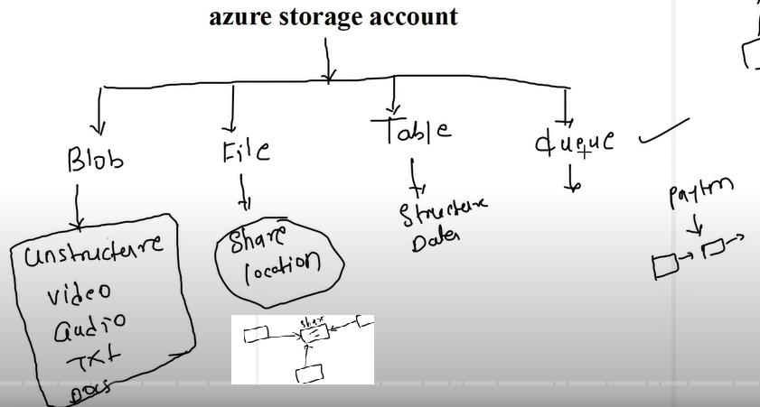

**ADLS** stands for **Azure Data Lake Storage**.

* It’s a **cloud-based storage service** from Azure, specially designed for **big data analytics and processing**.
* Think of it like **Azure Blob Storage**, but **optimized for analytics, hierarchical structure, and security**.
* Is a scalable and secure data lake service designed to store and analyze large volumes of structured and unstructured data.

**Types of ADLS**

Earlier there were two generations, but now everything is under **ADLS Gen2** (built on top of Blob storage).

1. **ADLS Gen1** – older, separate service (now retired).
2. **ADLS Gen2** – combines the best of Blob storage + Data Lake features.

ADLS Gen2 = Azure Blob Storage + ADLS Gen1

1. Hadoop compatible:

ADLS Gen1 is based on Hadoop Distributed File System (HDFS),

ADLS Gen2 is built on top of Azure Blob Storage.

1. Namespace and hierarchy:

ADLS Gen1 has a flat namespace.

ADLS Gen2 has a hierarchical namespace. ADLS Gen2 uses directories to organize data, which provides a more efficient way to manage large amounts of data.

1. Security:

ADLS Gen1 uses access control lists (ACLs) for authorization.

ADLS Gen2 uses role-based access control (RBAC) and Azure Active Directory (AAD) authentication.

1. Data Lake Analytics:

ADLS Gen1 integrates with Azure Data Lake Analytics, a cloud-based analytics service that can process big data using U-SQL, a language that combines SQL and C#.

ADLS Gen2 also supports Data Lake Analytics, but it uses Apache Spark instead of U-SQL.

ADLS Gen 2 supports access methods such as REST APIs, .NET, Java, and Hadoop Distributed File System (HDFS).

ADF is like a pipeline tool in Azure that helps us **extract data from multiple sources, transform it, and load it into target systems like Data Lake or Synapse**.  
It acts as an **orchestrator** – it doesn’t always process the data itself, but it makes sure the right data moves and gets processed at the right time using services like Databricks, SQL, or Synapse.”

**One-liner:**

* **ADF = Azure’s ETL + Orchestration tool for building and managing data pipelines.**

**Core components of Azure Data Factory**

1. **Pipeline** – the workflow or flowchart or container that tells ADF how to move and transform data.

In ADF, that whole workflow (Extract → Transform → Load → Report) = **Pipeline**.

1. **Activity** – the individual steps [tasks inside pipeline] (copy, transform, etc)
2. **Data sets** – represent the data structures (e.g., SQL table, CSV file, blob)
3. **Linked services** – connections to external resources (like storage accounts, APIs)
4. **Triggers** – define when the pipeline should run (schedule, event or manual).

**Example Scenario**

Let’s say pipeline needs to:

1. Copy data from an **on-prem SQL database** to an **Azure Data Lake**.
2. Transform the data using a **Databricks notebook**.
3. Load the cleaned data into **Azure Synapse Analytics** for reporting.

In ADF, this would look like:

* **Pipeline** = *Daily Sales Data Pipeline*
* **Activities**:
* Copy activity (SQL → Data Lake)
* Notebook activity (Databricks transformation)
* Copy activity (Data Lake → Synapse)
* **Trigger**: Schedule at 1 AM daily

**Pipeline**

**A data factory might have one or more pipelines. A pipeline is a logical grouping of activities that performs a unit of work.**

**Activity**

**Activities represent a processing step in a pipeline. (copy activity to copy data store)**

Search for “data factory”

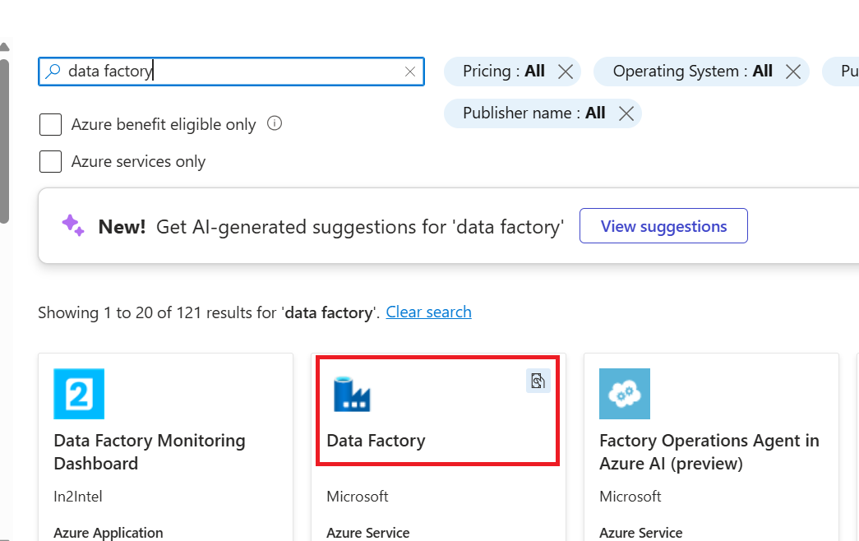

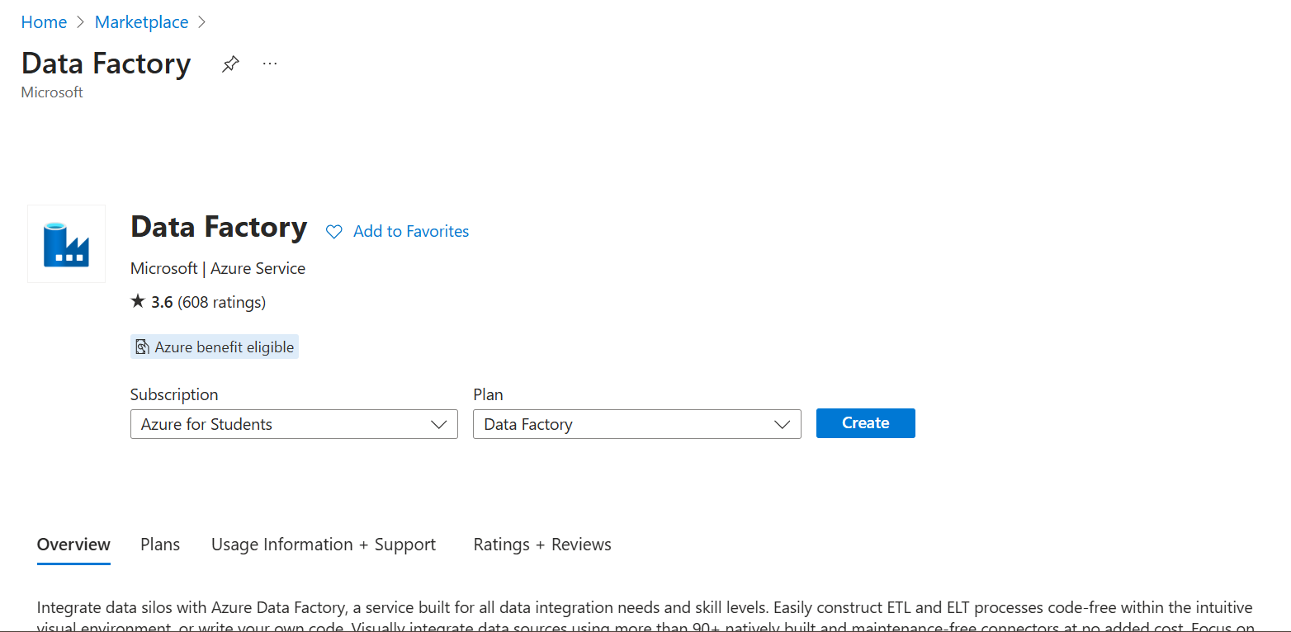

Select resource group

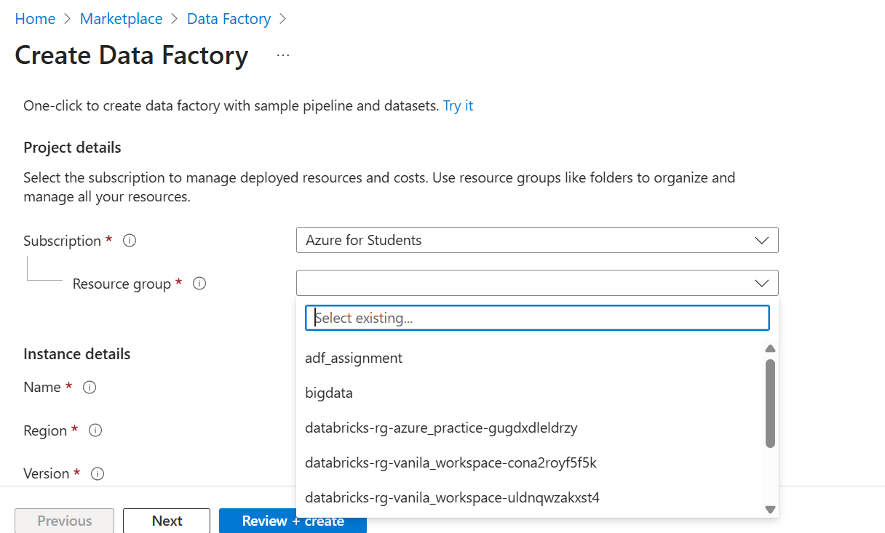

Data factory is created

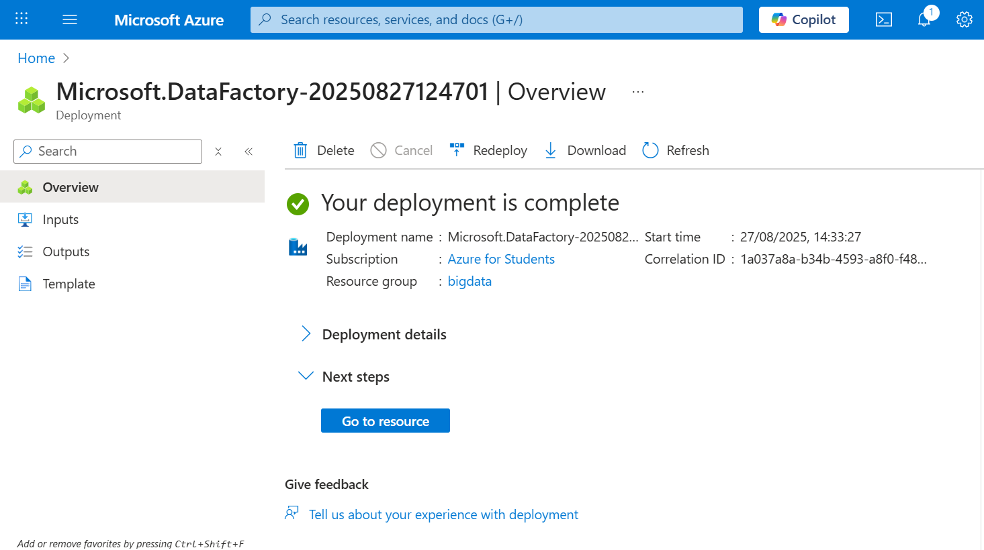

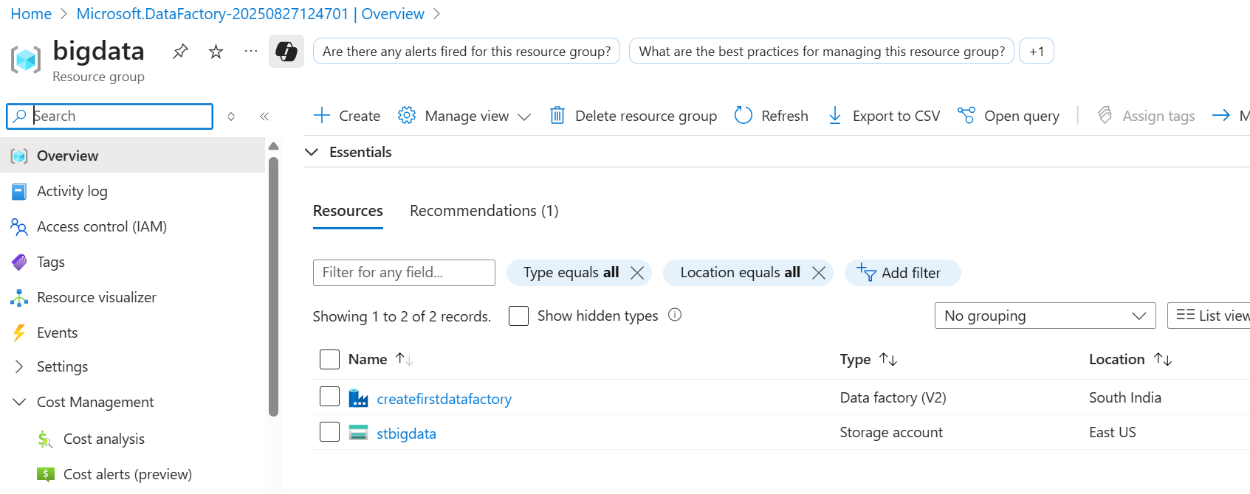

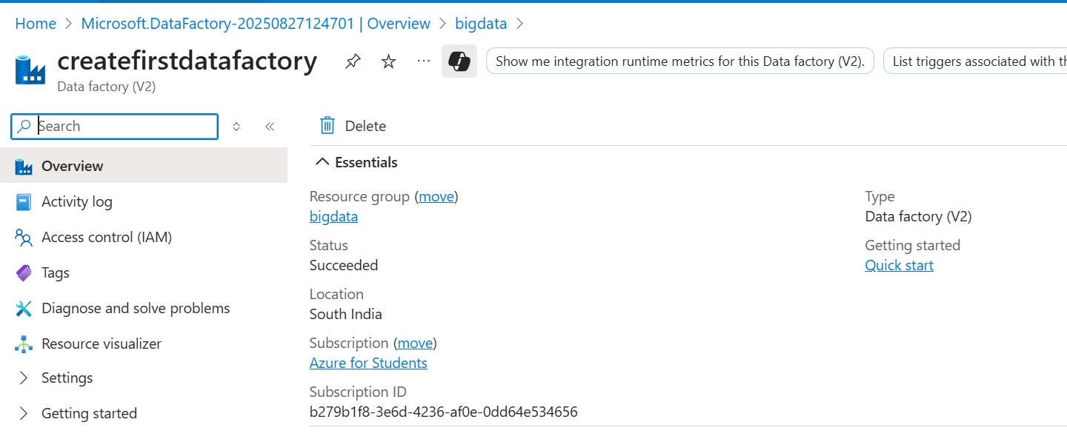

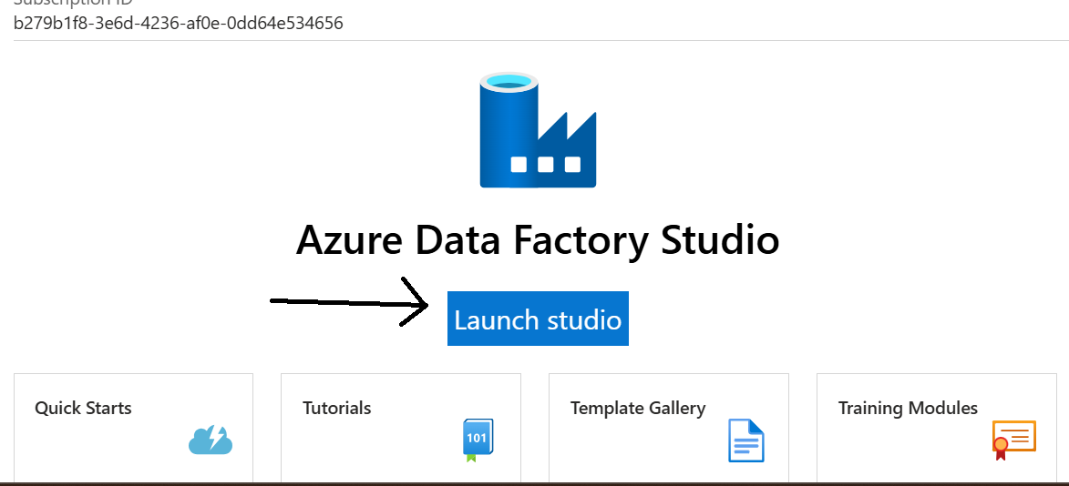

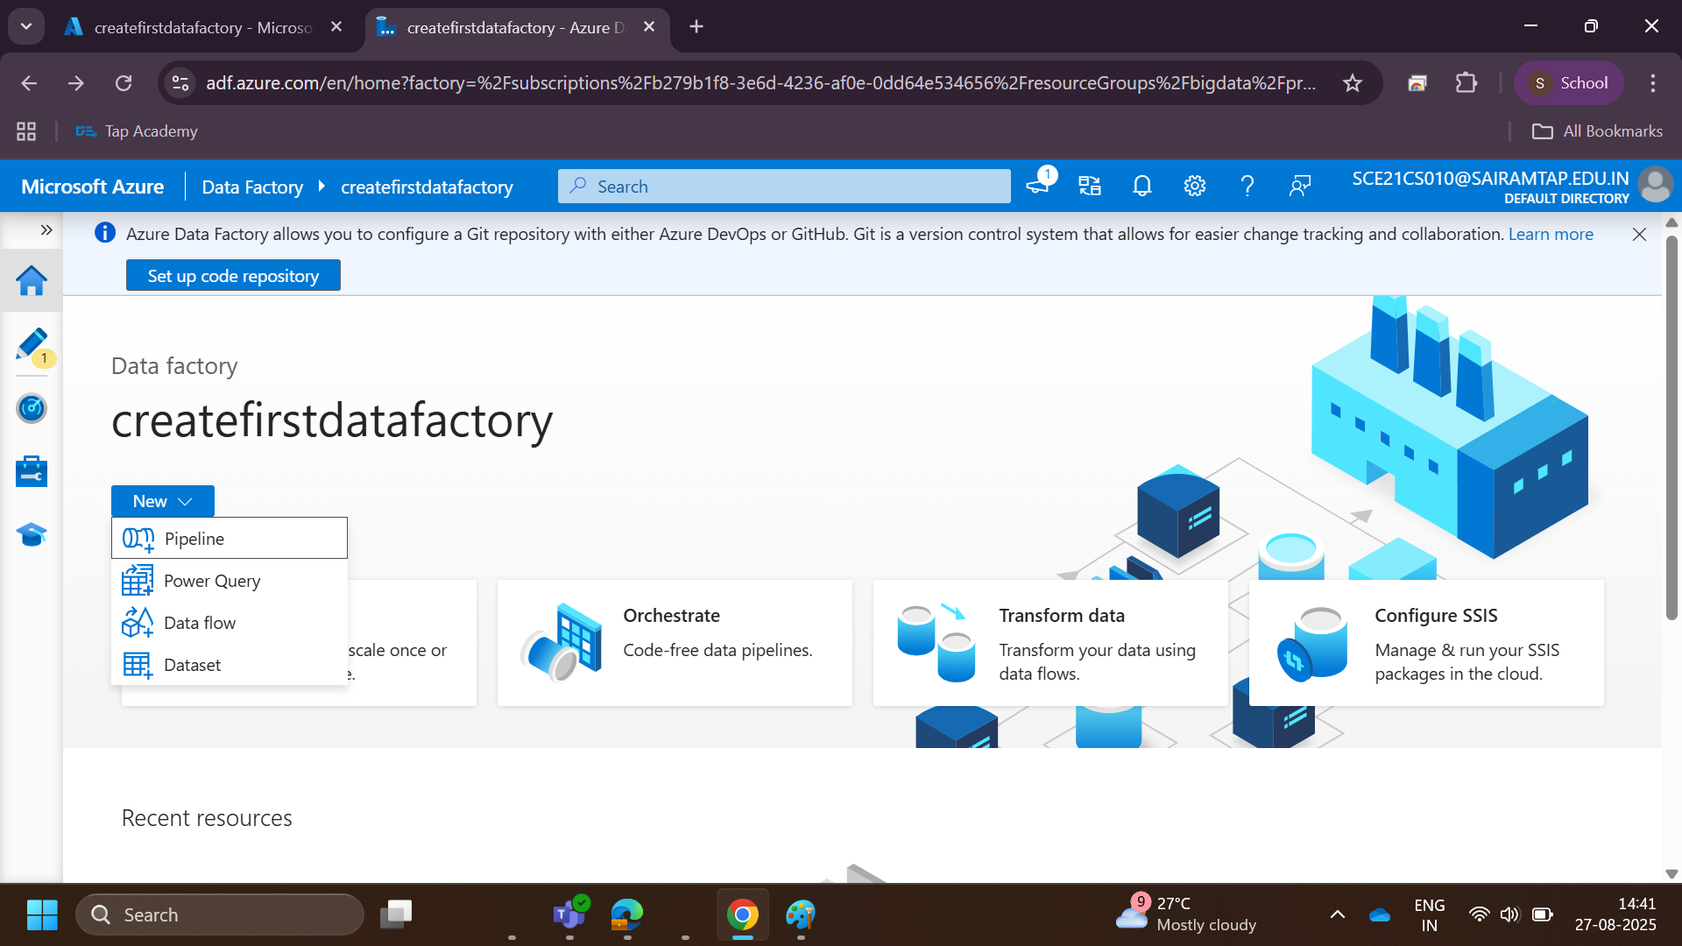

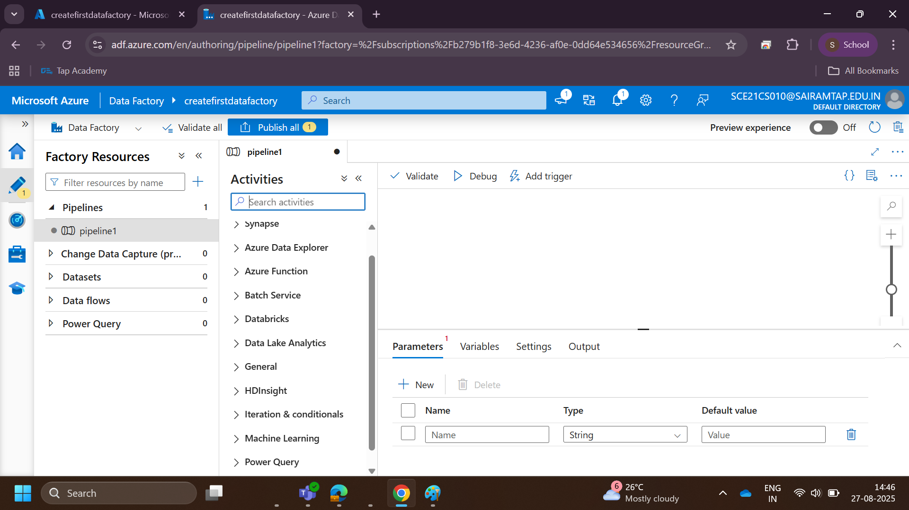

Drag and drop the activity

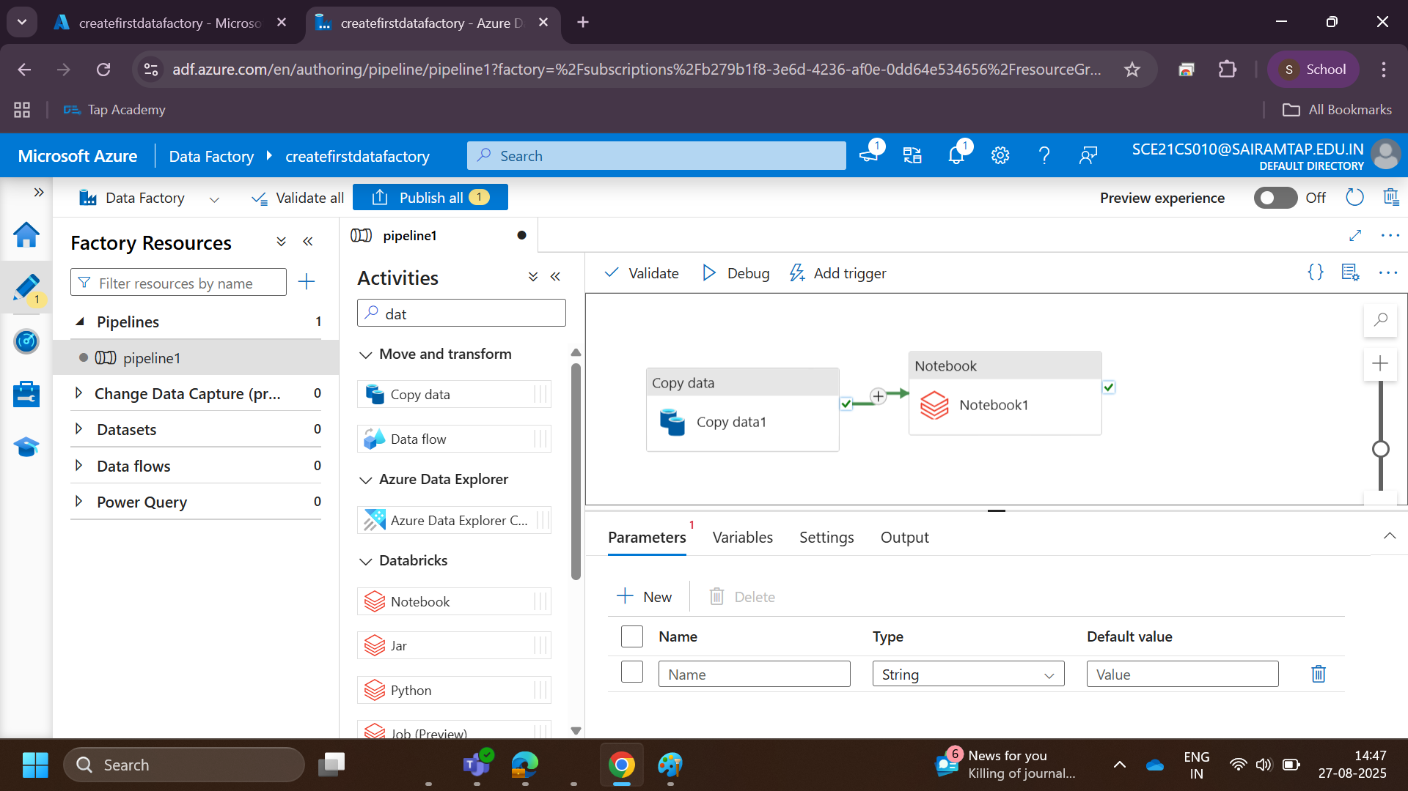

**Linked services & data sets**

Linked services are much like connection strings, which define the connection information that’s needed for data factory to connect to external resources.

It defines how to connect to a data source**.**

Datasets represent data structures within the data stores, which simply point to or reference the data you want to use in your activities.

Think of it as a **pointer to actual data** inside the data source.  
It represents the **structure & location** of the data you want to use.

For example,

* **Linked Service** → Tells ADF how to connect.
* **Dataset** → Tells ADF what data inside that source to use.

**Task:** Copy customer data from SQL Database to Azure Blob.

1. **Linked Service (SQL)** → Connection details to SQL DB.
2. **Dataset (SQL)** → Points to *dbo.Customers* table.
3. **Linked Service (Blob)** → Connection details to Blob Storage.
4. **Dataset (Blob)** → Points to *customers.csv* in container *raw-data*.
5. **Copy Activity** → Moves data from Dataset (SQL) → Dataset (Blob).

Click “New” to add the source data

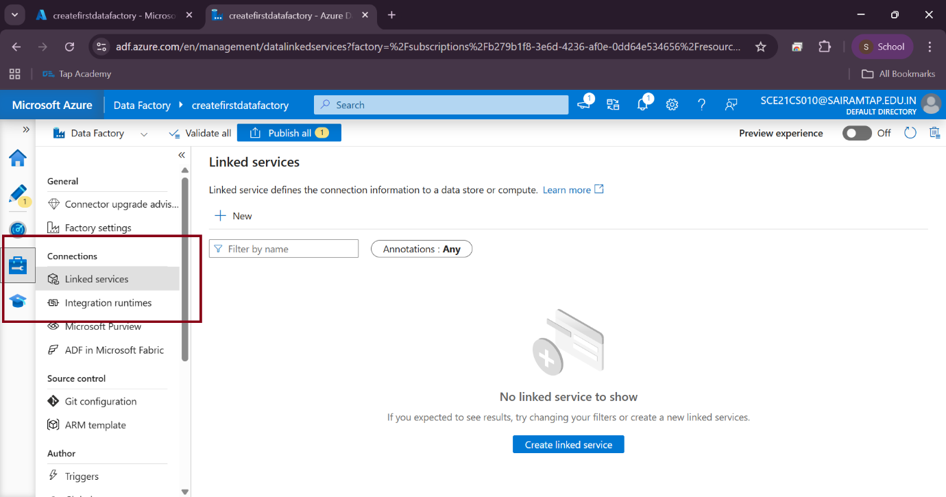

**Trigger**

A trigger defines when and how a pipeline should run.  
Pipelines don’t run automatically — you must either manually run them or use a trigger.

* Tiggers – you can execute your pipeline.
* It determines when a pipeline execution needs to be kicked off.
* Multiple triggers can kick off a single pipeline, or a single trigger can kick off multiple pipelines.
* Pipelines and triggers have a many-to-many relationship (except for the tumbling window trigger).

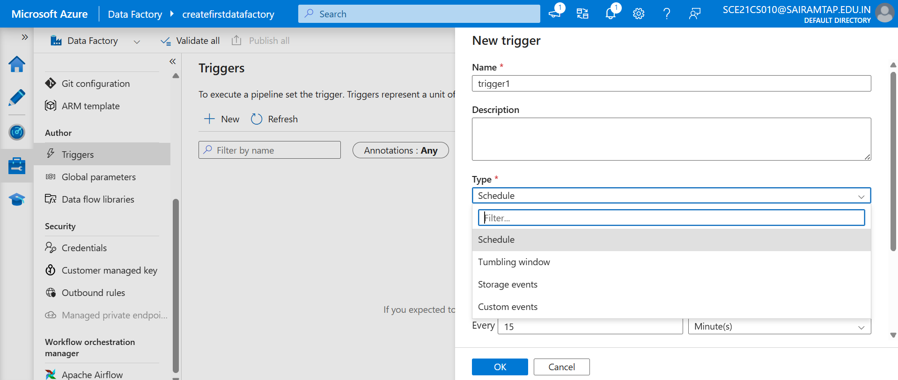

Types of triggers

* Schedule
* tumbling window
* storage events
* custom events

**Types of Triggers in ADF**

1. **Schedule Trigger**

* Runs a pipeline at **specific times** based on a schedule you define.
* Example: Run every day at **9 AM**, or every **30 minutes**.
* It is **time-based only**.
* Doesn’t care if previous runs are completed or not.
* No dependency between runs (they are **independent**).
* Best suited for:
  + Simple, fixed-time schedules.
  + Pipelines that do not depend on previous runs or data intervals.
* Example: Run a data backup job at **midnight daily**.

1. **Tumbling Window Trigger**

* Runs a pipeline at a **regular interval (window)**, but each run represents a **specific, non-overlapping slice of time.**
* Example:

Process data for each **hour**, where

10:00–11:00 is one window,

11:00–12:00 is the next window.

* Ensures **exactly once execution per window** (no overlaps).
* If a run for a window fails, the next window will wait until the failed one is re-run and succeeded.
* Supports **dependency chaining** (later runs can depend on the success of earlier windows).
* Useful for **incremental data processing**.
* You can **re-run** a specific failed window.
* Best suited for:
  + Time-partitioned data ingestion (hourly/daily batch data).
  + Scenarios where **no data window should be skipped.**
* Example: Process log files arriving **hourly**. If 2–3 PM failed, you can rerun just that window.

|  |  |  |
| --- | --- | --- |
| **Feature** | **Schedule Trigger** | **Tumbling Window Trigger** |
| Type | Calendar-based | Window-based (fixed intervals) |
| Dependency | No dependency between runs | Can depend on previous runs |
| Overlap | Runs can overlap | Non-overlapping windows |
| Use Case | Simple recurring jobs | Incremental, window-based processing |
| Retry/Re-run | Manual rerun of pipeline | Can rerun a specific failed window |

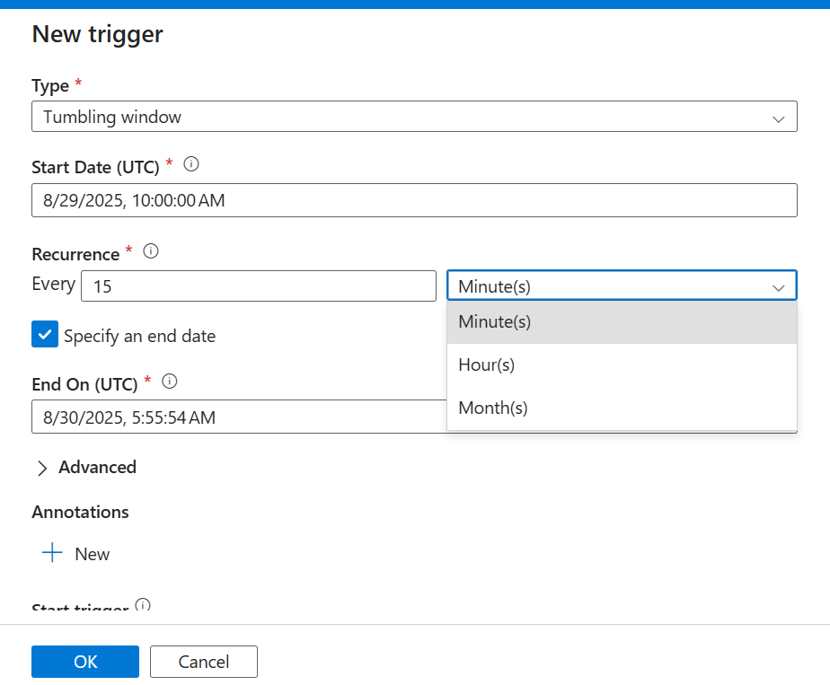

1. **Event-based Trigger**

* Runs a pipeline **when an event occurs**, not on a schedule.
* Commonly used with **Azure Blob Storage** or **ADLS Gen2**.
* Typical events:
* **Blob created** (new file uploaded)
* **Blob deleted**
* Runs only when the event happens
* Example:
* When a new file arrives in Azure Blob container, trigger pipeline to process it. (Run whenever a new orders.csv arrives in the raw-data container).
* Ingest data automatically when a **new CSV file arrives** in raw/sales/ folder.
* No need to schedule → the pipeline starts as soon as file lands.

1. **Manual or custom Trigger**

* **User-defined trigger** created using REST API, PowerShell, or SDK.
* Unlike Schedule, Tumbling, or Event triggers, you have **full control**.
* Useful when built-in triggers don’t fit your needs.
* You can invoke them programmatically with **custom logic** (from another system, app, or script).

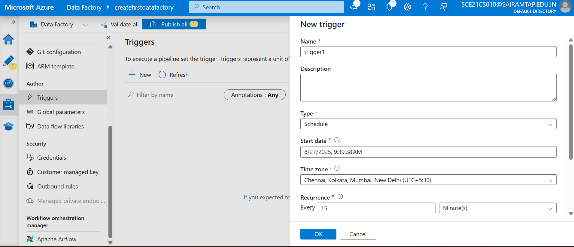

Practical demo of linked service

Connect the blob storage to ADF (use lined service) – customer.csv file

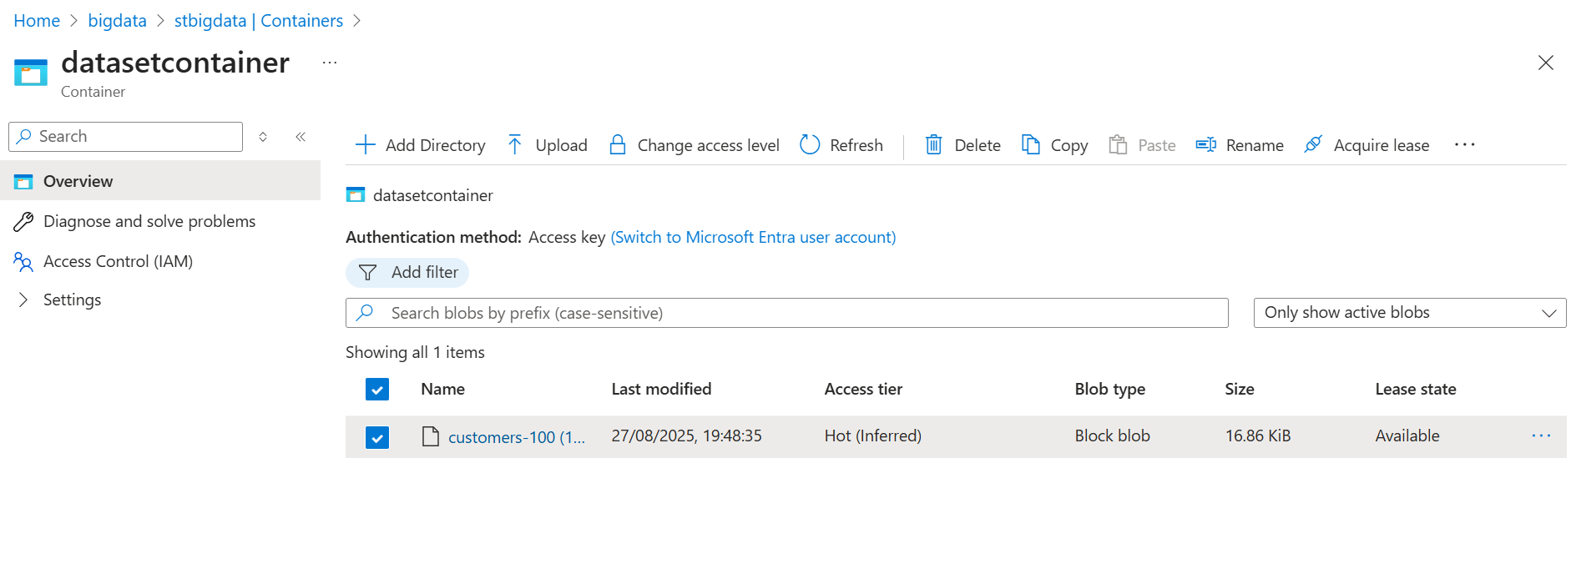

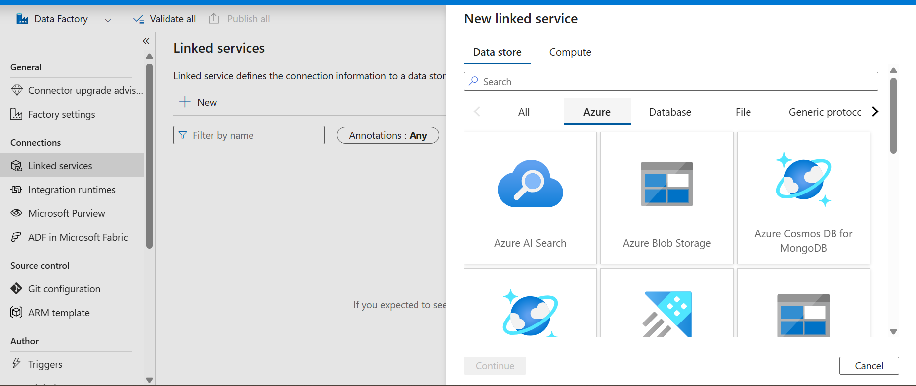

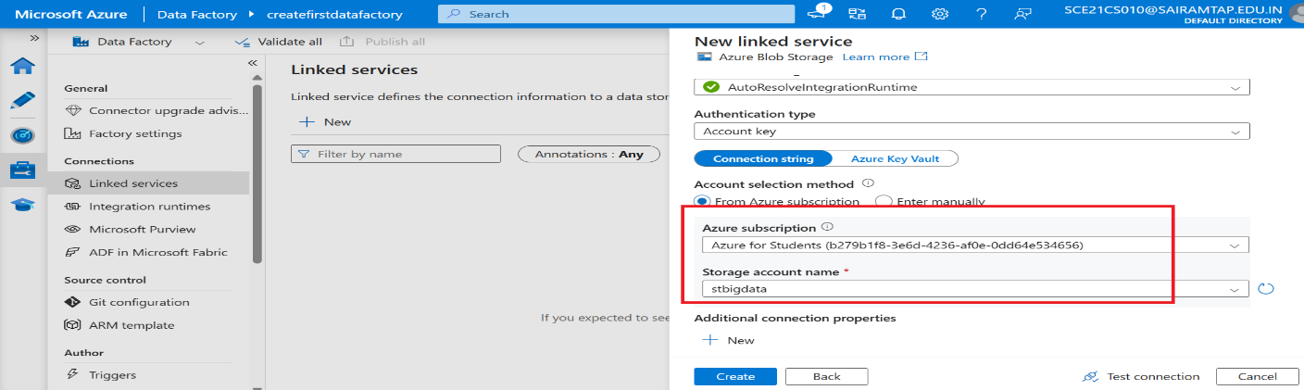

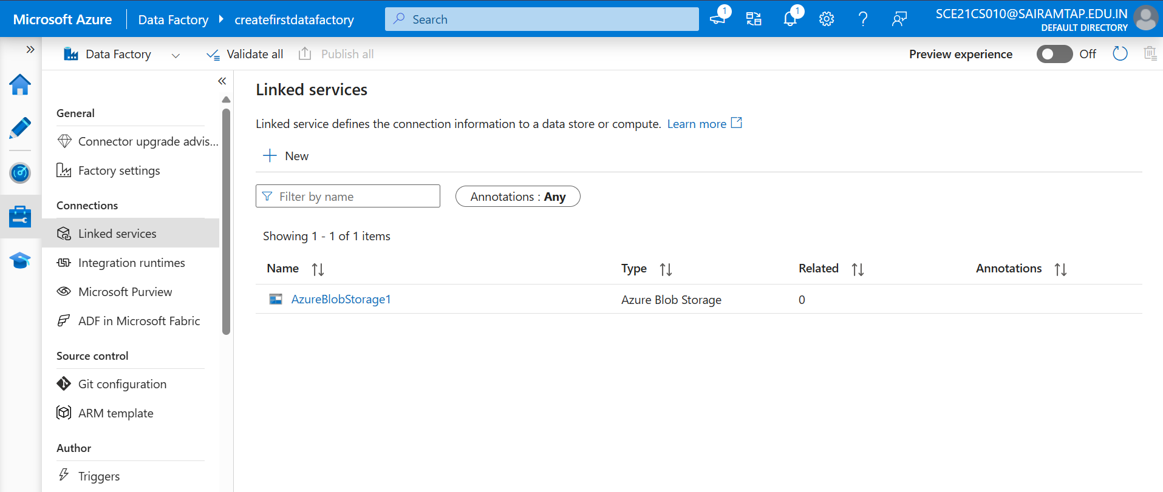

Create dataset

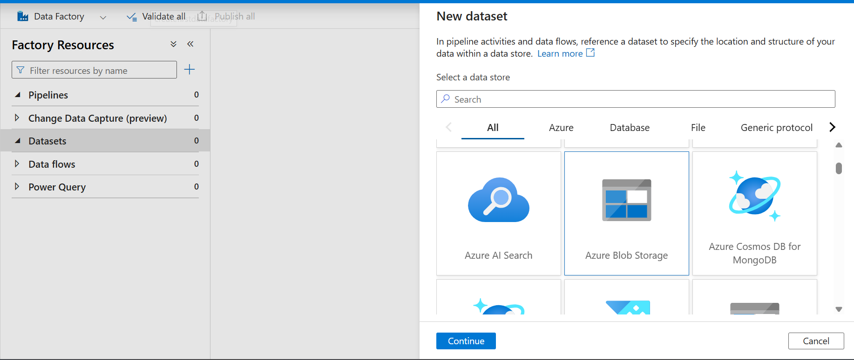

Select format

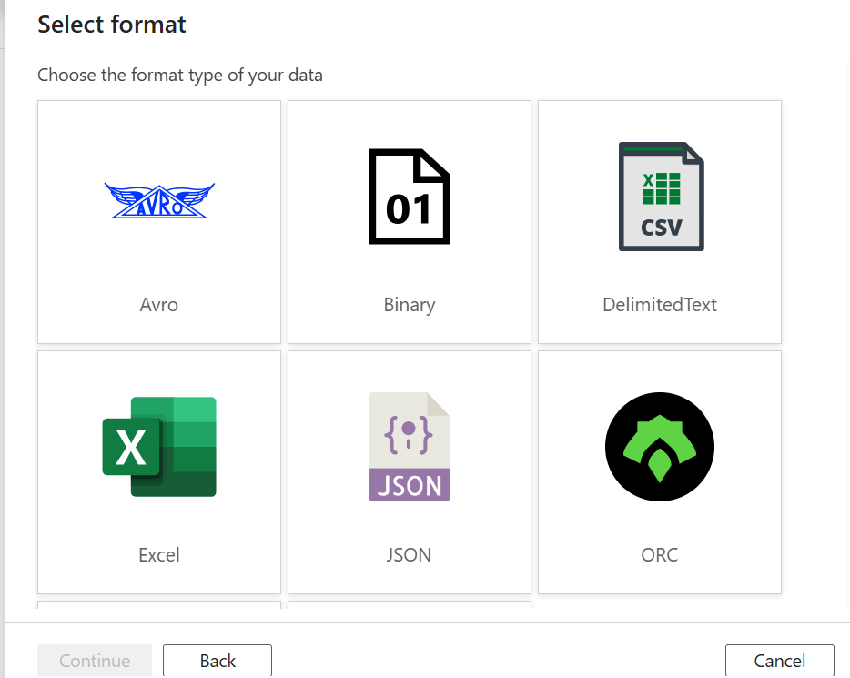

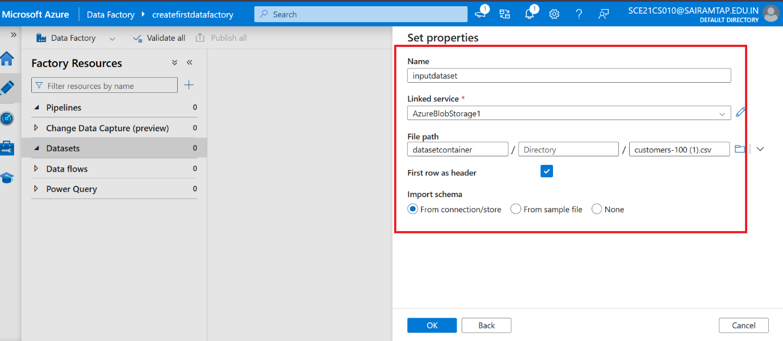

Same for input

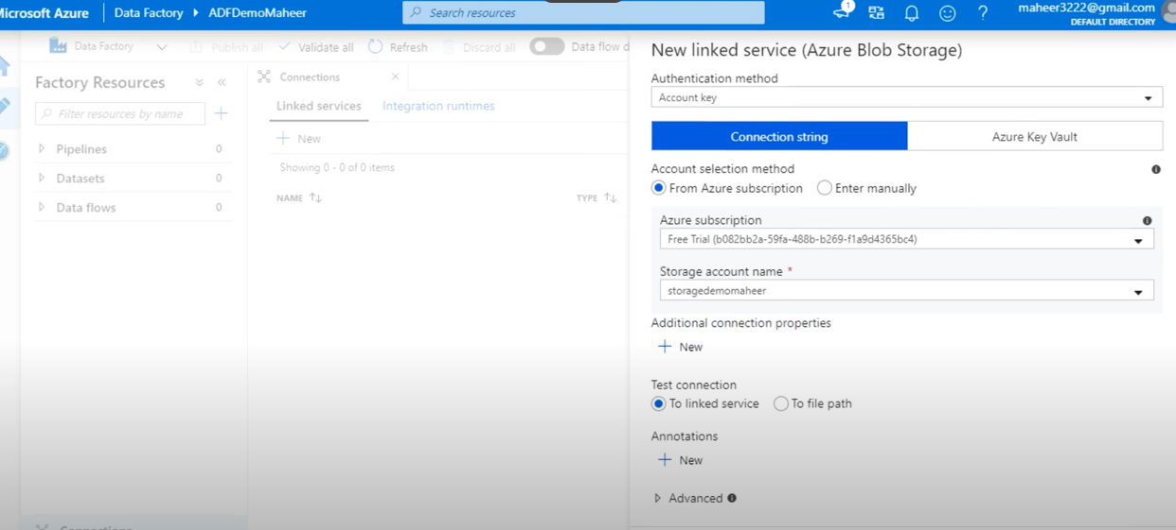

One for ouput

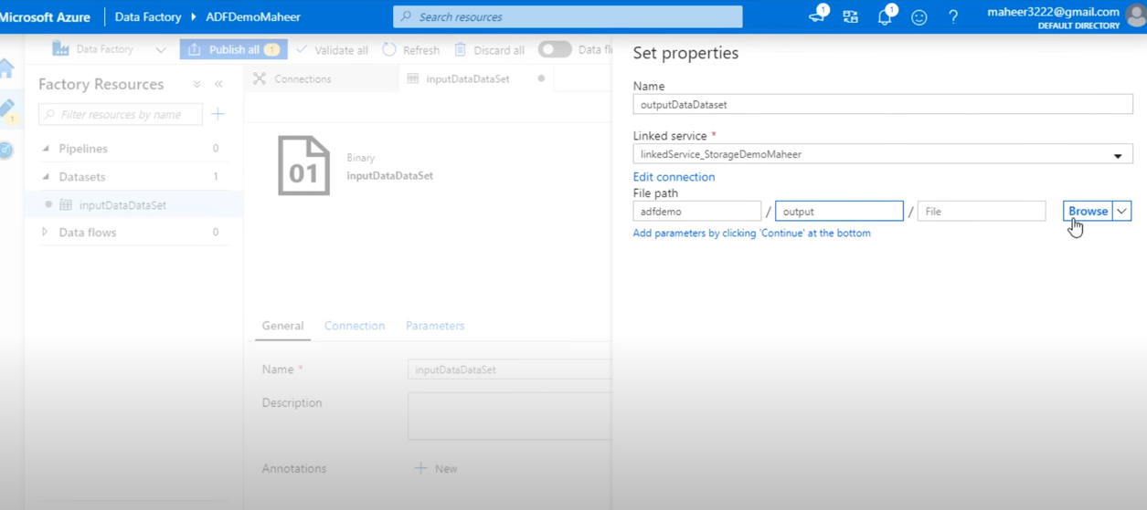

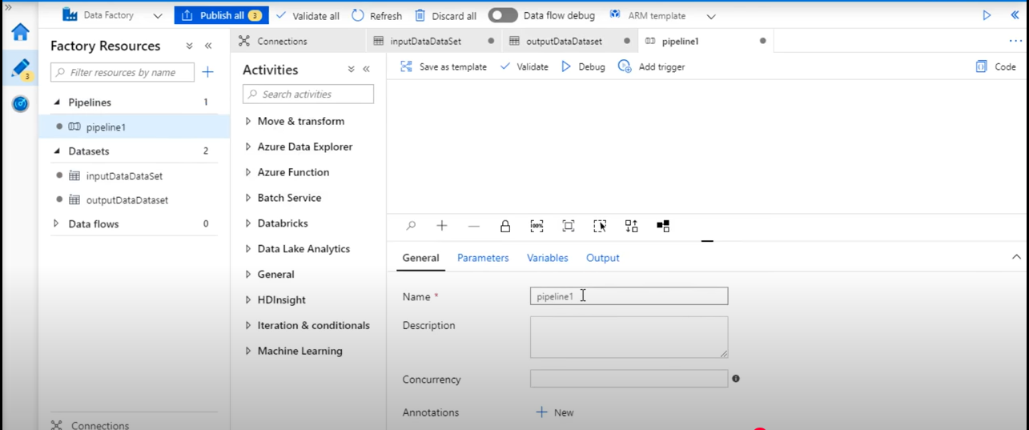

Copy activity – copy the data from the input folder to copy it output folder.

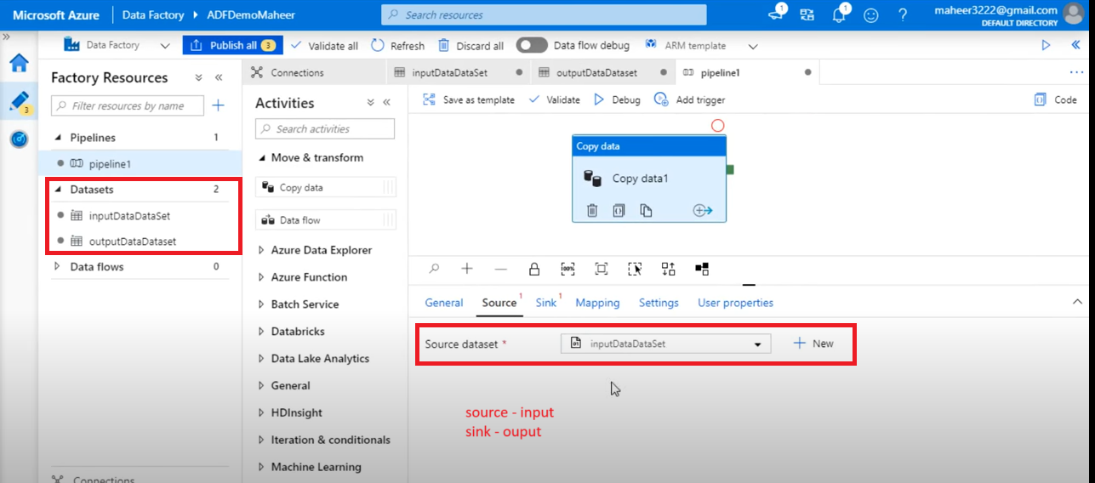

1st --- Validate

2nd --- Debug (whether data is copied or not)

It is ok then publish all

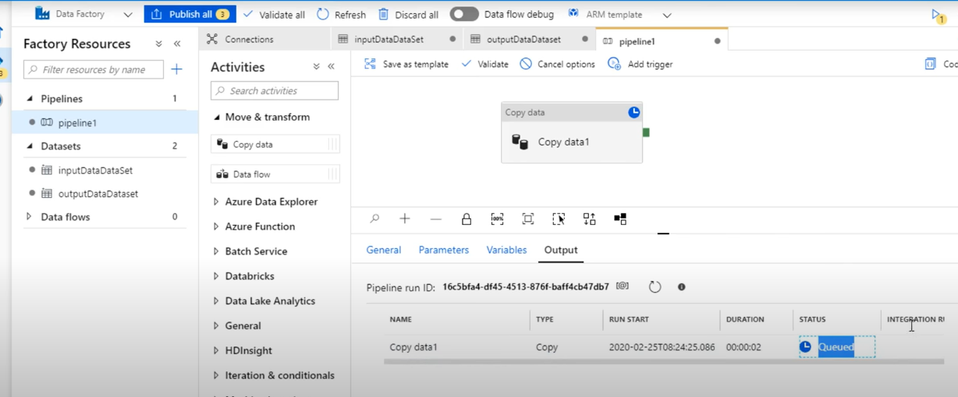

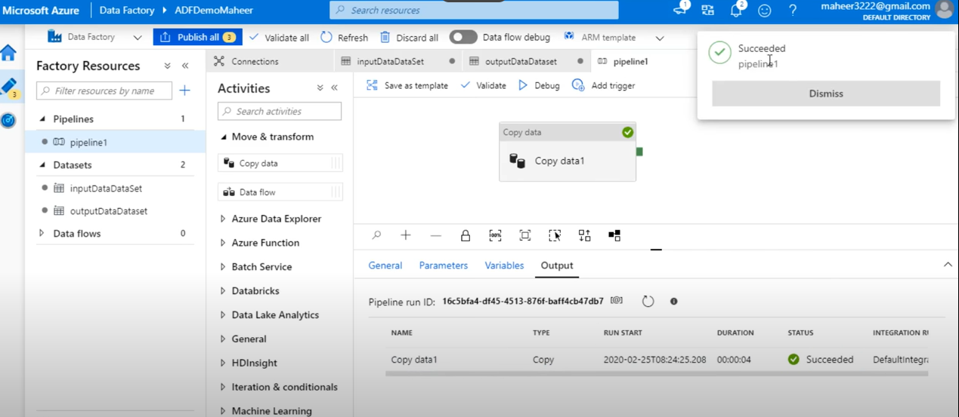

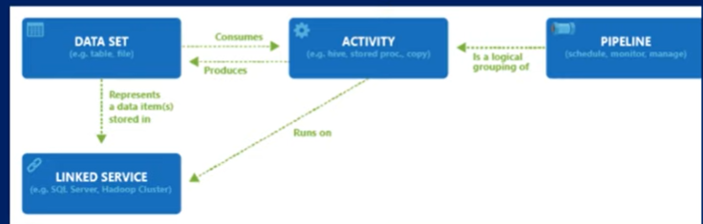

**Activities**

Types of Activities

* Data Movement Activities
* Data Transformation Activities
* Control flow activities

**First, think about Azure Data Factory (ADF)**

ADF is just an **orchestrator**.

* You design **pipelines** (like a recipe: "copy this data, transform that, load here").
* But ADF itself does **not** have the compute power to move or process the data.

So… something has to **do the actual work** → that’s the **Integration Runtime (IR)**.

**Integration Runtime (IR)**

The Integration Runtime (IR) is the compute infrastructure used by Azure Data Factory.

Azure Synapse uses to **move data, run transformations, and connect to data sources**.

[Integration Runtime (IR) is the compute engine of ADF/Synapse that provides the processing power and connectivity needed to move and transform data].

Note: (Think of it like the **engine** that executes your pipeline activities.  
Without an IR, your pipeline has the steps defined, but nothing to **run them**.)

Azure Synapse pipelines to provide the following data integration capabilities across different network environments:

* **Data Flow**: Execute a data flow in a managed Azure compute environment.
* **Data movement**: Copy data across data stores in a public or private network (for both on-premises or virtual private networks). The service provides support for built-in connectors, format conversion, column mapping, and performant and scalable data transfer.
* **Activity dispatch**: Dispatch and monitor transformation activities running on various compute services such as Azure Databricks, Azure HDInsight, ML Studio (classic), Azure SQL Database, SQL Server, and more.
* **SSIS package execution**: Natively execute SQL Server Integration Services (SSIS) packages in a managed Azure compute environment.

**Without IR, your pipeline is only instructions; nothing will actually run.**

Environment

IR types:

ADF offers 3 types of IR, and you should choose the types that best serves your data integration capabilities and network environment requirements.

* **Azure IR:** Handles cloud-based data integration tasks and is managed entirely by Azure. (default)
  + [Running dataflow
  + Running copy activities between cloud data stores.
  + Running transform activities]
* Best for **cloud-to-cloud data movement** and **transformations**.
* Supports **mapping data flows** and copying data between Azure & other cloud sources.
* **Self-hosted IR:** Supports data movement between on-premises systems and the cloud, making it ideal for hybrid scenarios.
* Installed on your **own machine (on-prem or in VM)**.
* Acts like a **bridge** between ADF and your **private network**.
* Required when you need to connect to:
  + On-premises databases (SQL Server, Oracle, MySQL, etc.).
  + Private network sources behind firewalls/VPN.
* Can also be used for **cloud-to-cloud** copy if you want data to pass through your network.
* Example: Copy data from On-Prem SQL Server → Azure Data Lake.

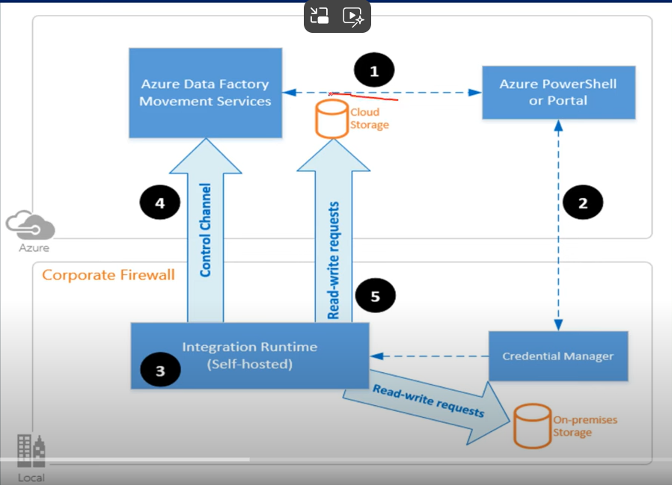

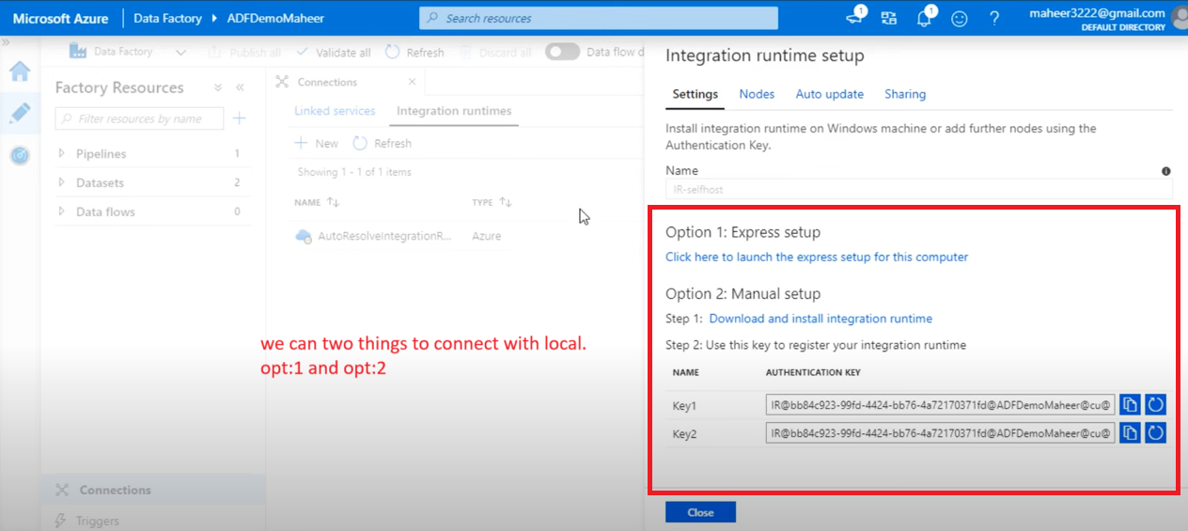

Need to install the **IR setup**.

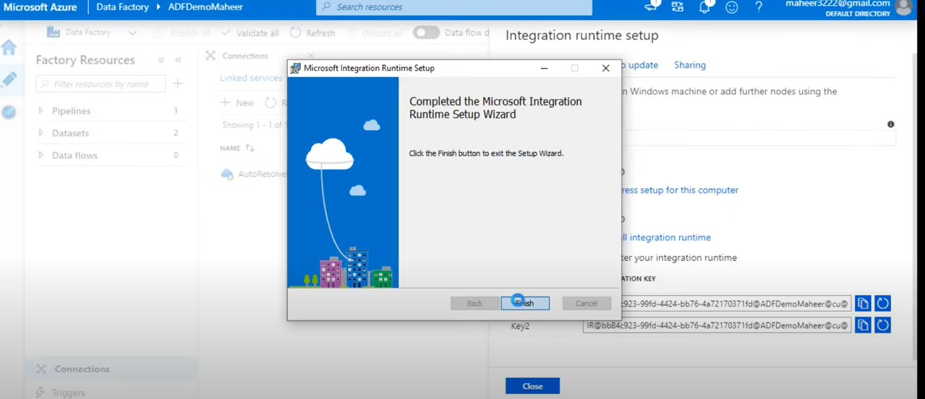

Copy the key and paste it.

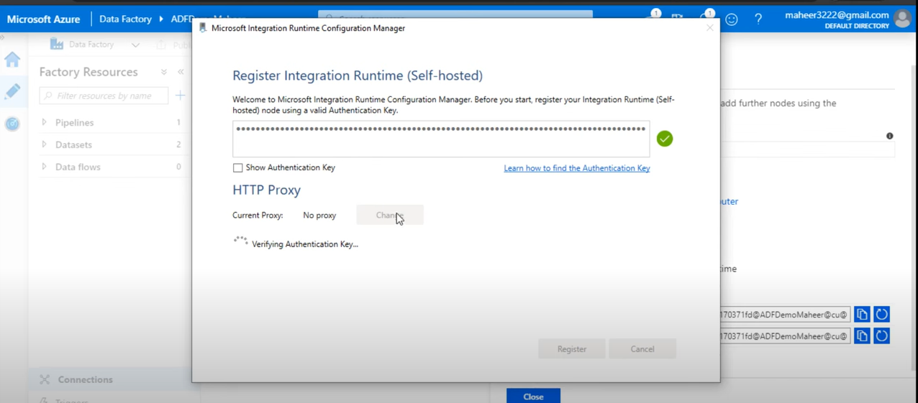

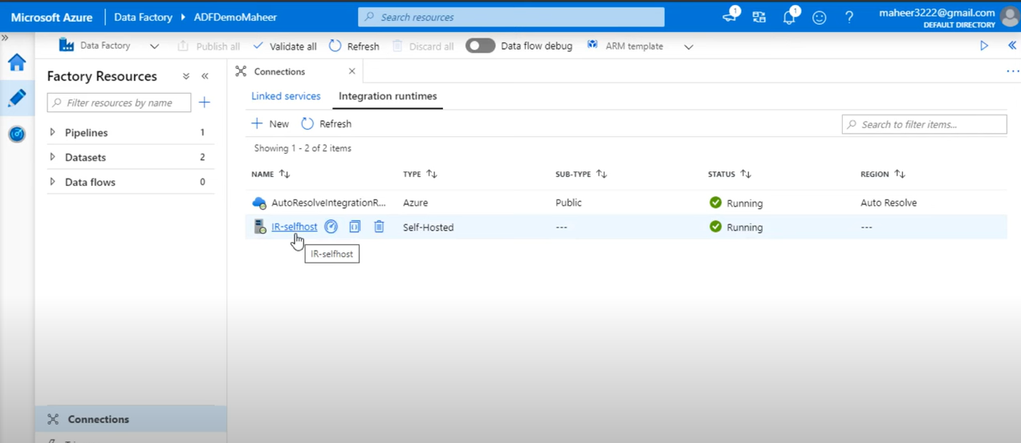

* **SSIS IR:** Enables the execution of SQL Server Integration Service(SSIS) packages within Azure, allowing you to reuse existing SSIS workflows in the cloud.

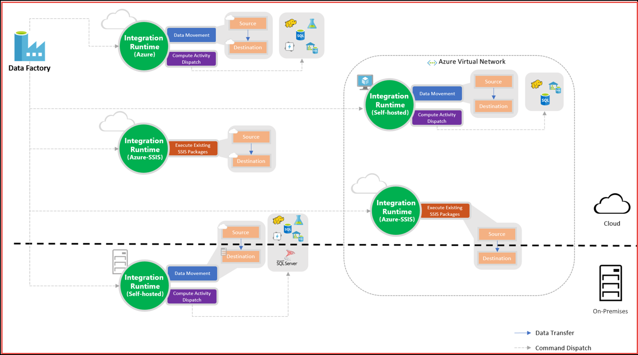

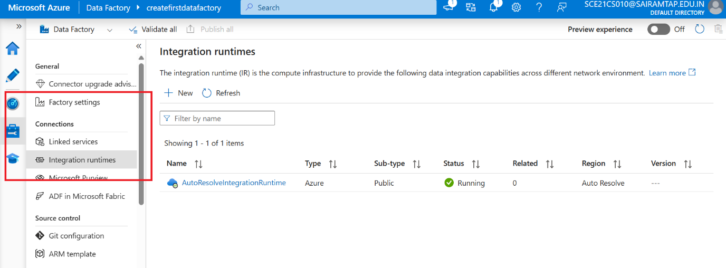

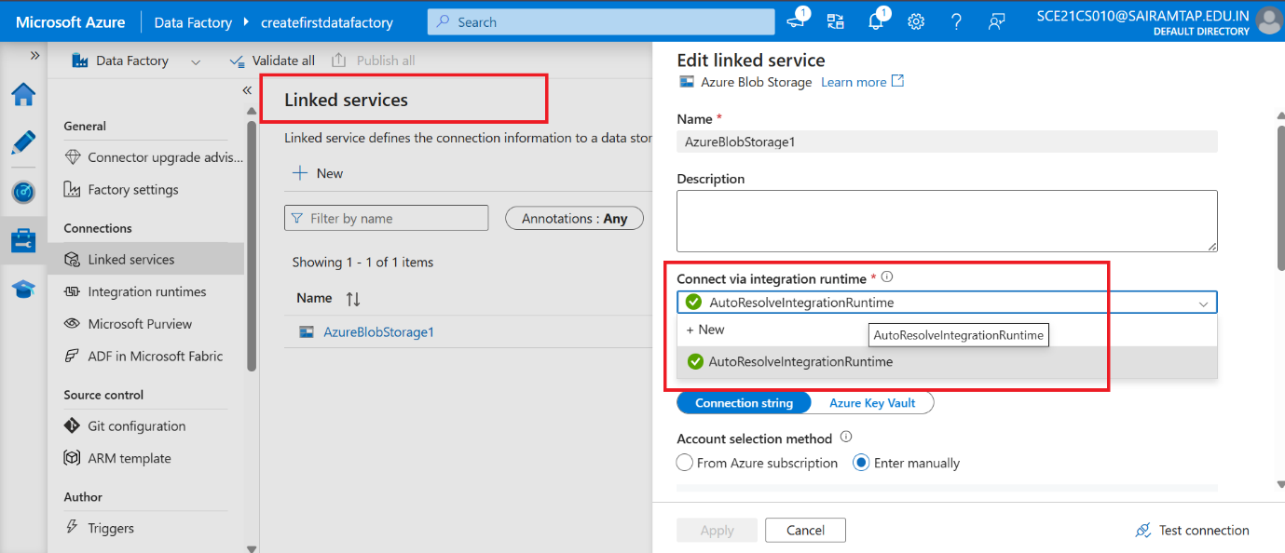

**Create new IR**

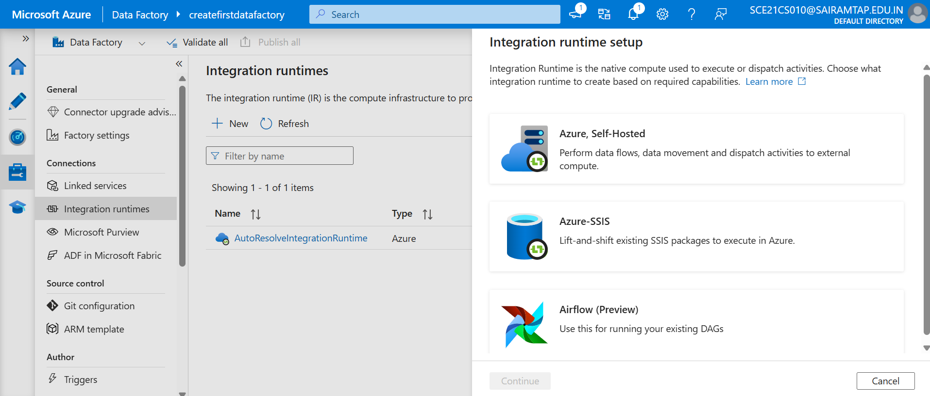

**Parameterize Linked Services**

Consider SQL server:

contains 10 databases, for that creating 10 linked service for all 10 DBs.

To avoid to this we use, **parameterization** (by this create only one linked service and use it for 10 dbs).

Create storage (sql server):

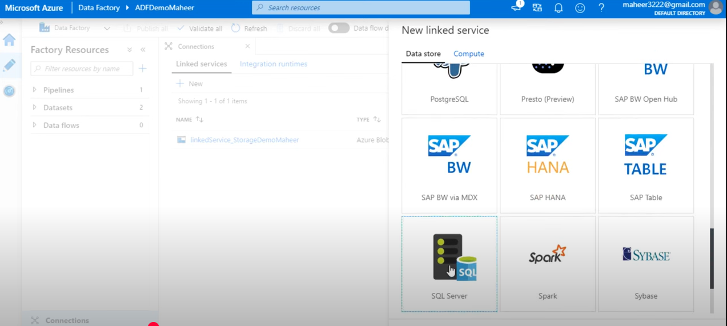

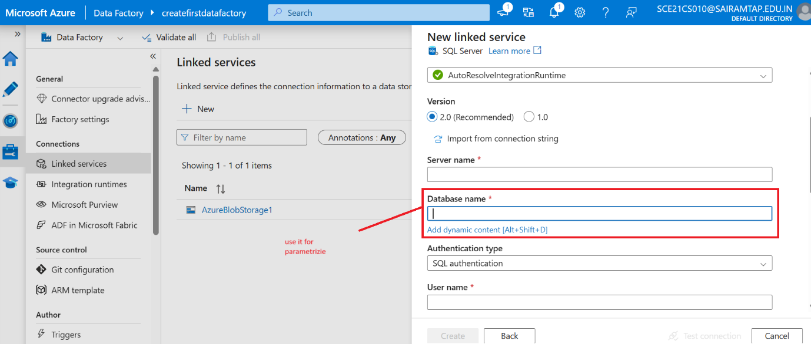

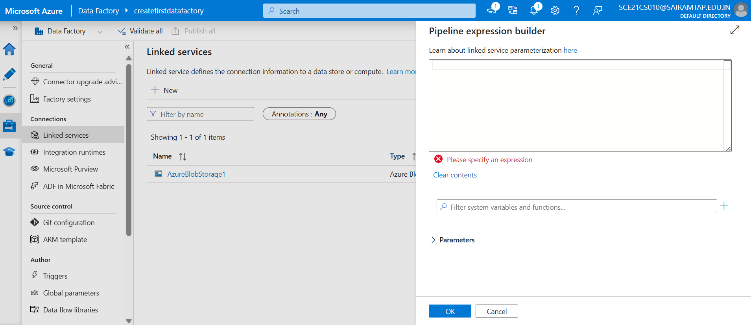

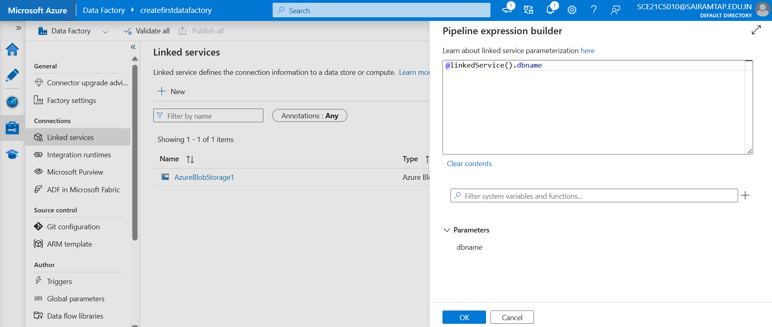

Once created

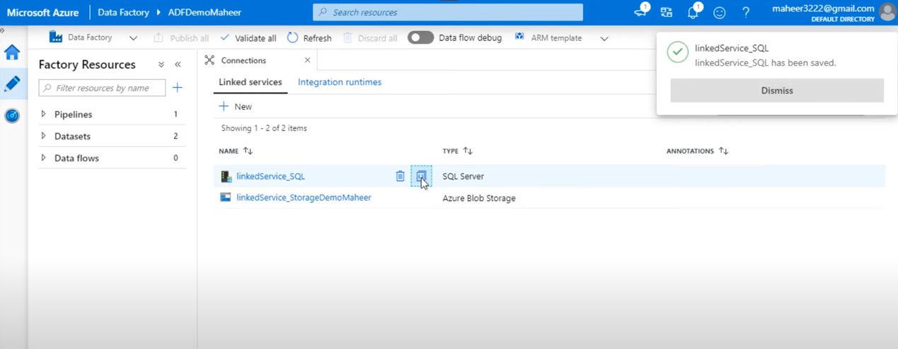

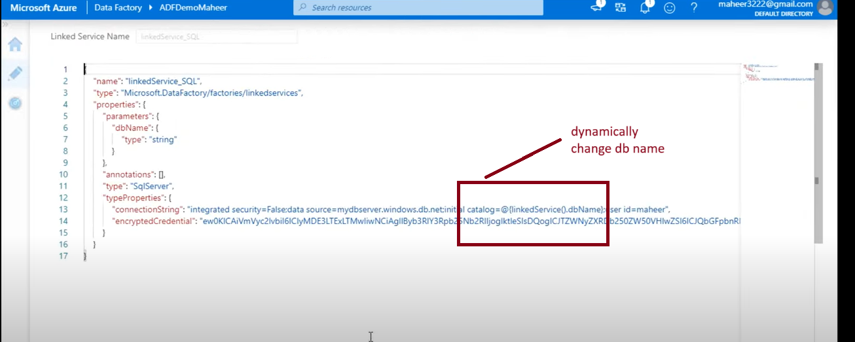

We can create the parameters for all the things like username, password, server name and database name.

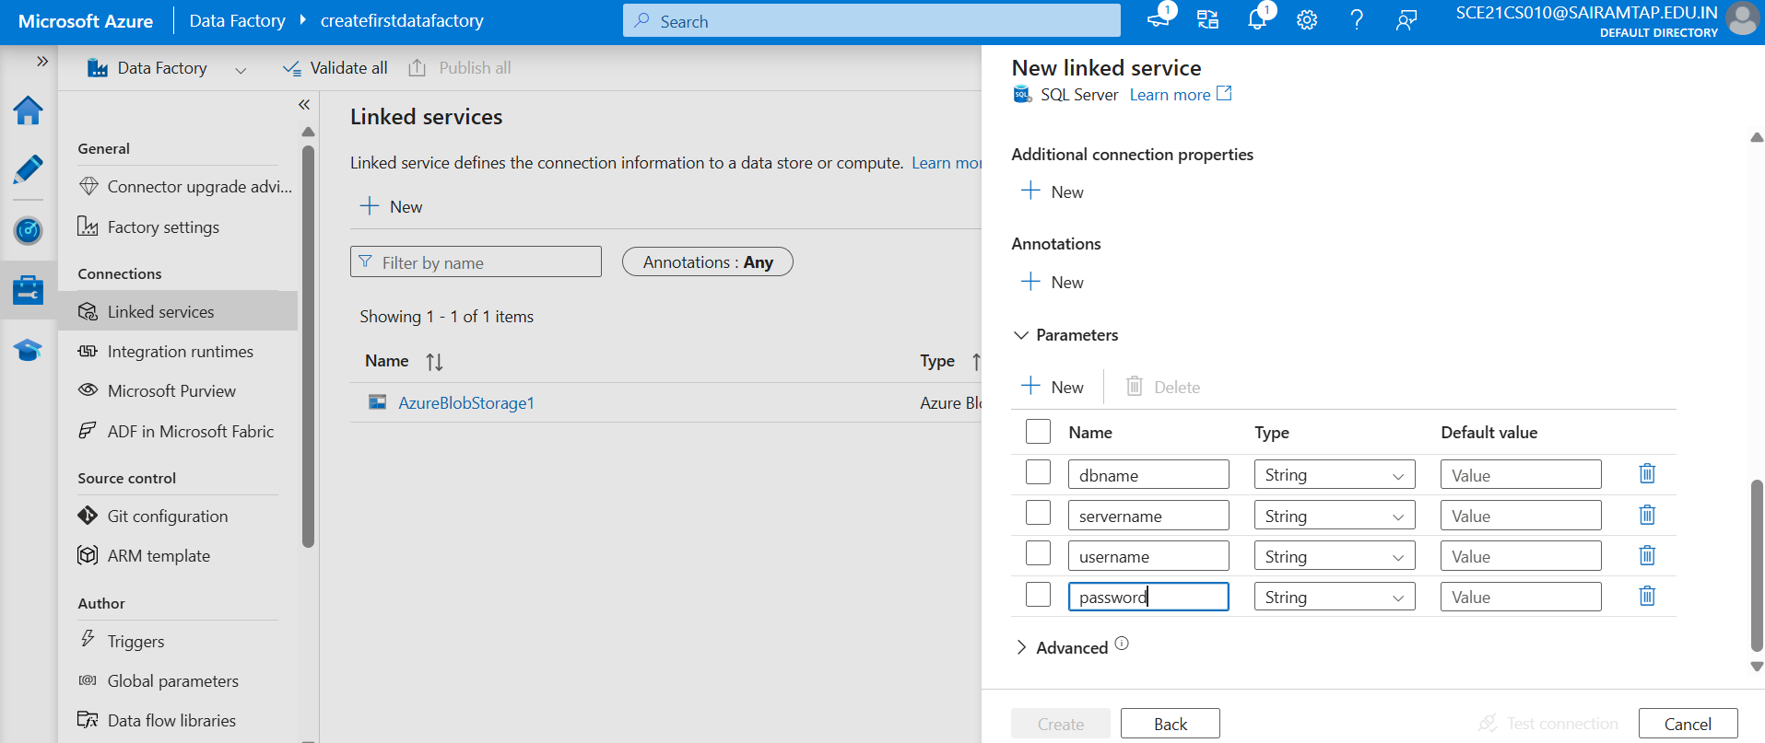

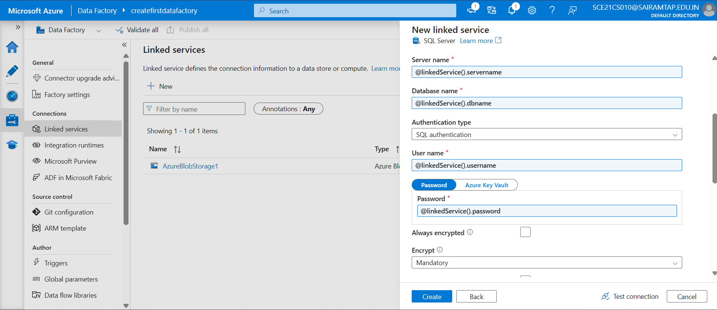

Parameterize Dataset and pipeline in ADF

You can parameterize a dataset and pass dynamic values at run time.

**Supported file format in ADF**

* **Avro format**
* **Binary format –** text files
* **Delimited text format –** csv file
* **JSON format**
* **ORC format**
* **Parquet format**

**Copy Data Activity**

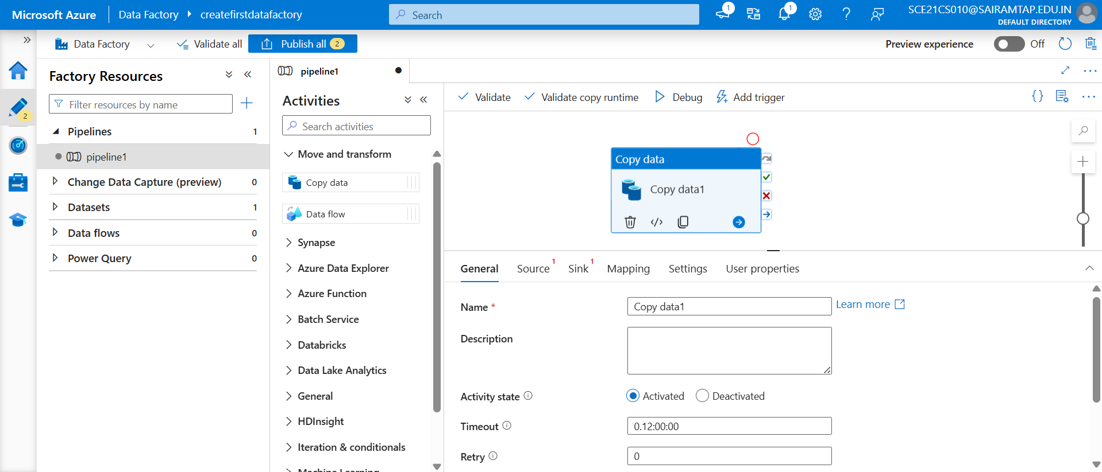

**Source**

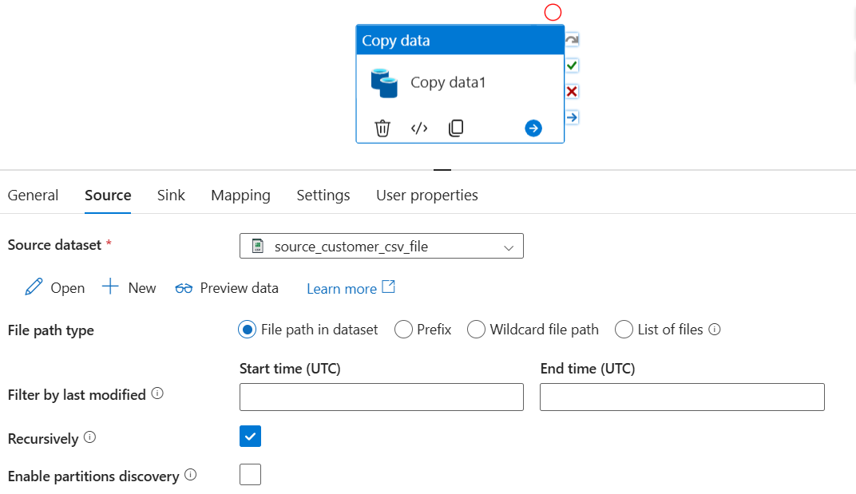

Destination - sink

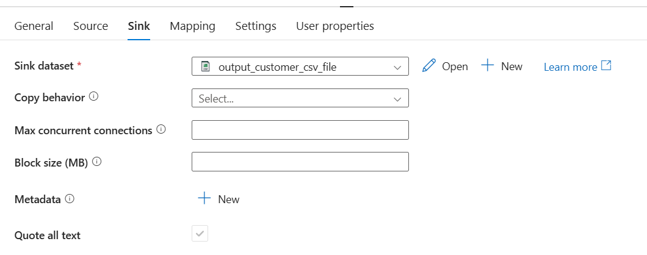

click on import schema

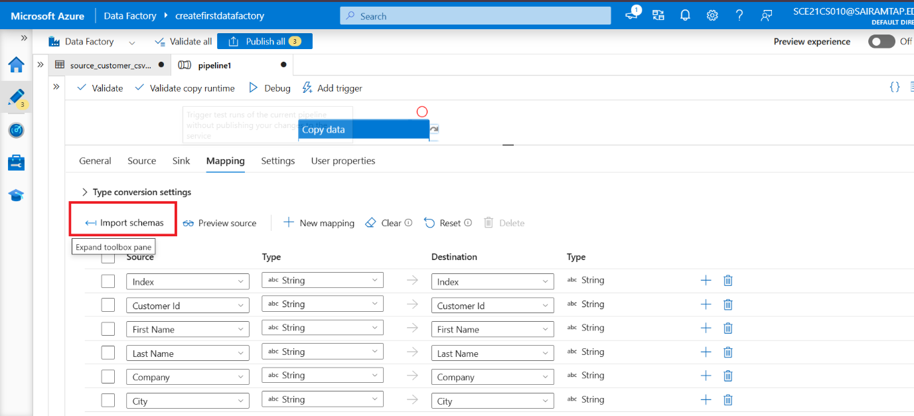

We change the column order and data type. Also delete the not required column in destination.

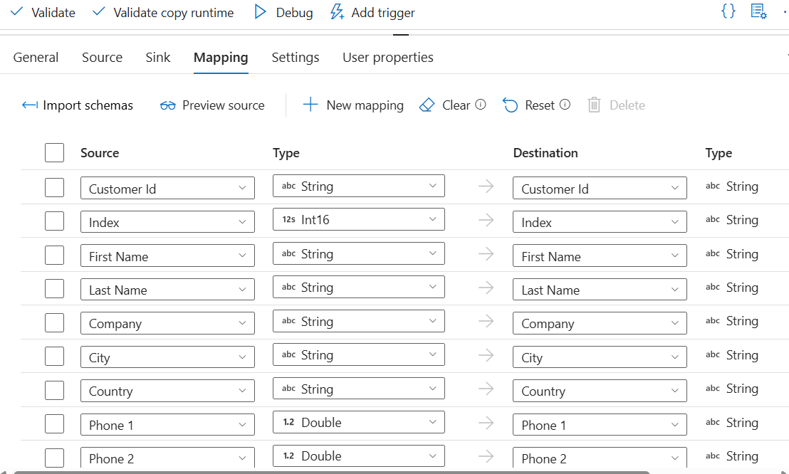

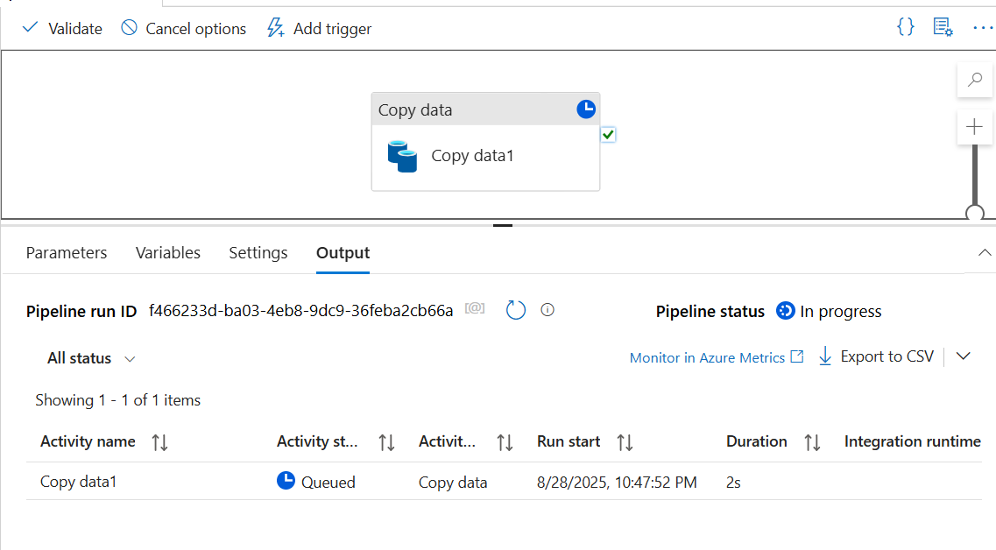

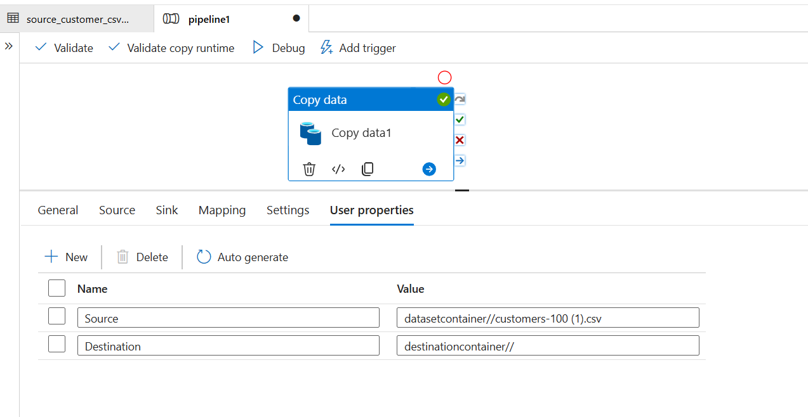

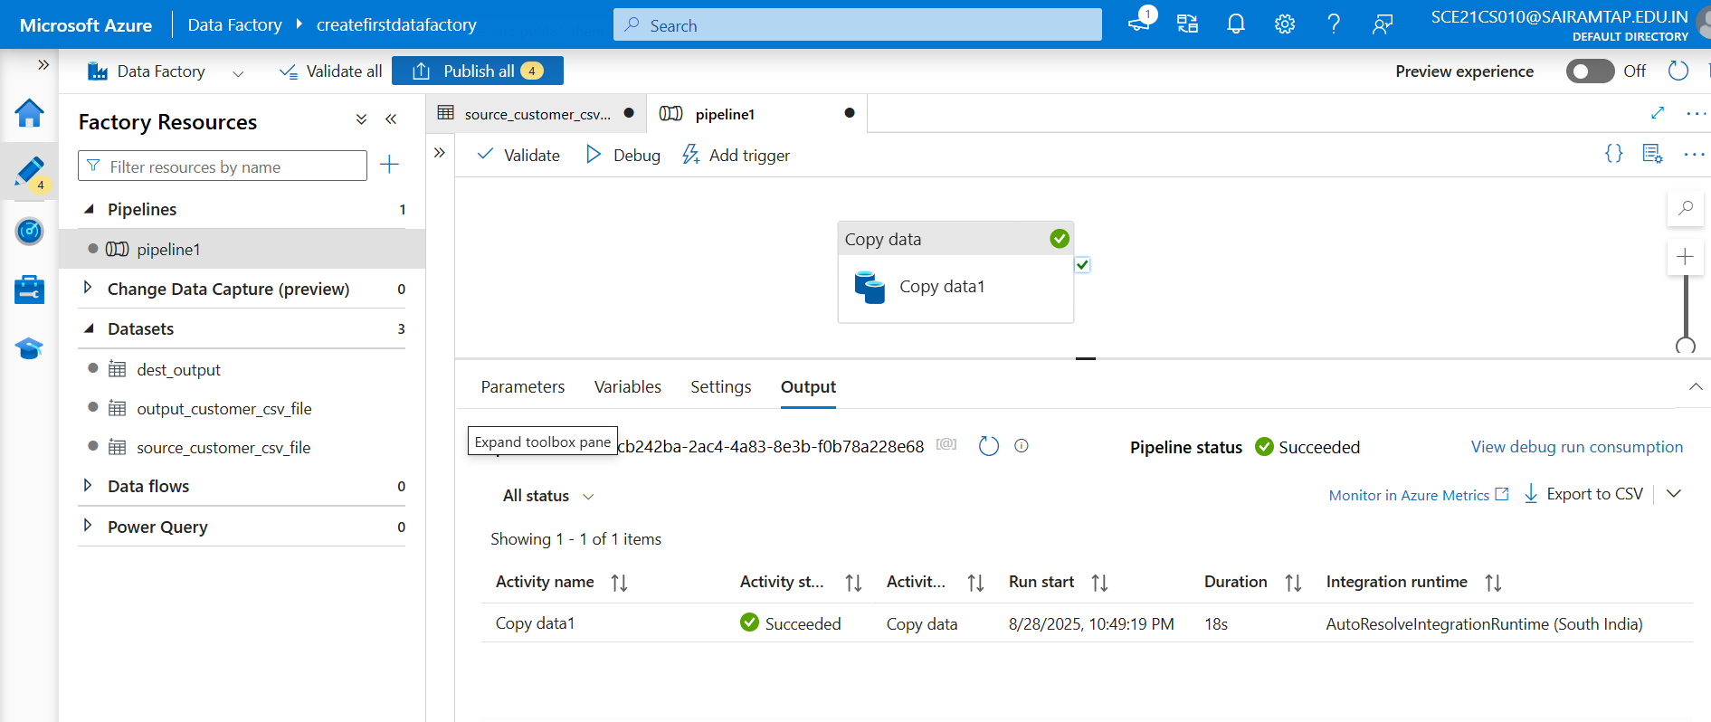

Publish

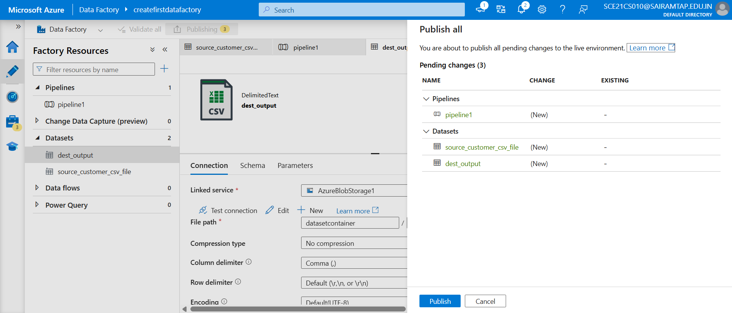

Copied from src to destination

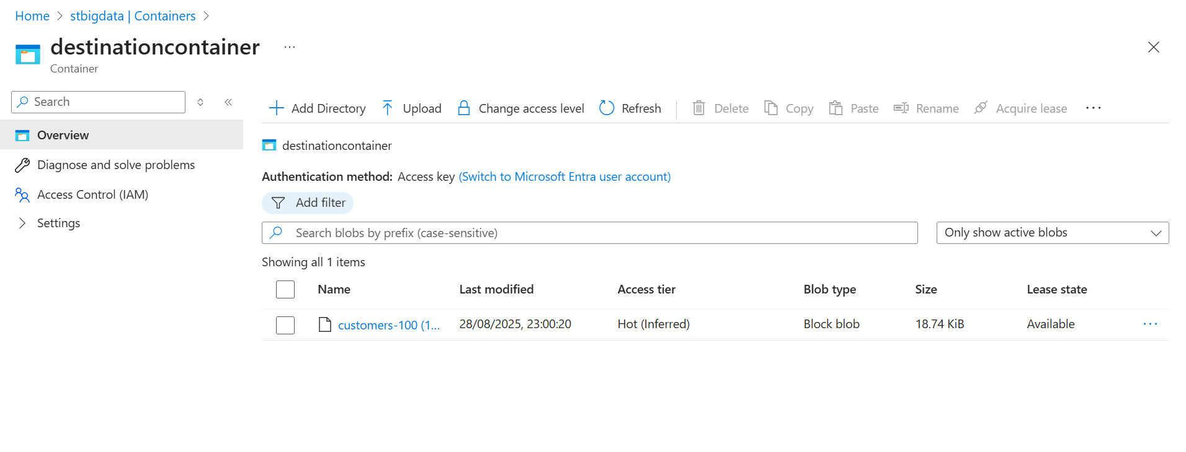

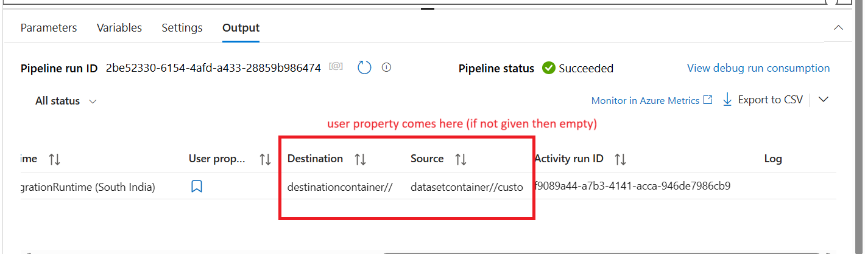

For copy the data from the API (use the base url)

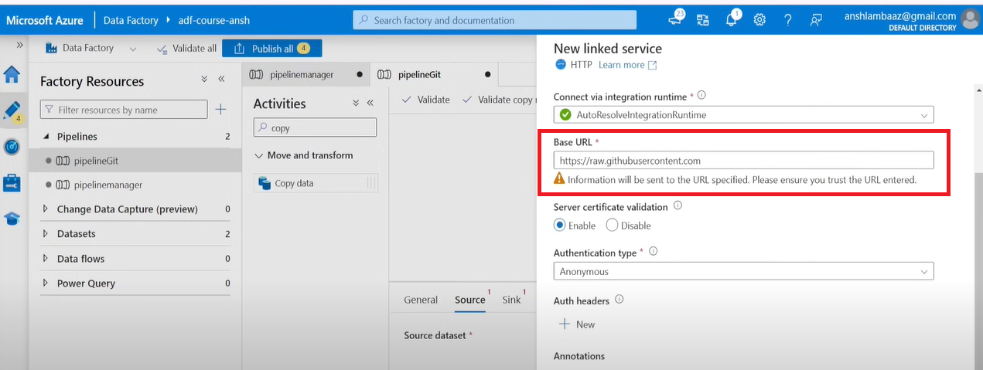

Relative url

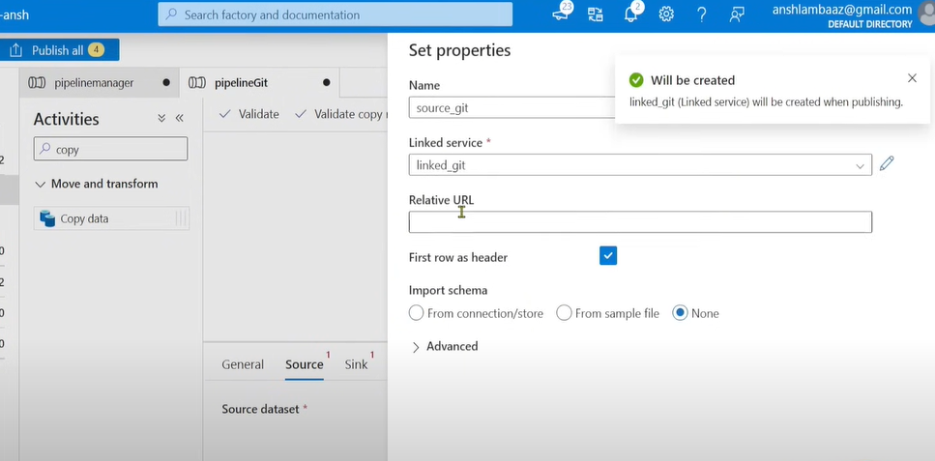

Monitor copy activity

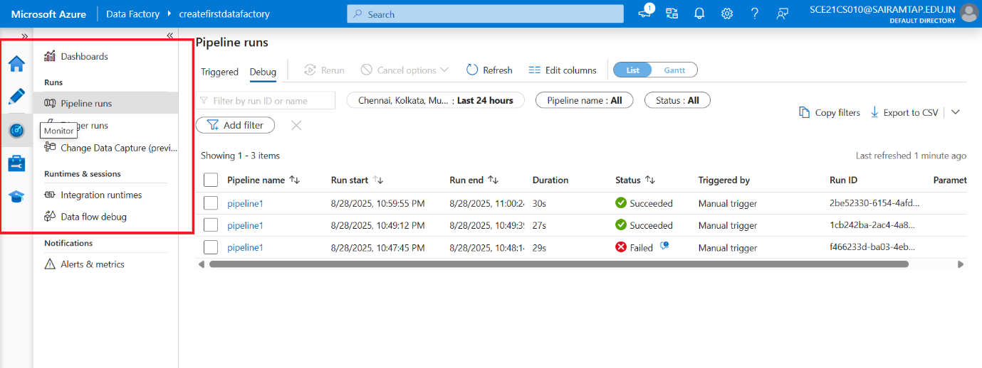

Check the details of the pipeline

Once you’ve created and published a pipeline in ADF, you can associate it with a trigger or manually kick off an hoc run. You can monitor all of your pipeline runs natively in the ADF user experience.

Delete Activity

You can use the delete activity in ADF to delete files or folders from on-premises storage or cloud storage.

Deleted files or folders cannot be restored.

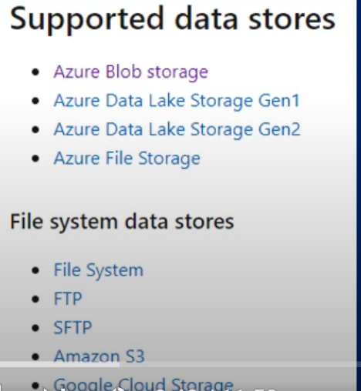

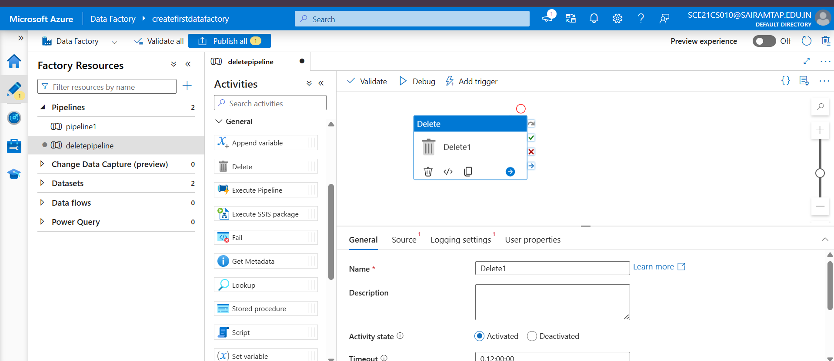

We can customize the file (*.txt – means delete only txt)

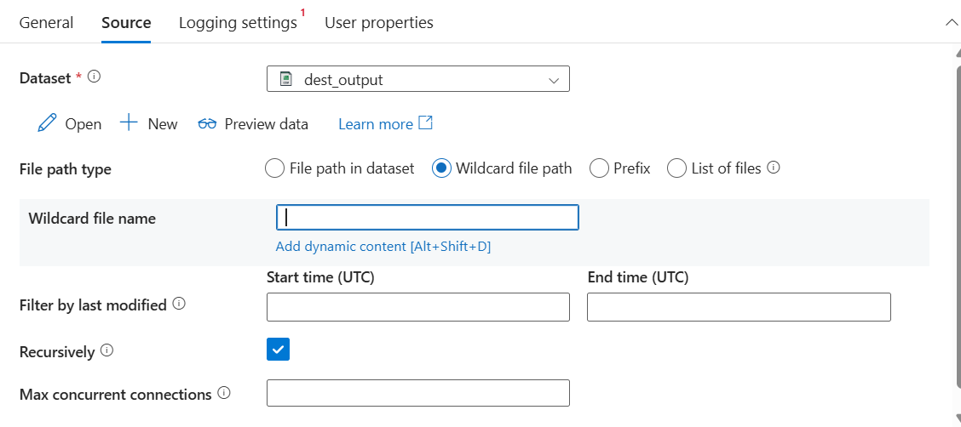

**Lookup Activity**

The Lookup activity in Azure Data Factory is a powerful tool used to retrieve data from an external source, such as a database or file system, and pass it to subsequent activities in a pipeline.

Lookup activity reads and returns the content of a configuration file or table. It also returns the result of executing a query or stored procedure.

The output from lookup activity can be used in a subsequent activity.

**What Lookup Activity Does:**

* It runs a **query** or **reads a file** and returns the result.
* The result can be:
  + **Single row** → returns key-value pairs.
  + **Multiple rows** → returns an array of JSON objects.

Limitation or drawback of lookup activity

* **Row Limit**: It can fetch a maximum of **5,000 rows**.
* **Data Size Limit**: The total size of the fetched data cannot exceed **4 MB**.

**Example Scenario**

* **Use Case**: Retrieve a file name from a database table to dynamically copy the file from Azure Blob Storage.

**Scenario**

We had to build a pipeline that **processes multiple files dynamically**.

* File details (name, path, active flag) were stored in a **control/config table** in Azure SQL DB.
* Each file had to be copied from **source Blob storage** to **curated ADLS zone** only if it was **active**.

**Step 1 – Lookup Activity**

* First, we used a **Lookup activity** to fetch all the file details from the control table.
* Lookup returned JSON like:

|  |
| --- |
| {  "value": [  { "FileName": "sales.csv", "Path": "/input/sales/", "IsActive": 1 },  { "FileName": "customer.csv", "Path": "/input/customers/", "IsActive": 0 }  ]  } |

* This allowed us to **parameterize the pipeline** and make it **dynamic**.
* Without Lookup, we would have to hardcode the file names.

**Step 2 – ForEach Activity**

* We passed the Lookup output array into a **ForEach activity**.
* ForEach iterated over each file record.

**Step 3 – Copy Activity (inside ForEach)**

* Inside ForEach, we placed a **Copy activity**.
* Source = Blob file path (parameterized from Lookup result).
* Sink = ADLS curated folder.
* Copy moved the actual file contents (GBs of data) from source → destination.

**Get Metadata**

The Get Metadata activity in Azure Data Factory (ADF) is a control flow activity that retrieves metadata from a specified data source.

This metadata can include details like file names, sizes, structure, or even the existence of a file or folder.

It is particularly useful for **dynamic pipelines** where decisions depend on the properties of the data.

1. **Supported Data Sources**: Works with various sources like Azure Blob Storage, Azure Data Lake, SQL databases, and more.
2. **Metadata Properties**: **(Field list)** You can retrieve properties such as:
   * File name
   * File size
   * Last modified date
   * Child items (for folders) – items which are available with this folder
   * Column structure (for tables)
   * Add dynamic

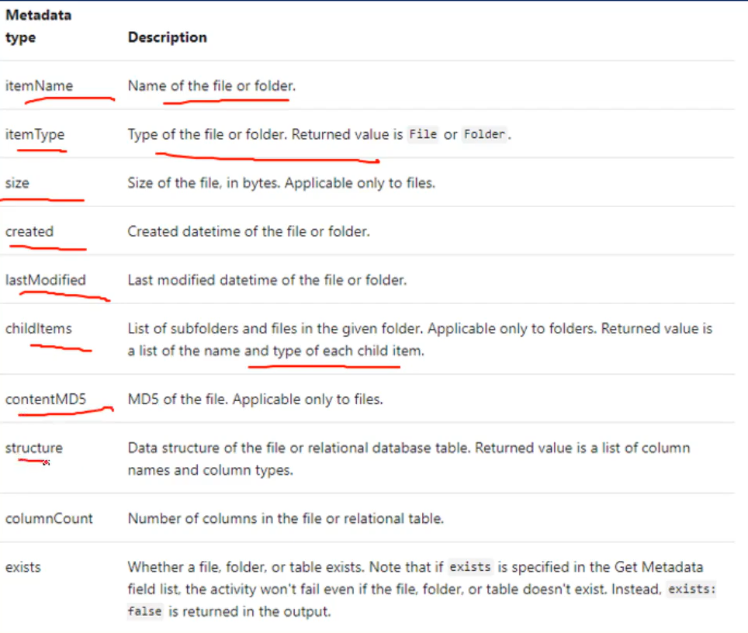

1. **Dynamic Pipelines**: Enables conditional logic based on metadata, such as checking if a file exists before processing.

**Example Use Cases**

* **File Validation**: Check if a file exists before copying or transforming it.
* **Dynamic Processing**: Retrieve column names or structure to dynamically configure downstream activities.
* **Folder Iteration: List all files in a folder for batch processing.**
* **Usage:** Useful when you need to dynamically get information about files or datasets, such as file names, size, last modified timestamps, or even schema information.

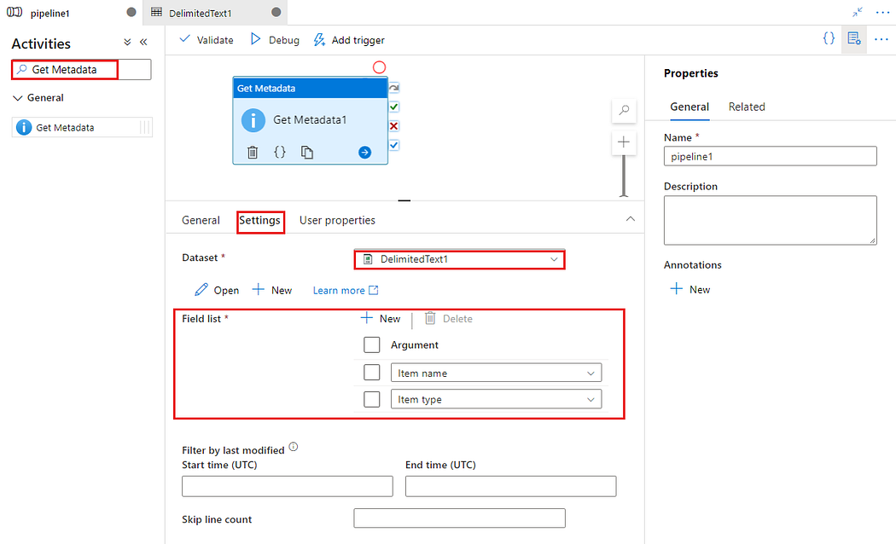

This activity is a powerful tool for building dynamic and intelligent data pipelines in ADF.

**Use the Output**: The output of this activity will be an array of file names. You can use this output to dynamically create pipelines or copy activities for each file.

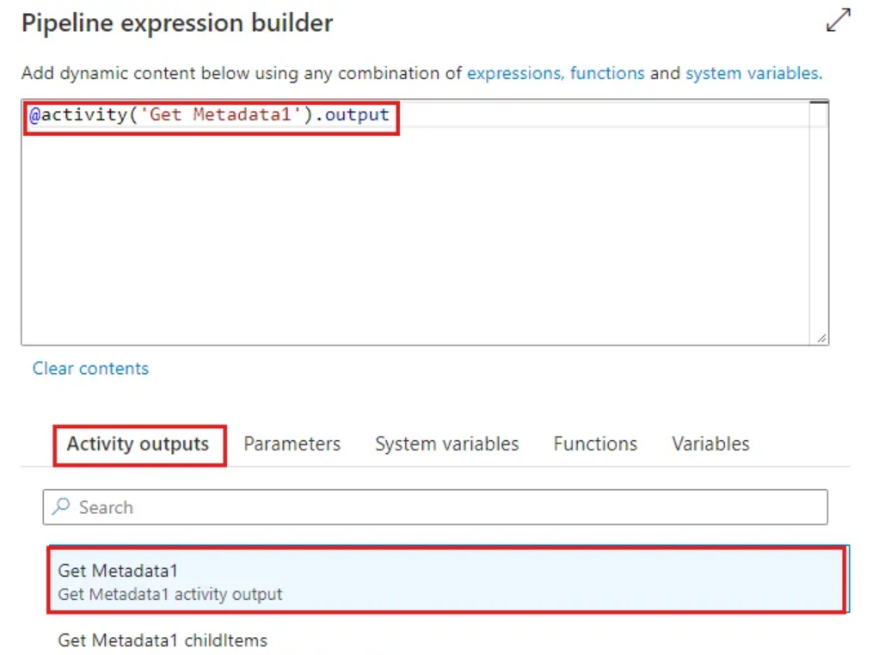

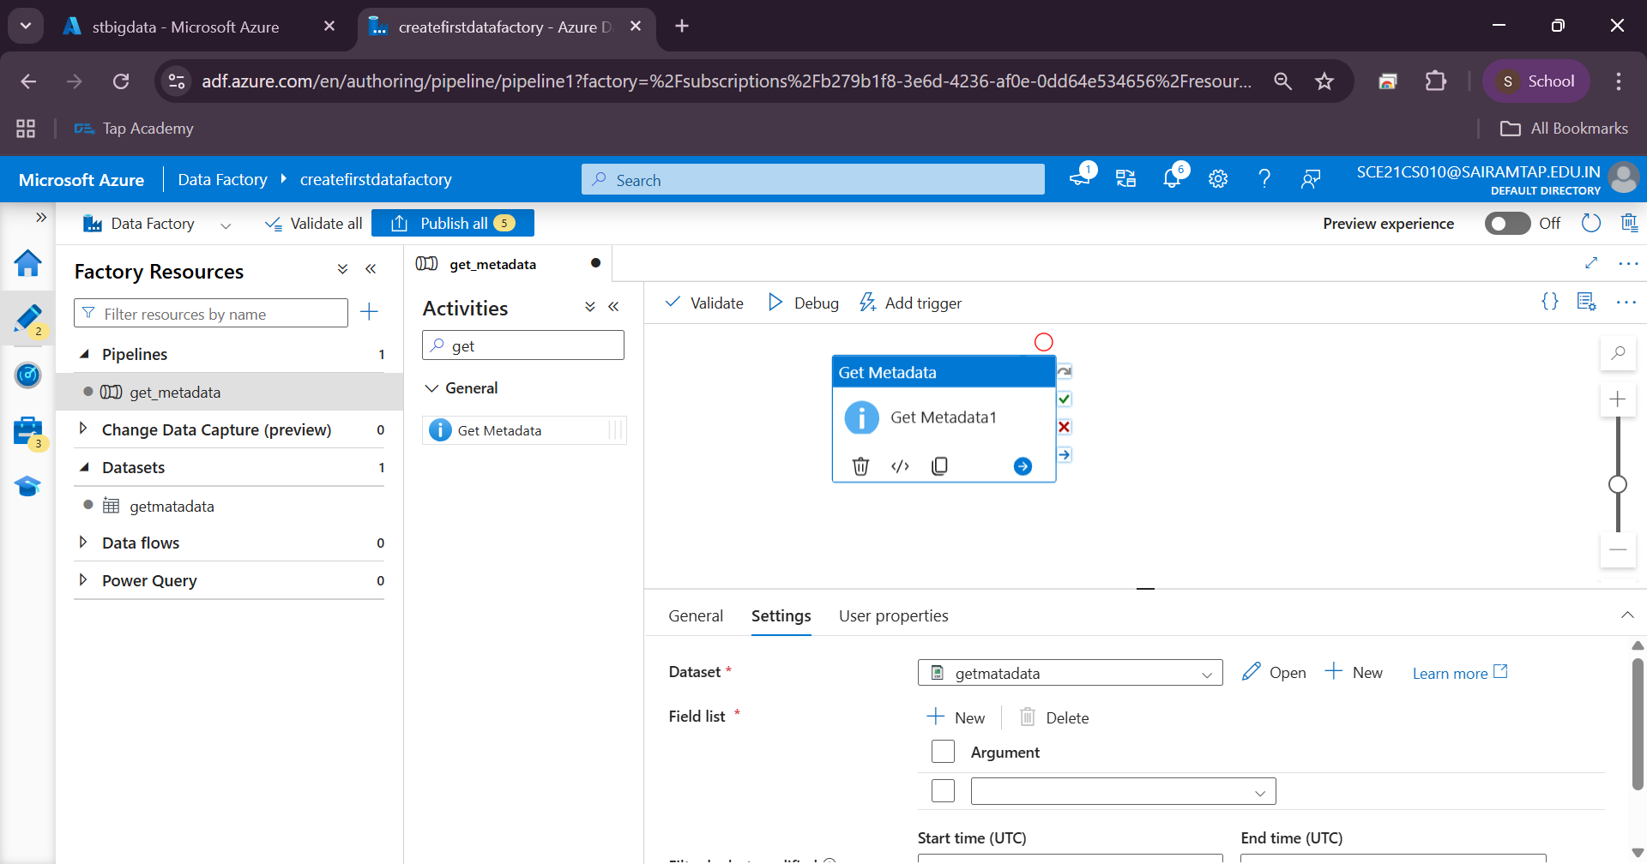

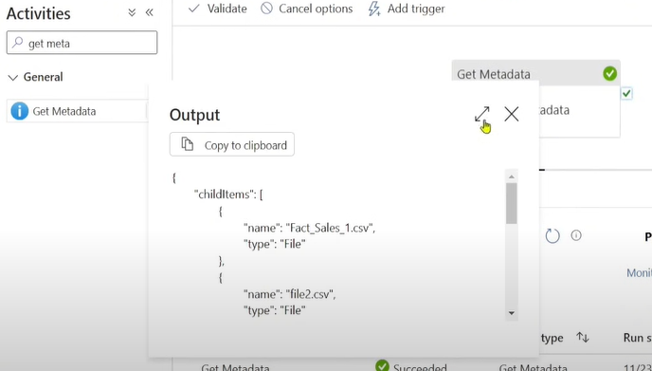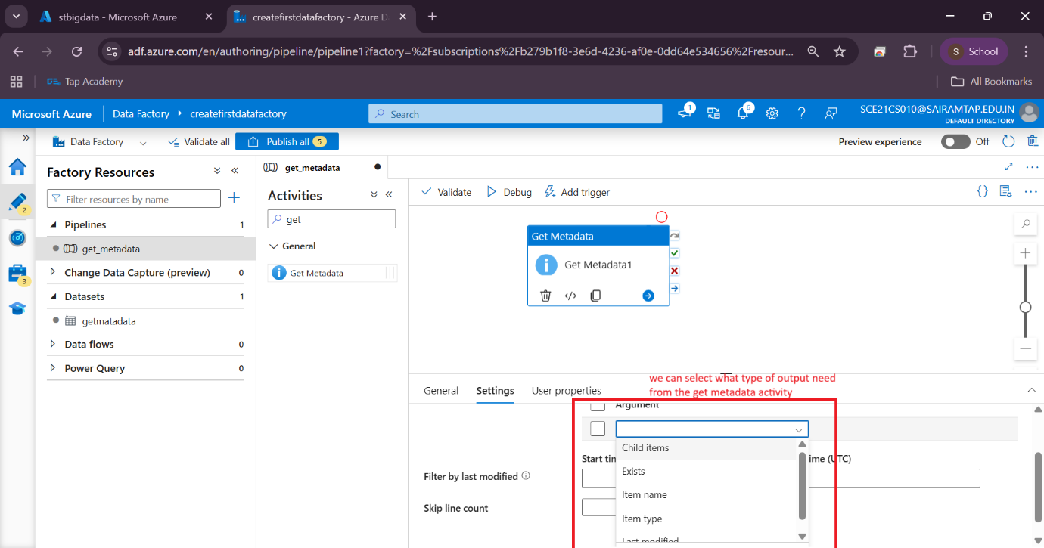

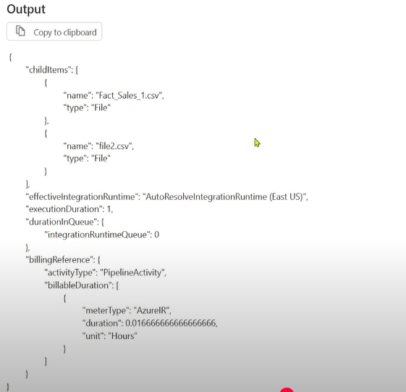

Now to connect the output of the get metadata to the for each activity (for taking the file name)

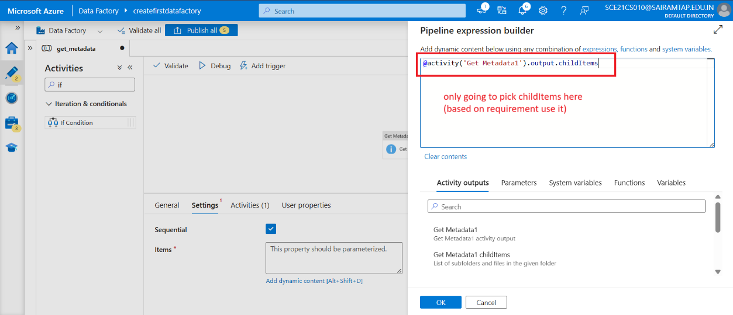

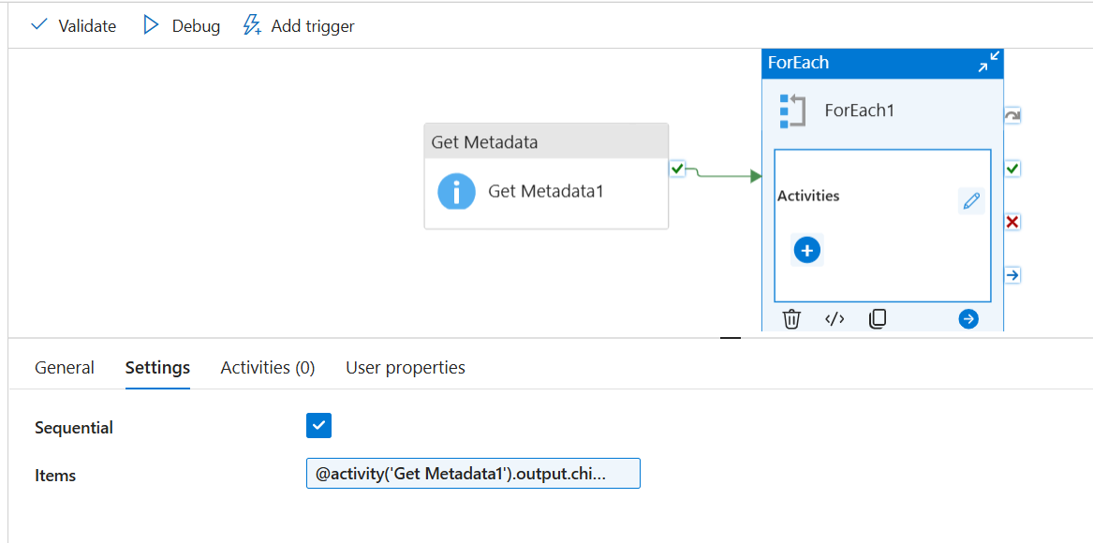

Set the condition inside the “if activity”

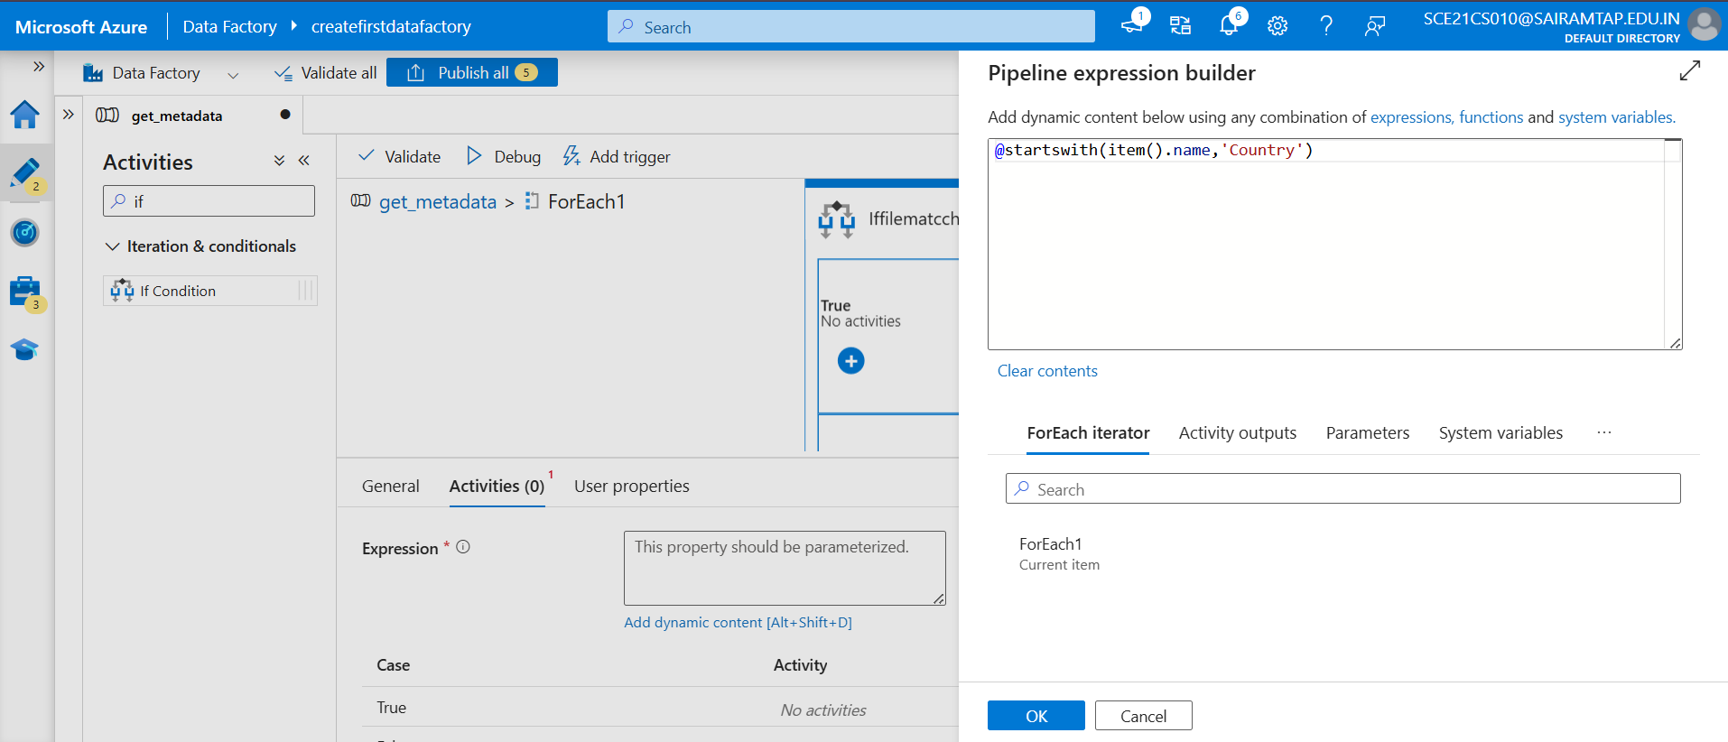

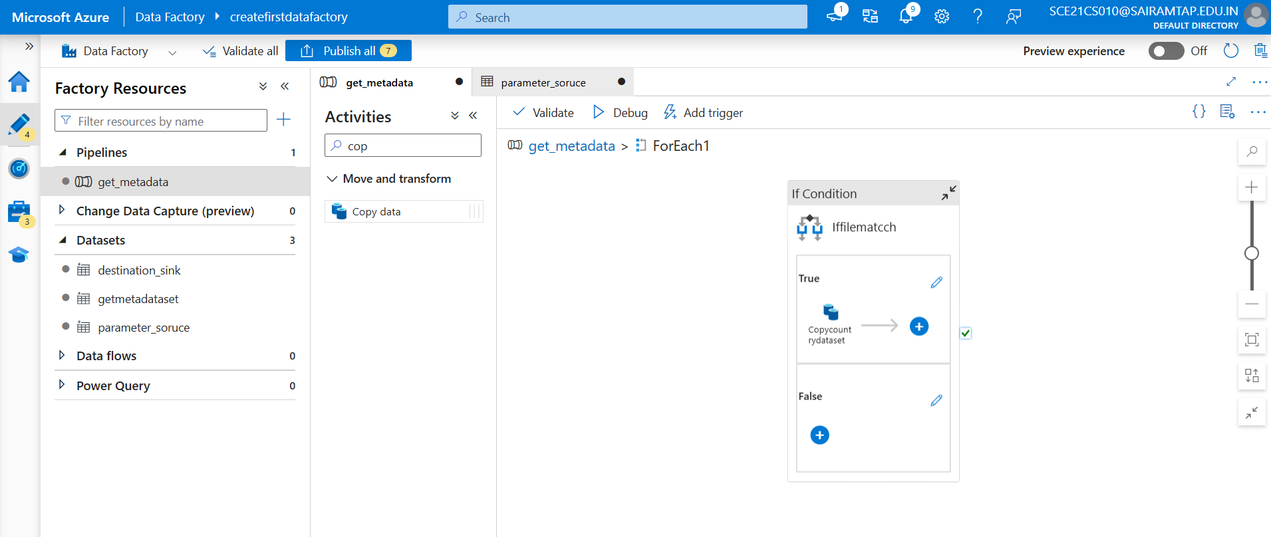

**Step to Add the file name Dynamically**

Create the dataset, while create it select the folder, directory, leave file name empty

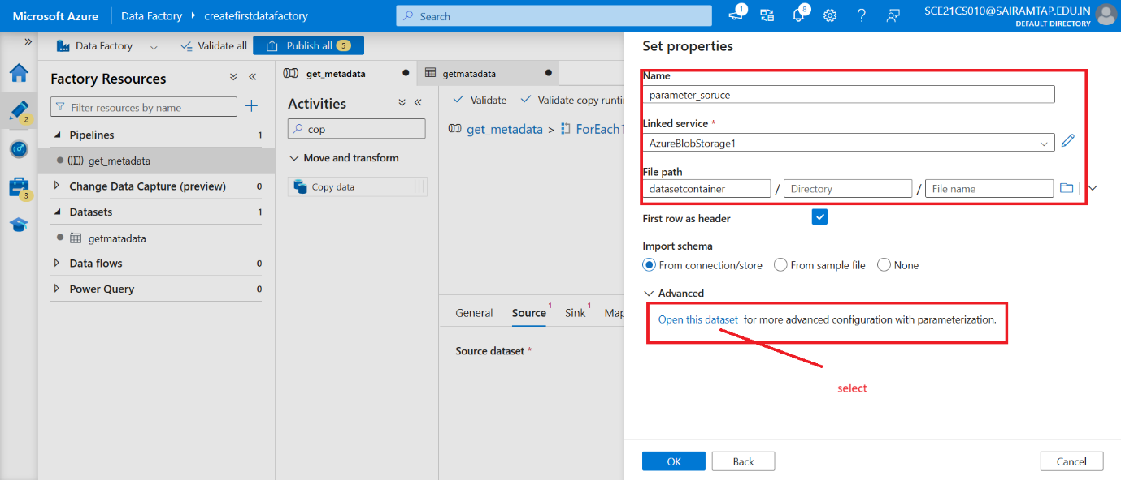

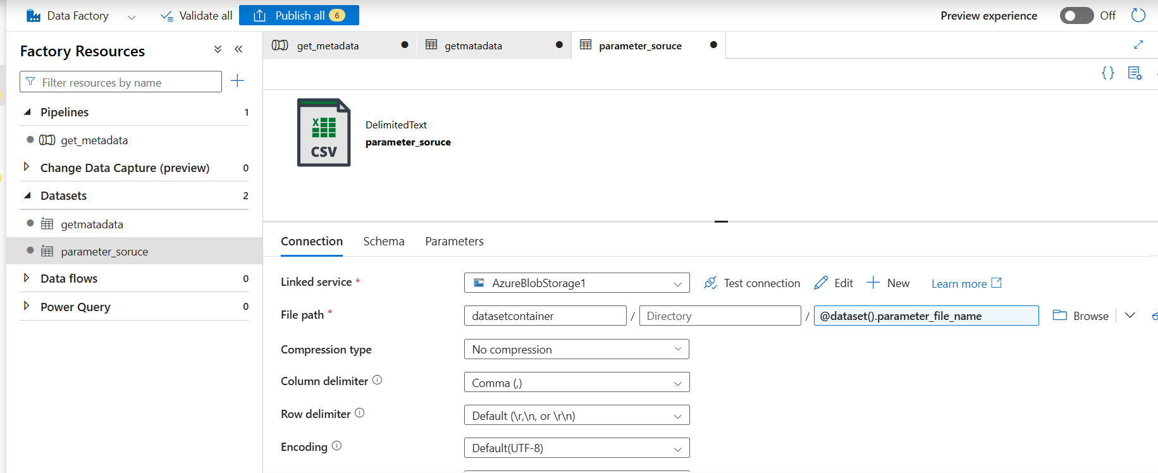

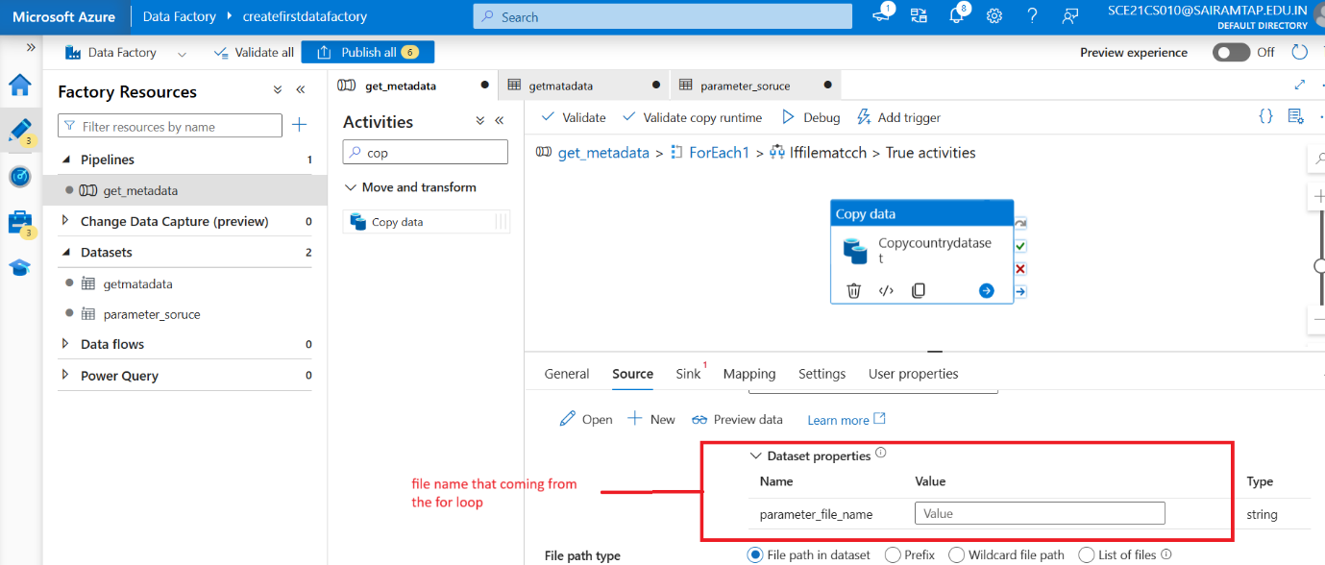

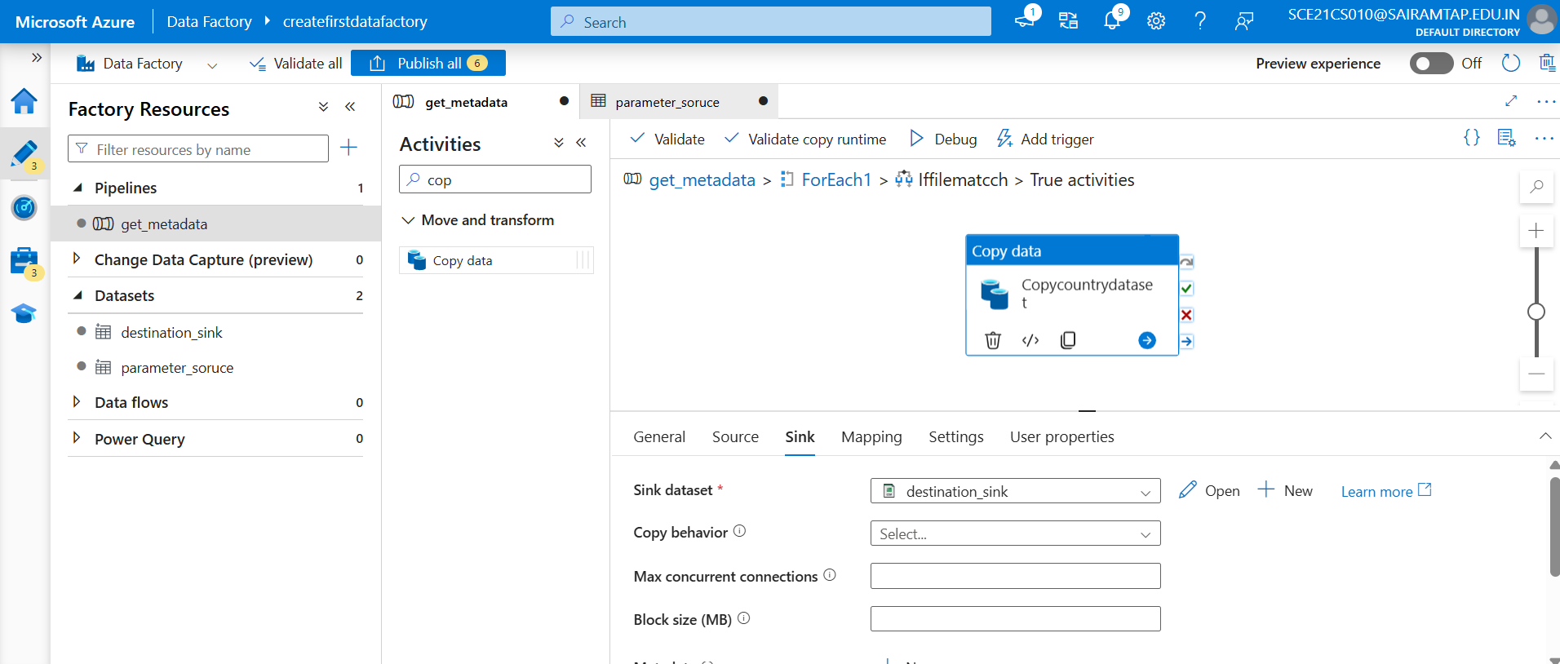

**Get metadata 🡪 for each 🡪 if (True) 🡪 copy activity**

**output**

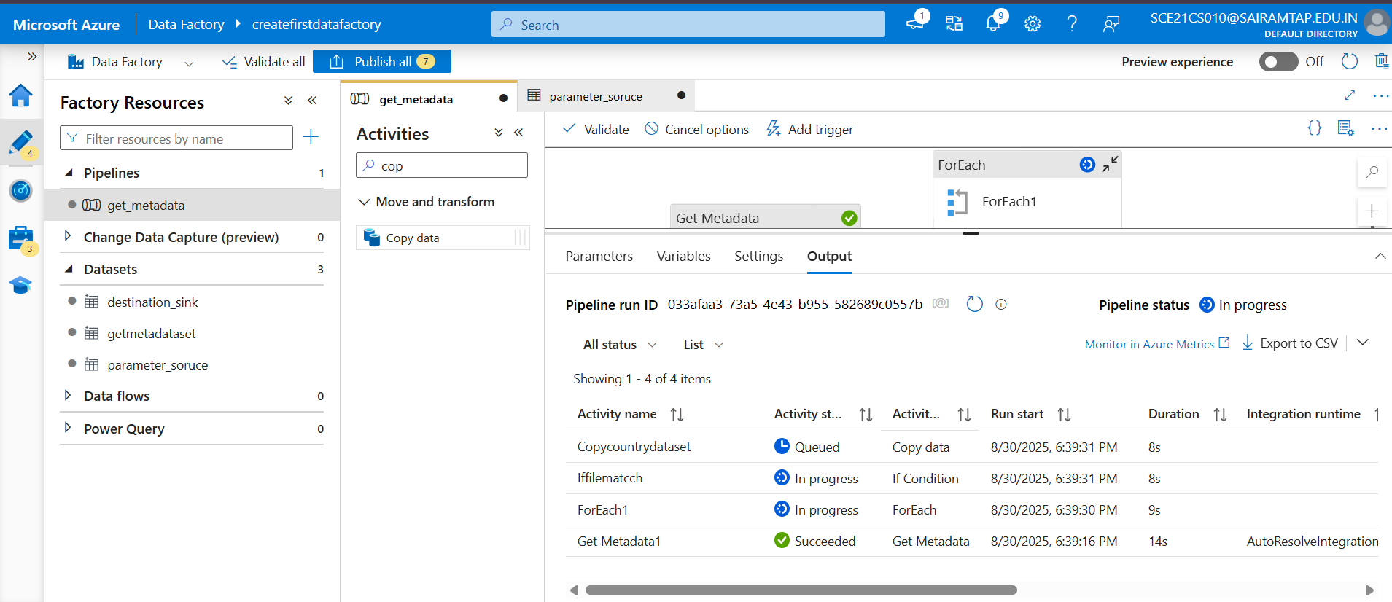

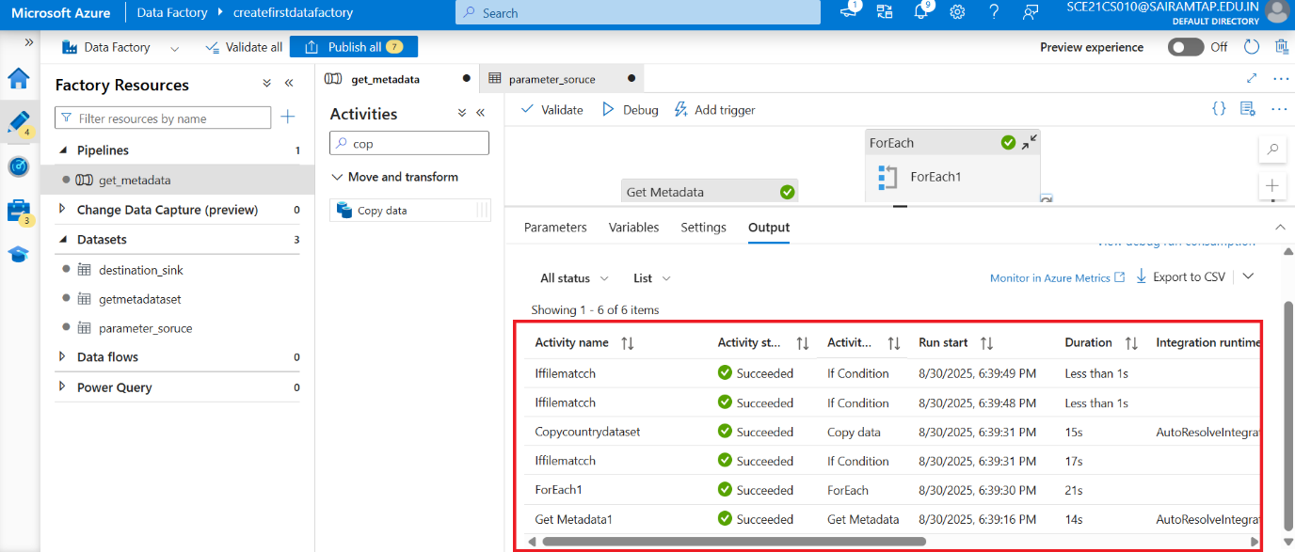

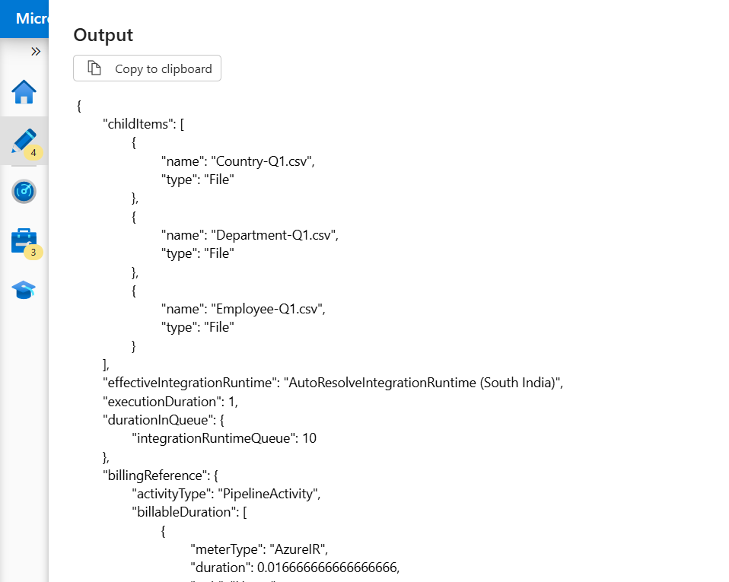

**Only country dataset is copied**

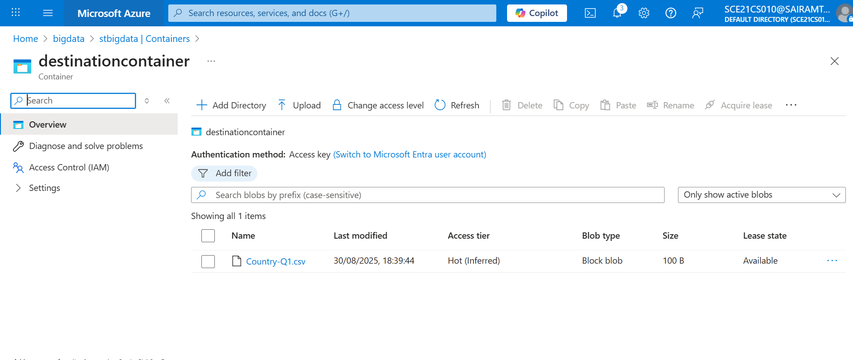

|  |  |  |
| --- | --- | --- |
| **Feature** | **Lookup Activity** | **Get Metadata Activity** |
| Returns | **Data values** (rows from source) (5000rows or 4 MB) | **Properties/metadata** of dataset |
| Scope | Works on **structured data sources** (SQL, files, API) | Works on **files, folders, tables** |
| Typical Use | Drive pipeline logic based on data | Drive pipeline logic based on file/dataset properties |
| Example | Get list of customer IDs from SQL | Get list of files in blob storage. (If you want to **get all CSV file names in a folder)** |

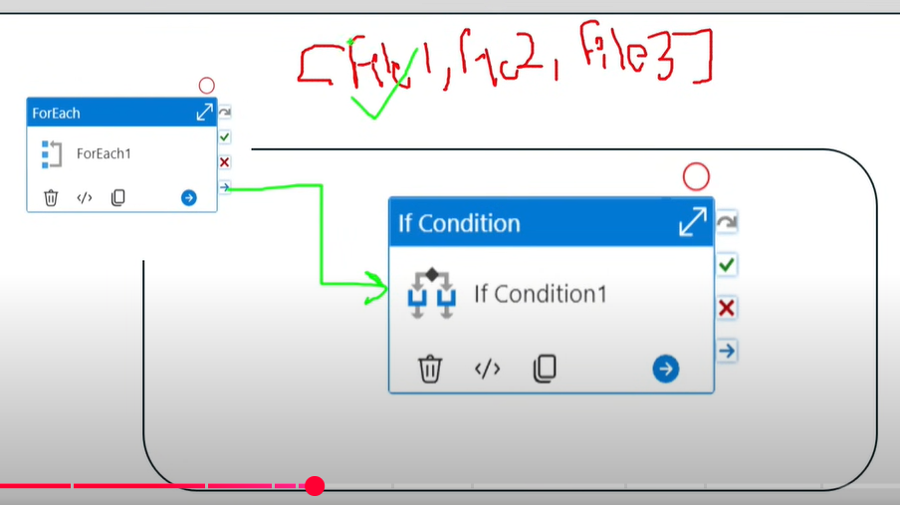

**If condition activity**

The **If Condition activity** in Azure Data Factory (ADF) is a control flow activity that allows you to execute different sets of activities based on a logical condition. It evaluates an expression and executes one of two activity groups: one for when the condition evaluates to **true** and another for when it evaluates to **false**.

**Key Features of If Condition Activity**

* **Logical Evaluation**: You define an expression that evaluates to either true or false.
* **True and False Paths**:
  + If the condition is **true**, the activities in the **True** branch are executed.
  + If the condition is **false**, the activities in the **False** branch are executed.
* **Dynamic Content**: You can use dynamic expressions to evaluate variables, parameters, or outputs from other activities.

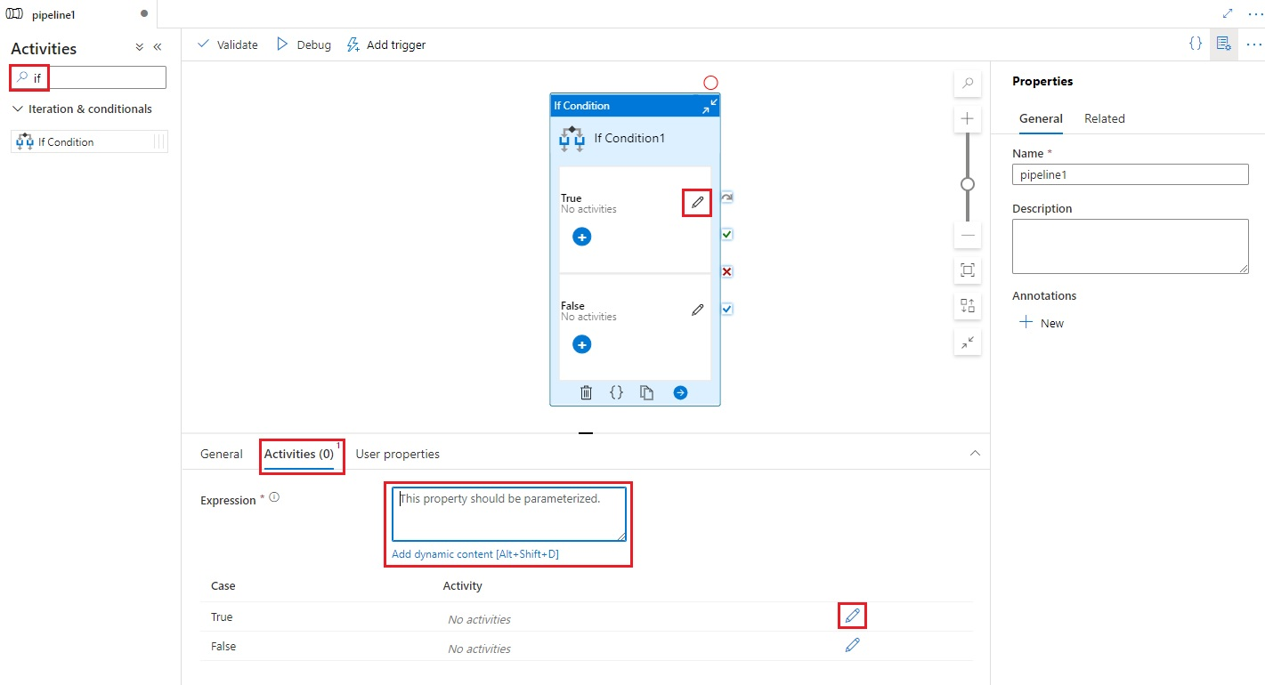

**Key Points:**

* **Expression-Based:** It evaluates an expression (typically using Azure Data Factory expressions) and executes activities based on the result (true or false).
* **Single Condition:** Supports only one condition evaluation per activity.
* **Control Flow:** Directs the workflow based on the evaluated condition.

**Switch Activity**

When dealing with bigger sets of circumstances, this method is frequently thought to be more effective than a block of If, Else If, Else If, Else type logic tests.

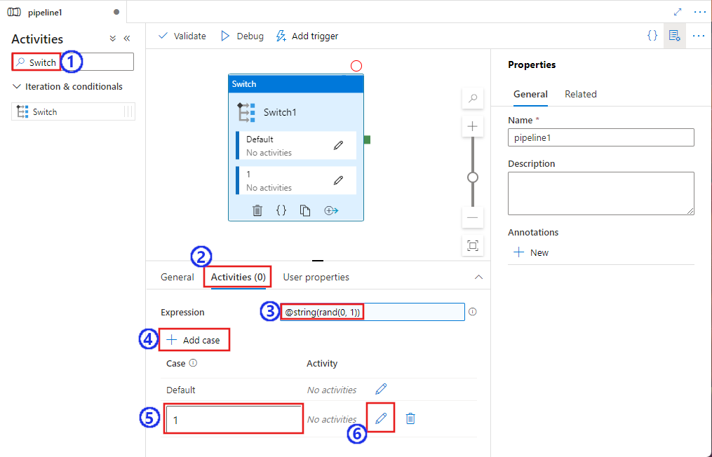

* **Use Cases:**

1. **Multiple Conditions:** Use Switch when you have multiple conditions to evaluate and based on each condition, you want to execute different sets of activities. For instance, processing files of different types or performing different transformations based on data characteristics.
2. **Dynamic Branching:** It provides a structured way to handle complex branching logic where you need to evaluate multiple expressions and route based on different outcomes.

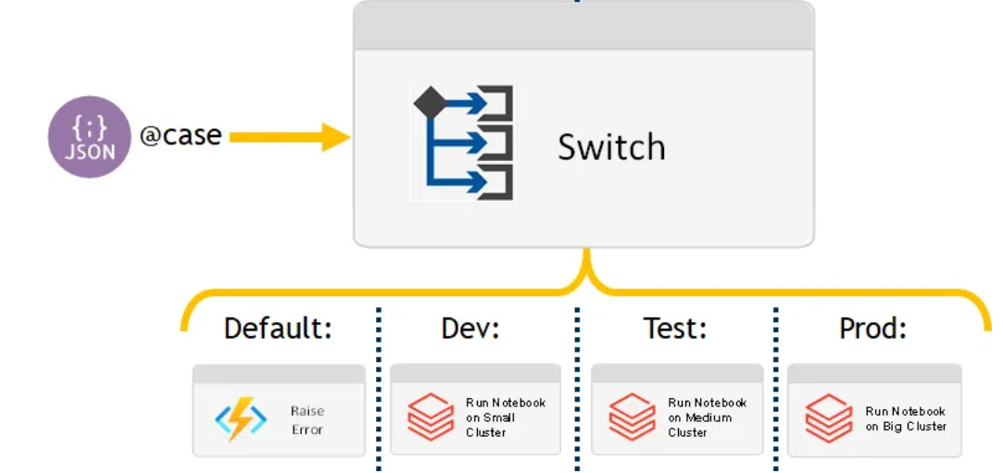

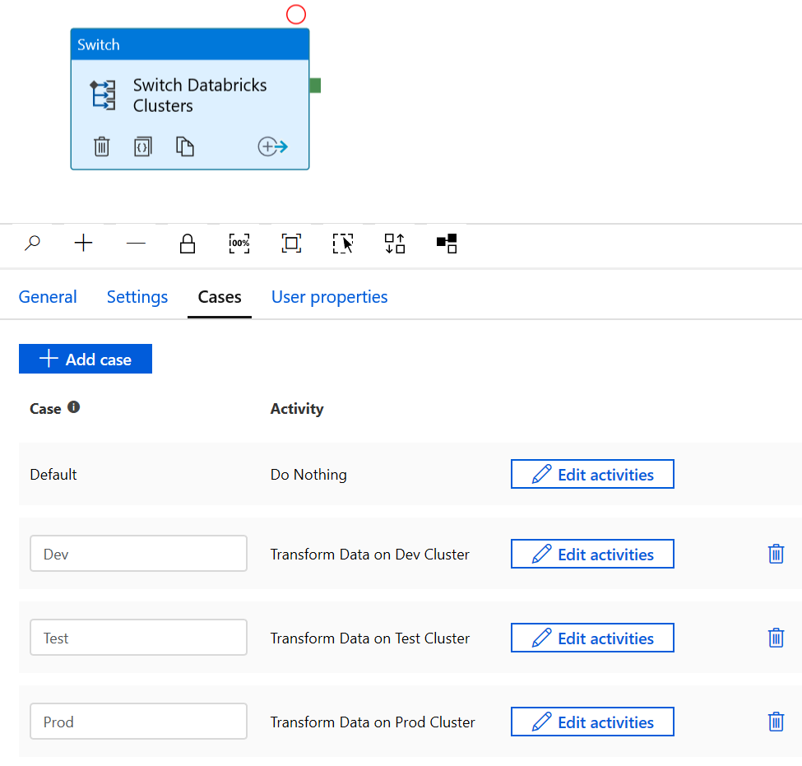

**Key Points:**

* **Multi-Condition:** Allows defining multiple conditions (cases) and corresponding activities or control flows for each case.
* **Structured Flow:** Offers a more structured approach to handle multiple scenarios compared to nested If Condition activities.
* **Enhanced Readability:** Improves pipeline readability when dealing with several branching scenarios by organizing them into distinct cases.

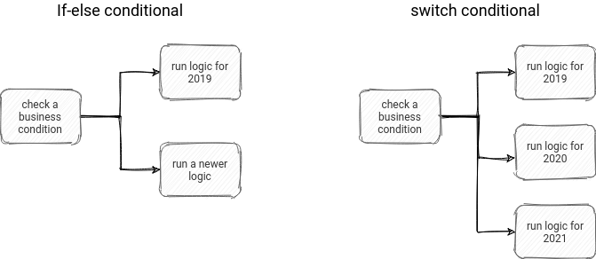

Wait Activity in ADF

When you use a wait activity in a pipeline, the pipeline waits for the specified period of time before continuing with execution of subsequent activities.

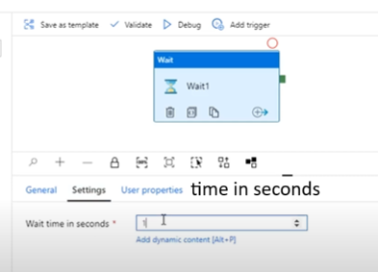

**Execute Pipeline Activity:**

This activity is essential when you need to chain pipelines together and execute them in a sequence, ensuring a smooth workflow from one process to another.

**Execute Pipeline Activity in Azure Data Factory allows one pipeline to invoke and execute another pipeline, enabling modular, reusable, and sequential workflows.**

This activity allows you to call and run another pipeline within a pipeline. It helps you break down complex workflows into smaller, modular components, which can then be executed in a sequence or based on certain conditions.

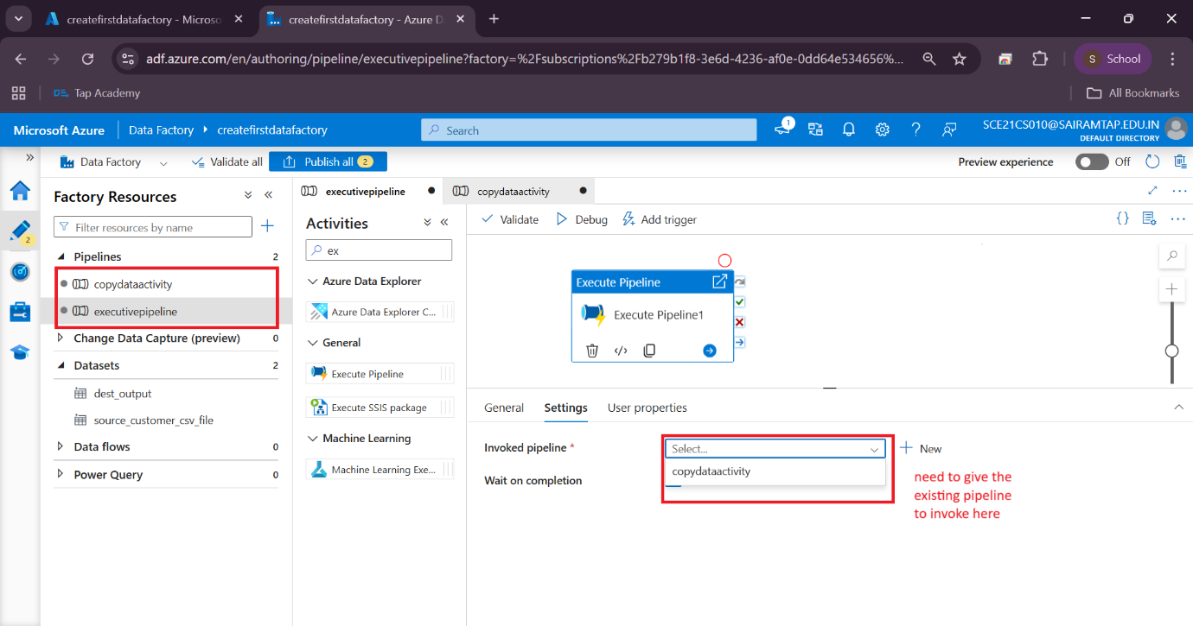

Wait on completion: wait for the selected pipeline(child pipeline) to complete (if checked)

There is difference between parameter and variable:

**For Parameter value is passed in the Triggers**

Parameter are external values passed into pipelines, datasets or linked services. The value cannot be changed inside a pipeline.

Variable 🡪 set values for these variables inside pipelines

variable are internal values set inside a pipeline. The value can be changed inside the pipeline using set variable or append variable activity.

Variable in ADF:

Variables are like internal to pipeline and they can be changed inside your pipeline.

Variables support 4 data type: **string, bool, array, integer**

**@variables(‘variableName’)**

**Set variable activity**

If we want to set the value for the variable during the pipeline execution, we can use this.

Use the set variable activity to set the value of an existing variable of type **string, bool or array** defined in a Data factory pipeline.

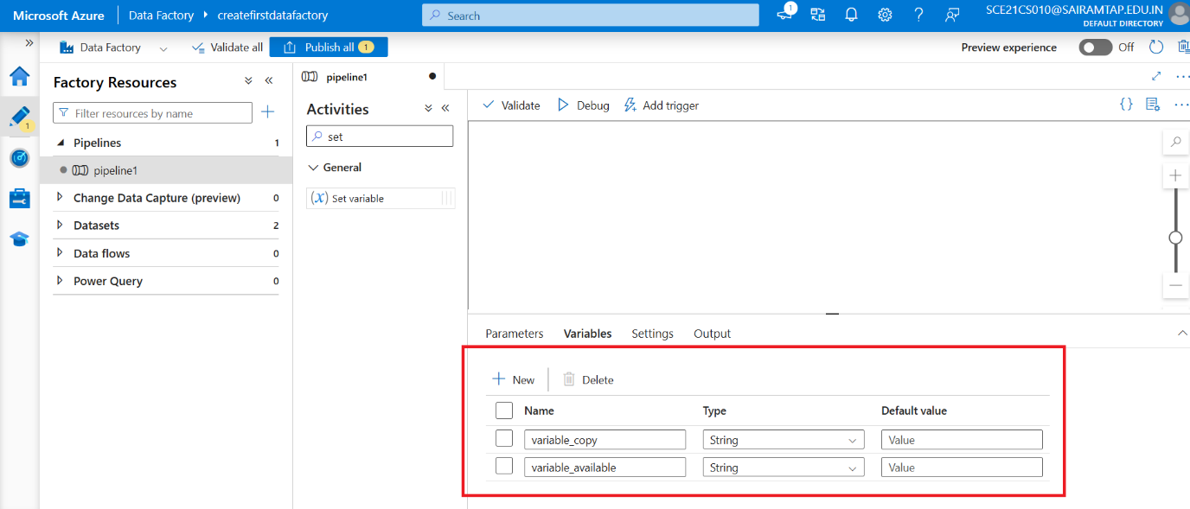

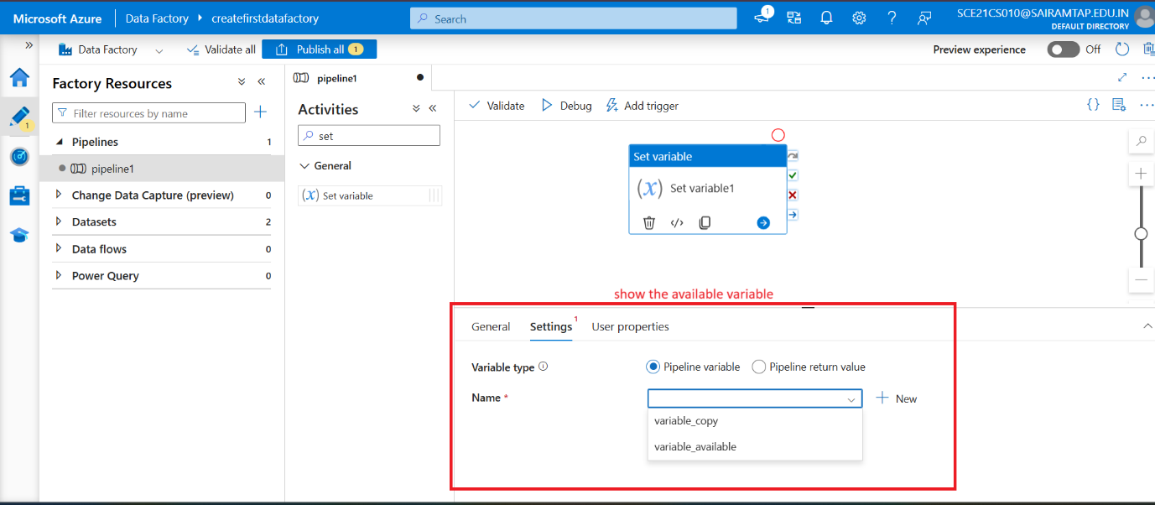

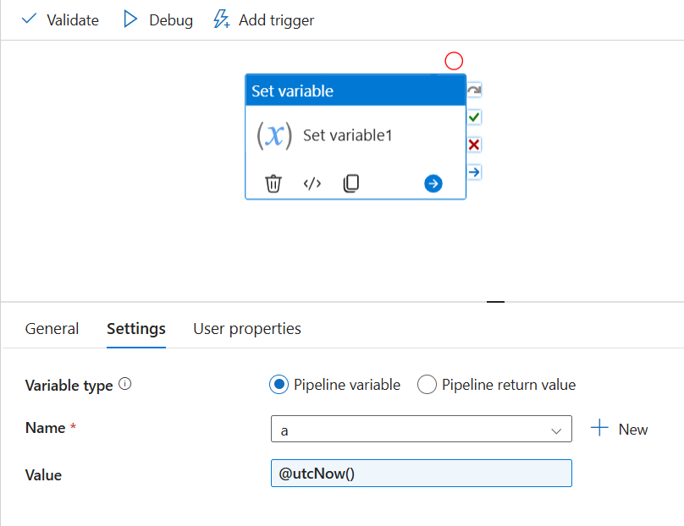

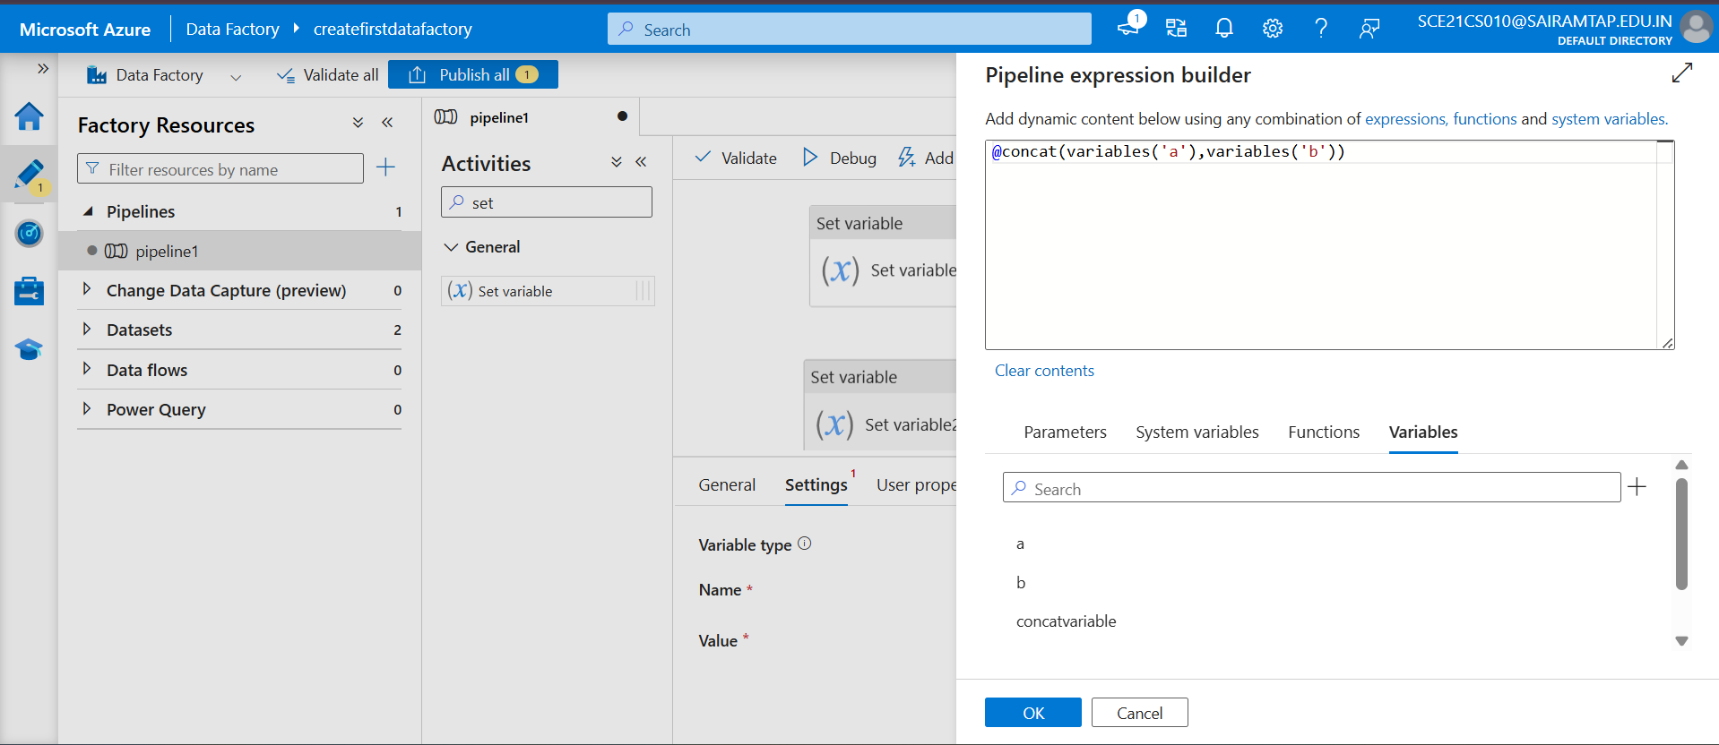

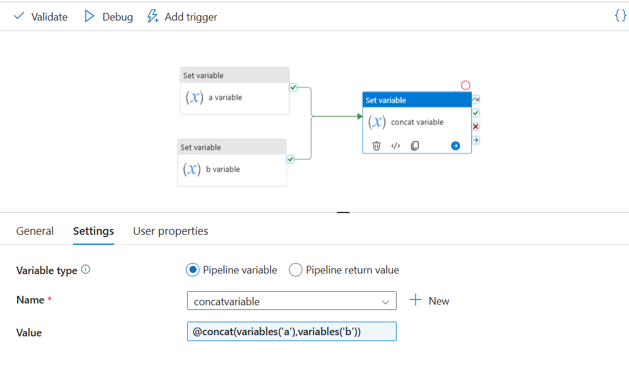

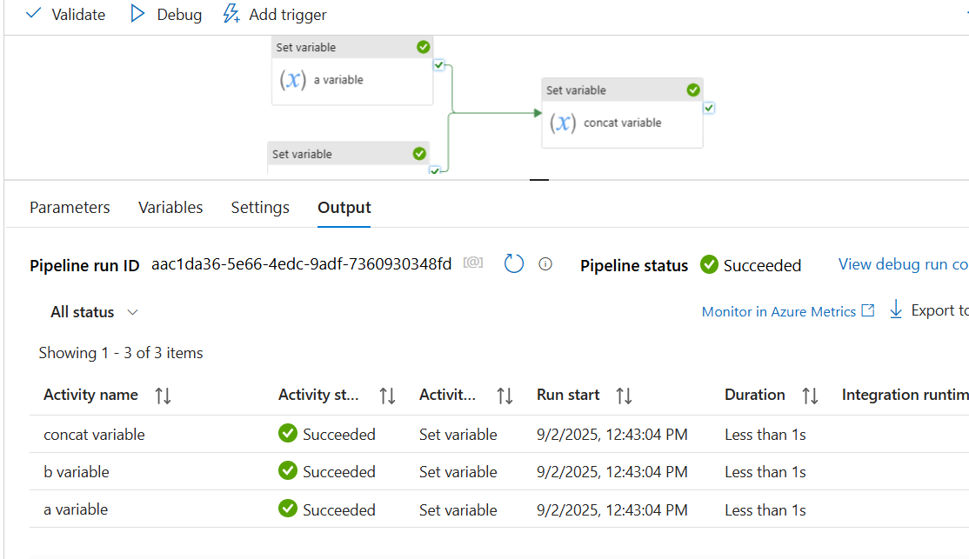

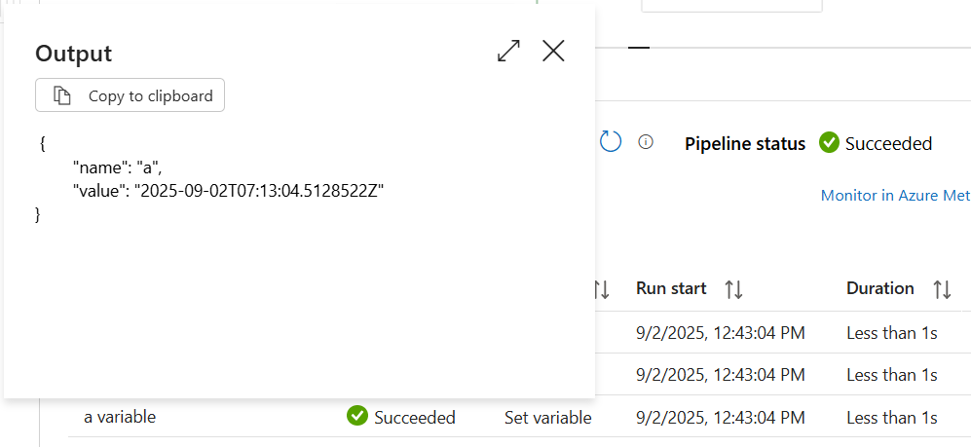

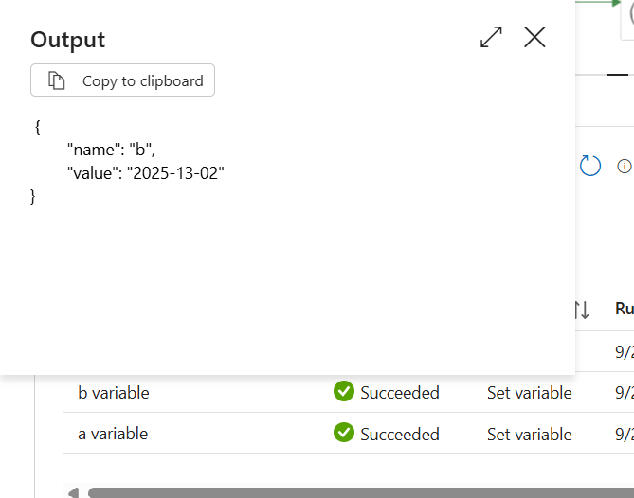

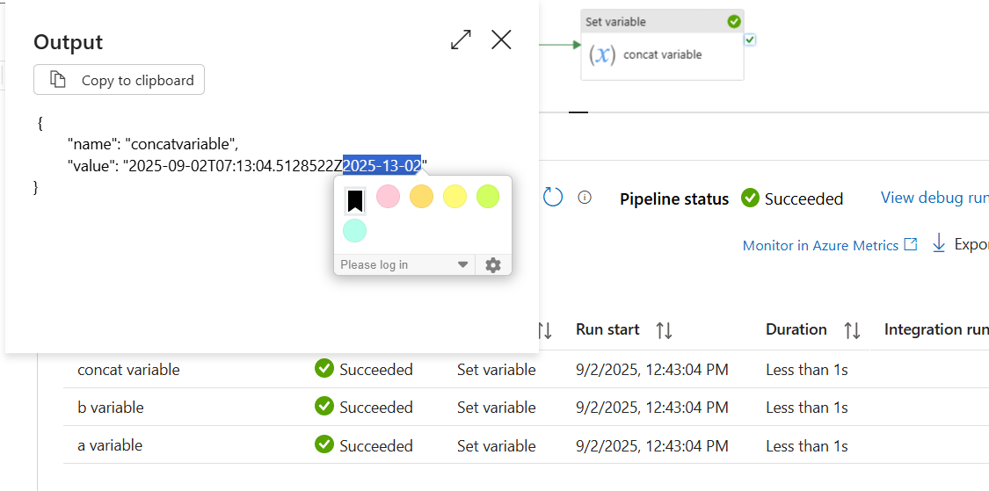

**Append Variable**

The **Append Variable** activity is used to add (append) values to an **array variable** during pipeline execution.

* You **cannot use it with string or int variables**, only with **Array type variables**.
* Each execution appends a new element to the existing array.

**Steps to Use Append Variable**

1. **Create a Variable** in your pipeline (type = Array).

"variables": {

"FileList": {

"type": "Array",

"defaultValue": []

}

}

1. **Add Append Variable Activity**

* Select the variable (FileList).
* Provide the value to append (can be dynamic expression).

**@concat('file_', pipeline().RunId, '.csv')**

**Example**

Let’s say you loop through a list of file names and want to store them:

* Initial variable (FileList): []
* First Append Variable: append "customer.csv" → ["customer.csv"]
* Second Append Variable: append "sales.csv" → ["customer.csv", "sales.csv"]
* Third Append Variable: append "product.csv" → ["customer.csv", "sales.csv", "product.csv"]

**Real-time scenarios**

* Collect file names processed in a loop.
* Store failed records file names for logging.
* Build a dynamic list of values to use later in the pipeline (for email notifications, logging tables, etc.).

**Store Procedure**

A stored procedure is a prepared SQL code that you can save, so the code can be reused again.

So, if you have an SQL query that you write again, save it as a stored procedure, and then just call it to execute it.

You can also pass parameters to a stored procedure, so that the stored procedure can act based on the parameters value that is passed.

You can use the stored procedure in

* Azure SQL Database
* Azure synapse analytics
* SQL server database

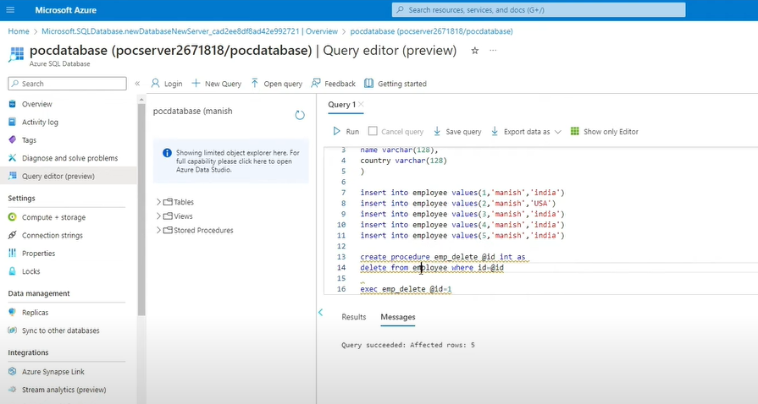

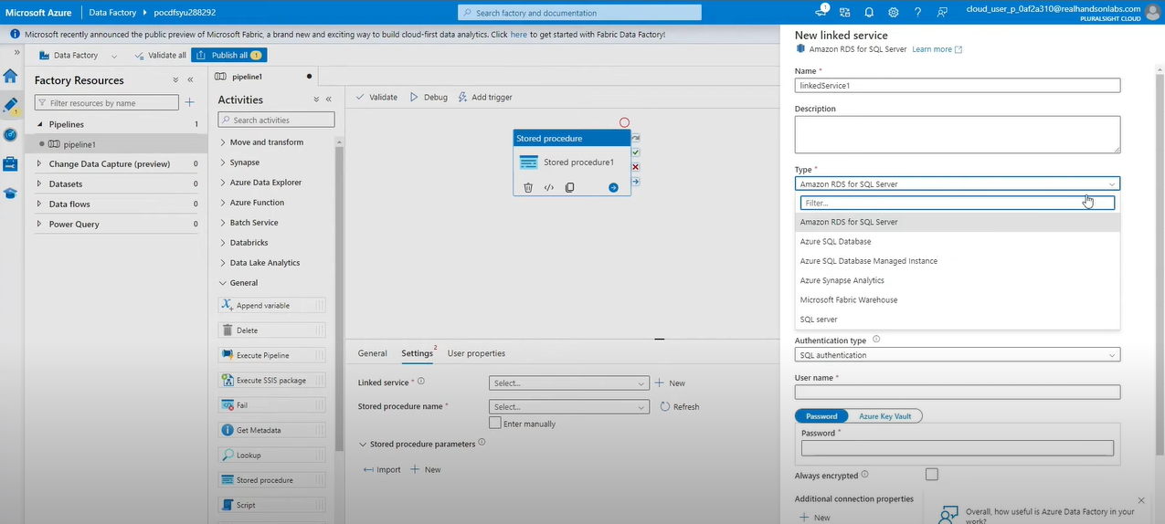

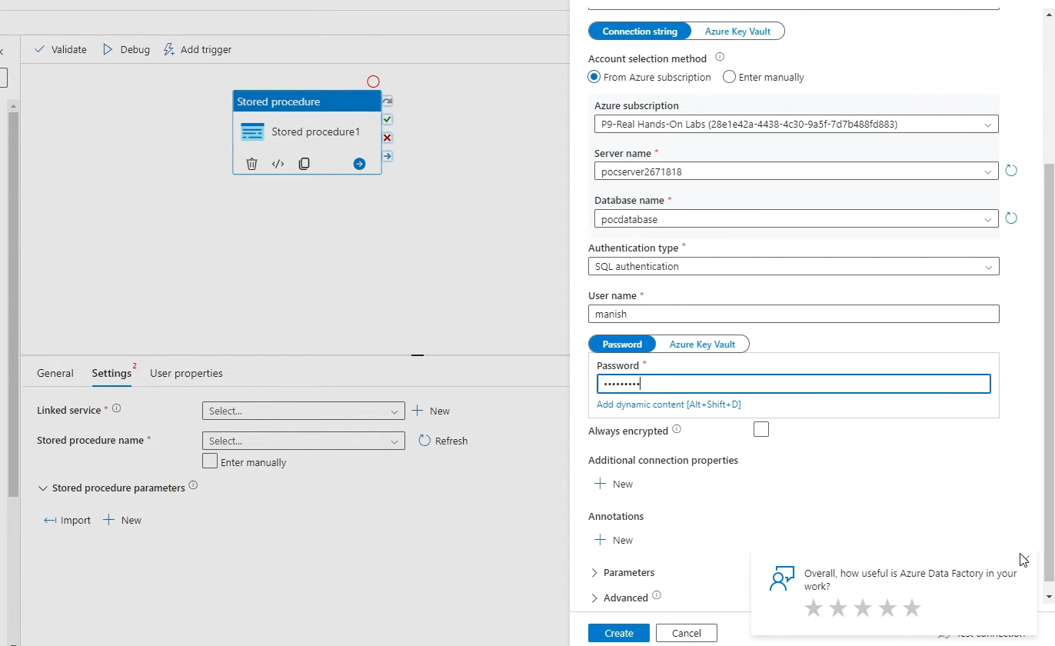

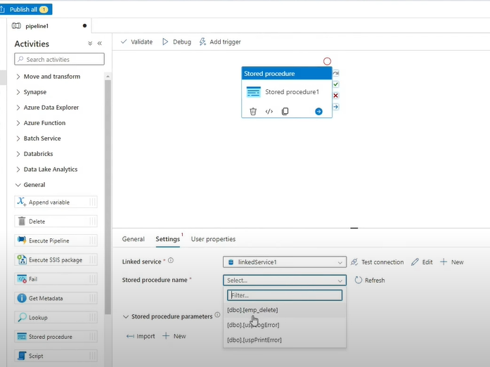

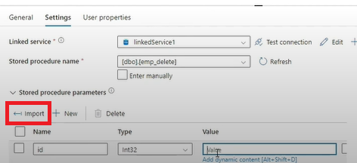

Until activity

The until activity is a looping activity in ADF pipeline

It repeatedly executes one or more activity until a condition is met (like a WHILE LOOP)

(Until it work the given condition becomes TRUE)

**Expression (Condition):**

* Defines when the loop should **stop**.
* Written using ADF expression functions (e.g., @equals(variables('status'),'Success')).

**Activities inside Until:**

* You can put multiple activities inside (Copy, Lookup, Stored Proc, Web activity, etc.).
* They will repeat until the condition is true.

**Timeout:**

* Prevents infinite looping.
* Example: 7.00:00:00 → loop stops after 7 days even if condition is not met.

**Real-Time Uses**

* Waiting for files to land in storage.

(Wait Until File Arrives

Suppose ADF must wait until a file is available in Azure Blob before proceeding)

* Polling an external API until processing completes.
* Checking for flag/status in a control table.
* Retrying logic until resource is ready.

Set the variable as **false (until it becomes TRUE this will until activity will work)**

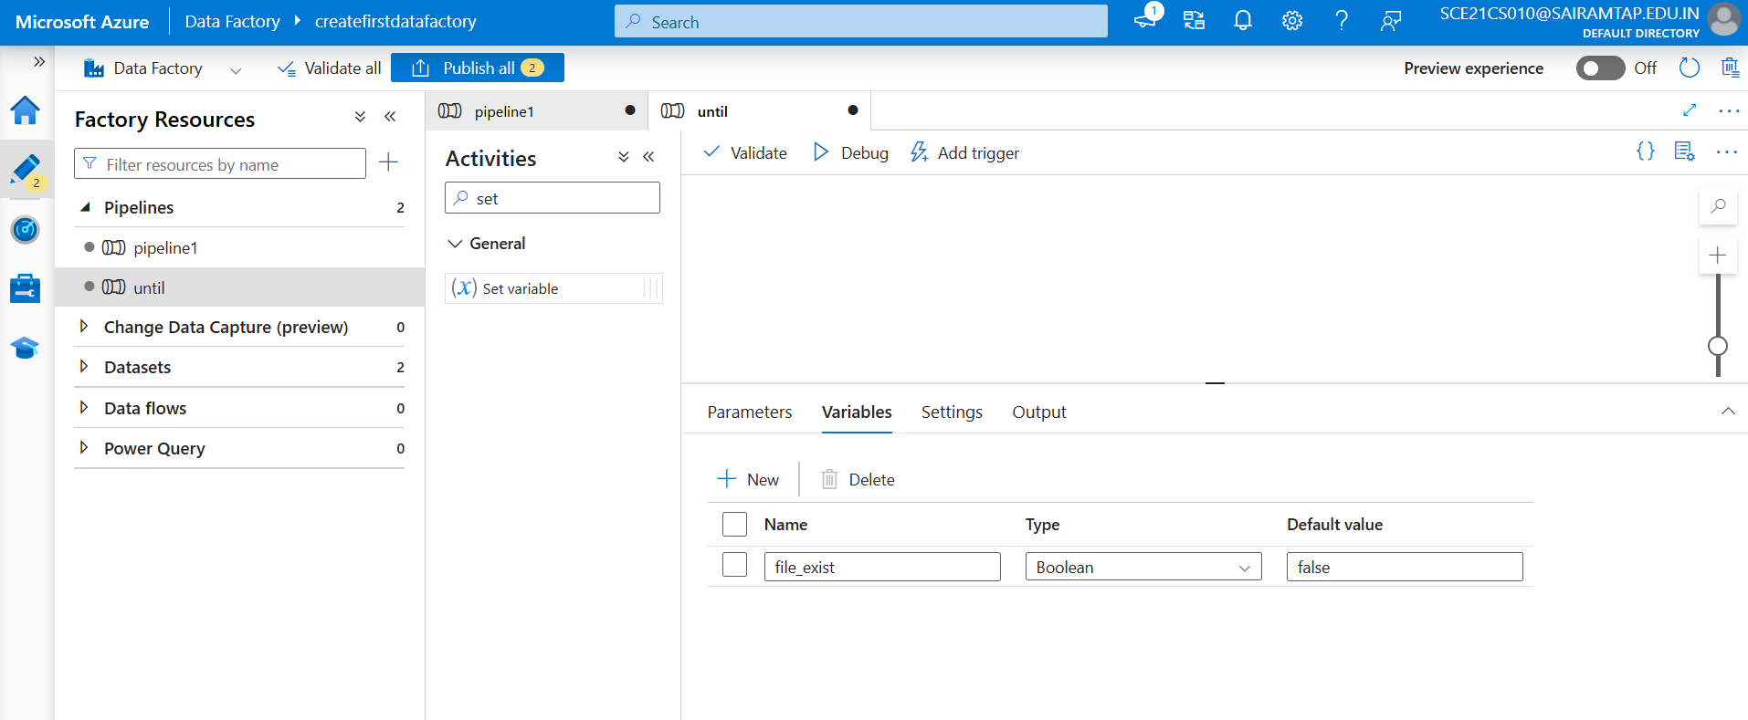

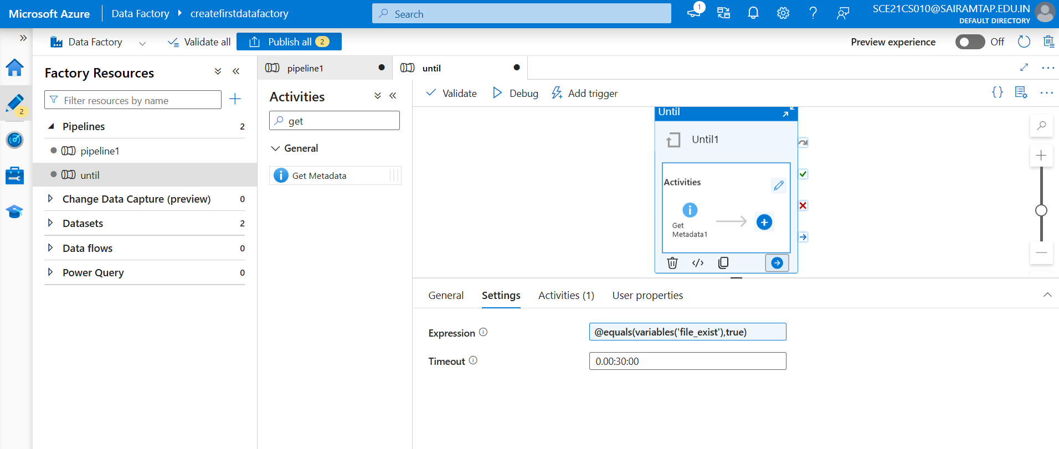

**Get Metadata Activity**

* Point it to the **file path** in your Blob dataset.
* Under *Field list*, check **Exists**.
* This will return "exists": true/false.

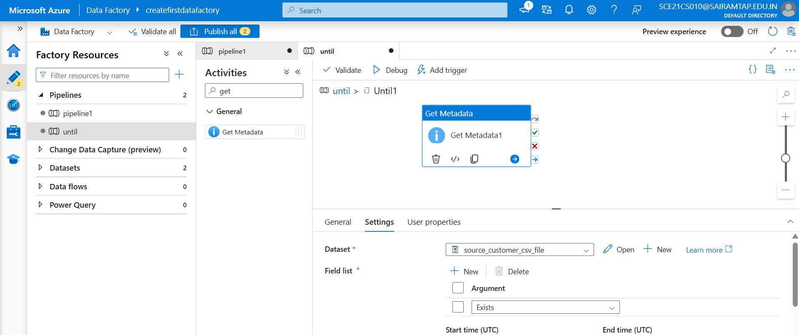

Output of this get metadata activity given to the set variable to update it dynamically.

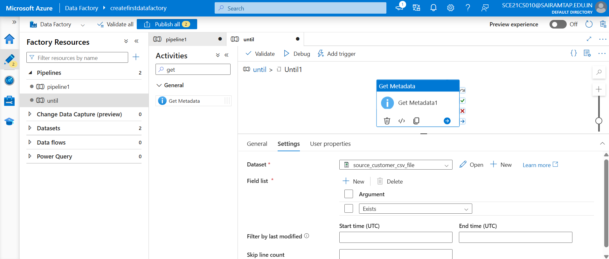

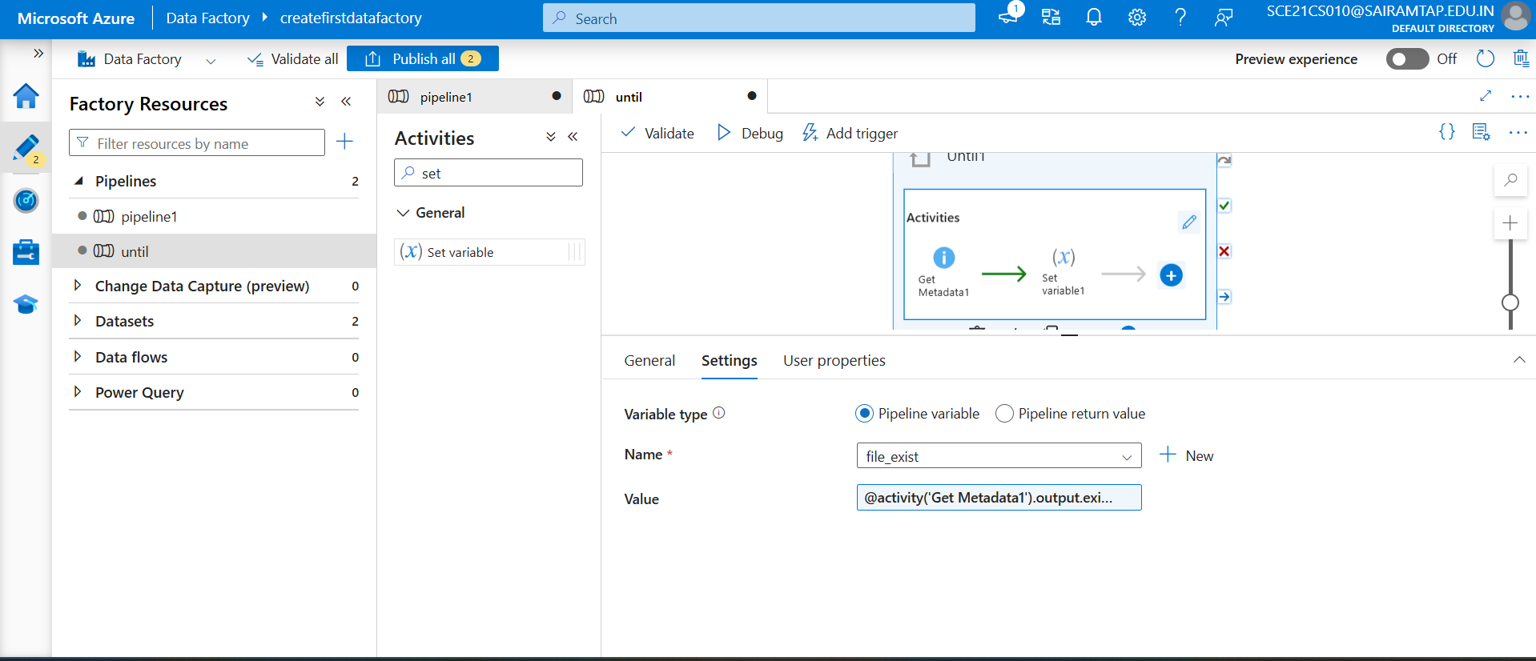

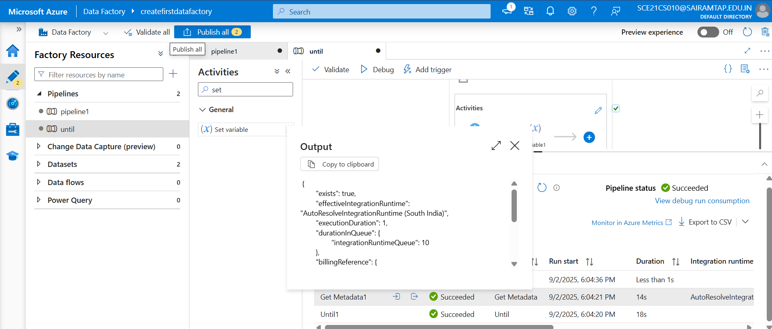

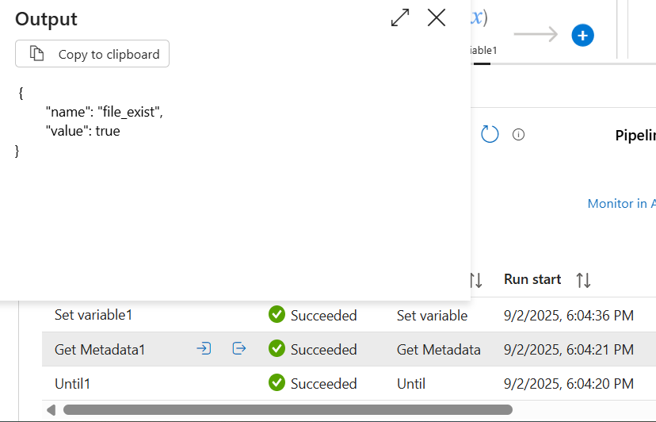

**Web Activity in ADF**

The **Web Activity** lets us to **call REST endpoints** (HTTP APIs) from inside your pipeline.  
It’s useful when you need to **interact with external services or trigger jobs** from ADF.

You can pass datasets and linked services to be consumed and accessed by the activity.

**Key Properties**

1. **URL** → The endpoint you’re calling (e.g., https://www.dummy.restapiexample.com/).
2. **Method** → GET, POST, PUT, DELETE.
3. **Headers** → You can pass things like Content-Type: application/json,

**Authorization**: Bearer <token>.

1. **Body** → Used in POST or PUT calls to send data (must be valid JSON).
2. **Authentication** (supports multiple types):

* None
* Basic (username/password)
* MSI (Managed Identity)
* Service Principal

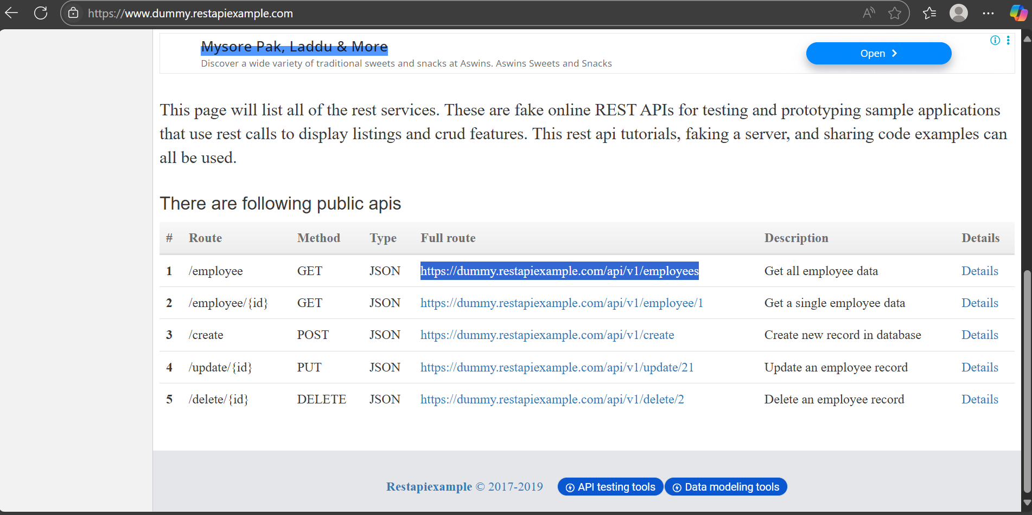

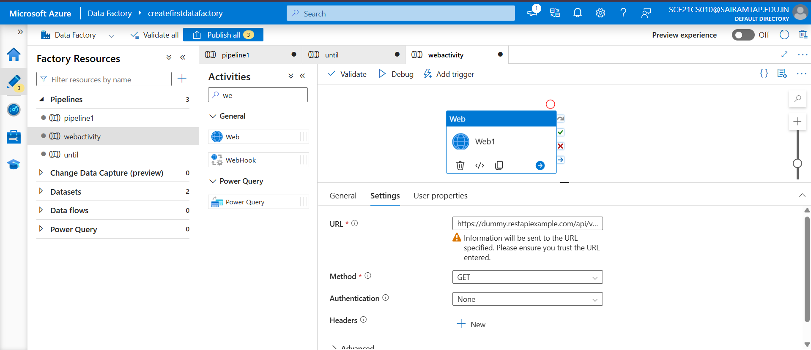

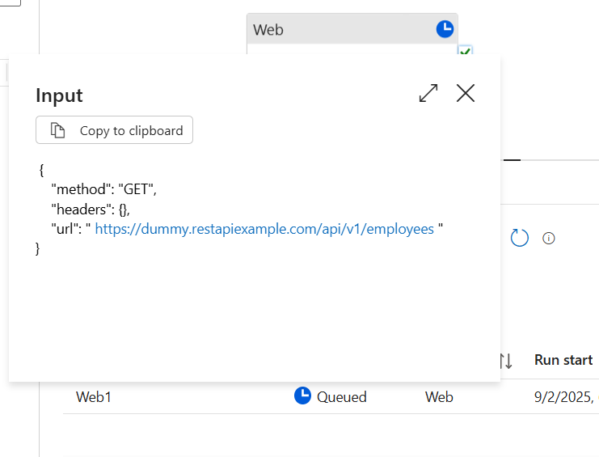

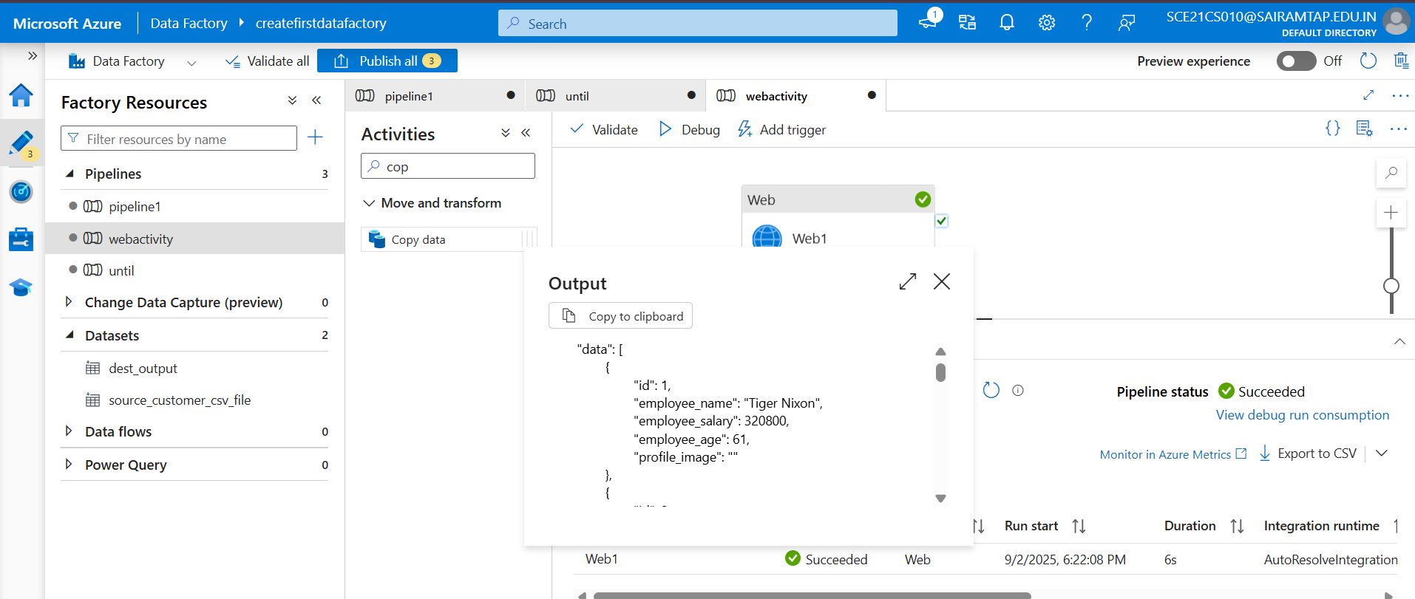

For post

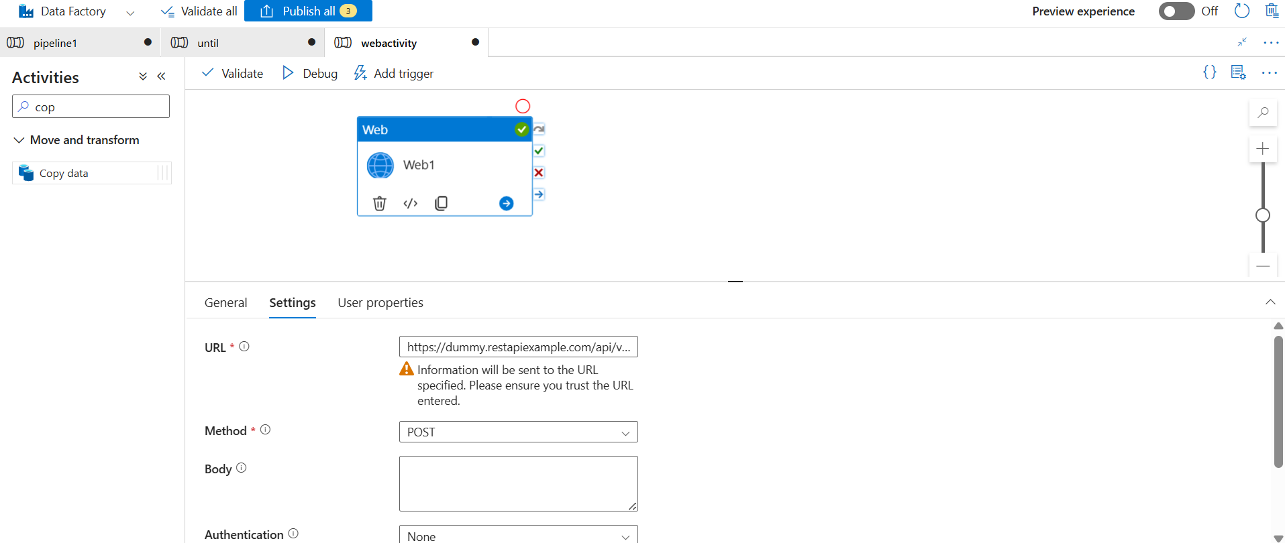

**Web Hook activity**

The **Webhook activity** in Azure Data Factory is a powerful feature that allows you to interact with external systems or services by **calling an endpoint and waiting for a callback response.**

**Web Activity** → just calls an API and moves on (doesn’t wait).  
**Webhook Activity** → calls an API (usually long-running jobs) and **waits for a callback response** before pipeline continues.

**How It Works**

1. **Trigger External Service**: The Webhook activity sends a request to an external endpoint (e.g., REST API) (post request).
2. **Callback URL**: ADF provides a callback URL in the request payload. The external service must invoke this URL once its processing is complete.
3. **Wait for Completion**: The pipeline execution pauses until the callback URL is invoked or a timeout occurs.

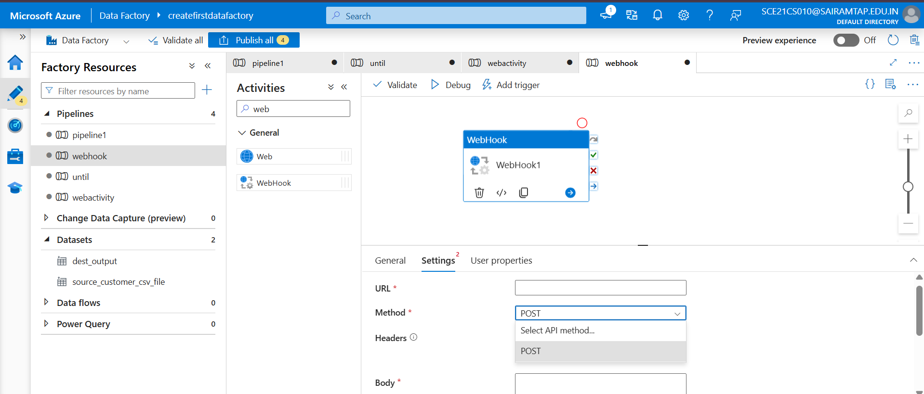

* **Scenario**: Trigger a Logic App to process data and wait for its completion before moving to the next pipeline step.

**Databricks activity**

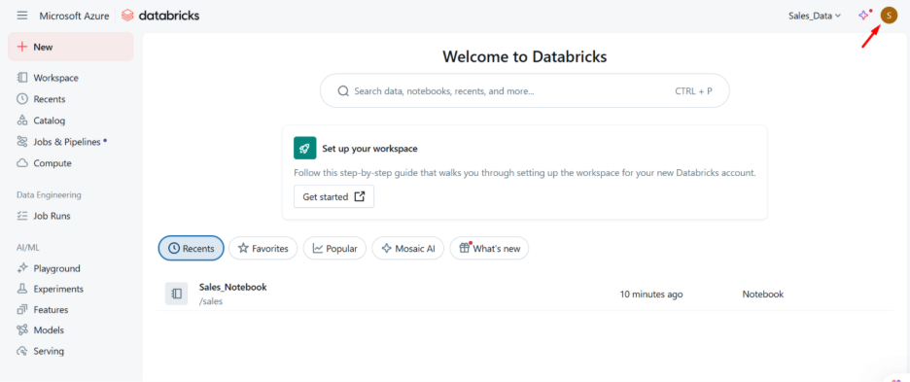

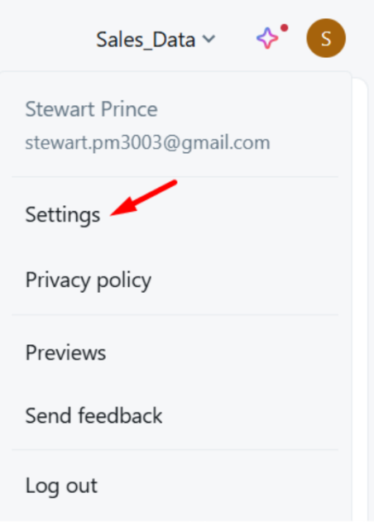

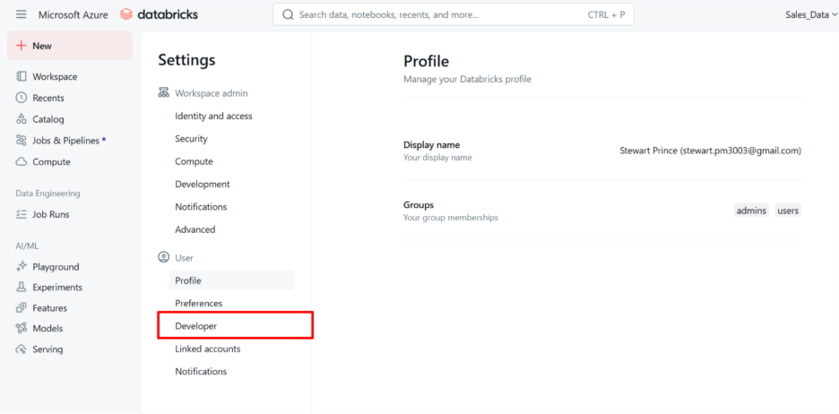

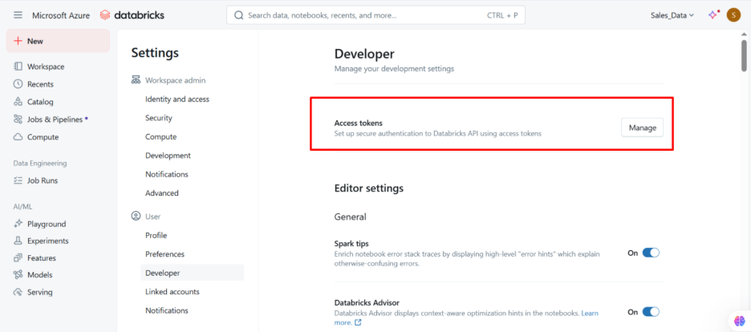

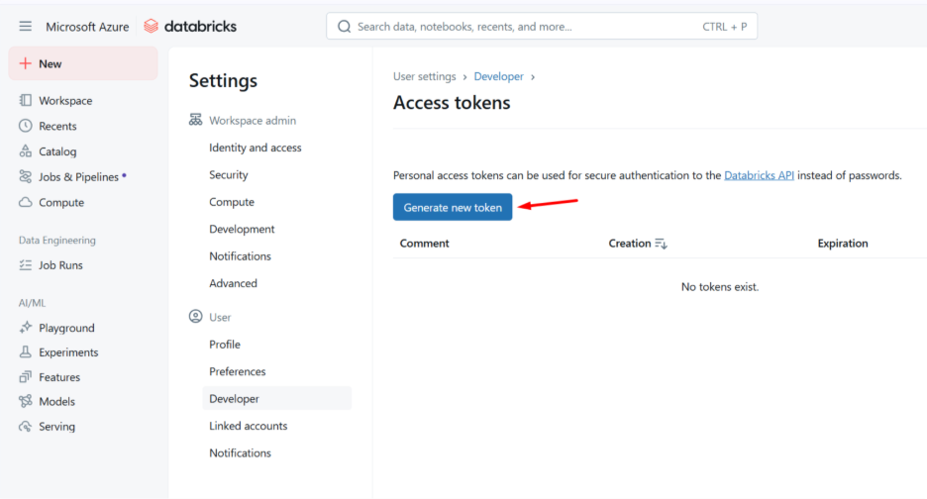

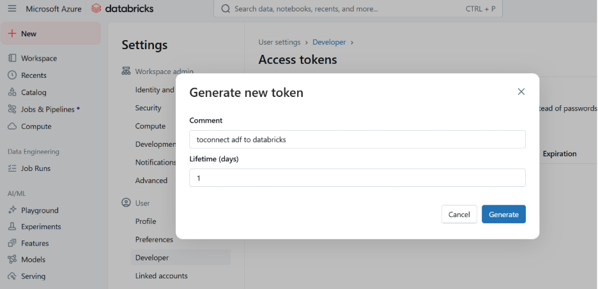

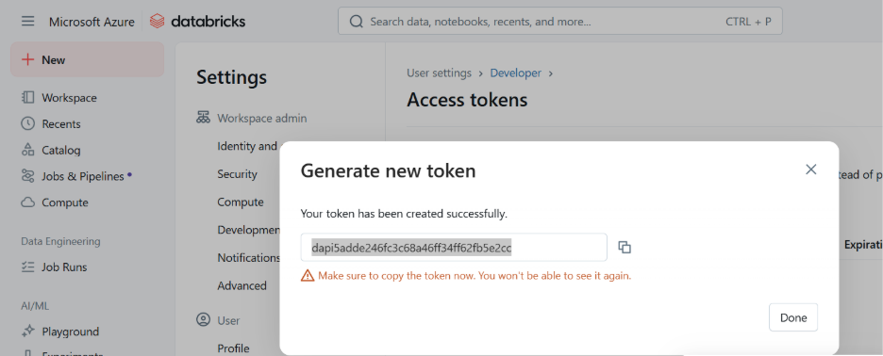

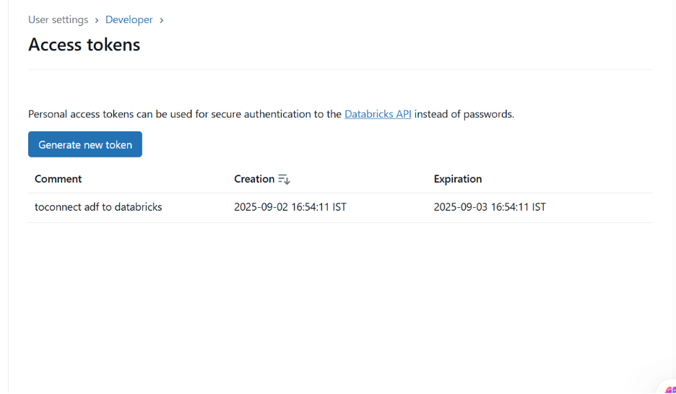

Create linked service for databricks (go to compute)

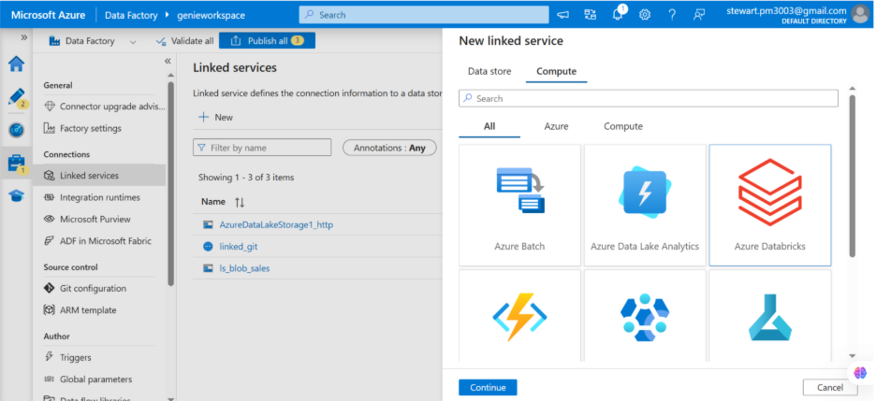

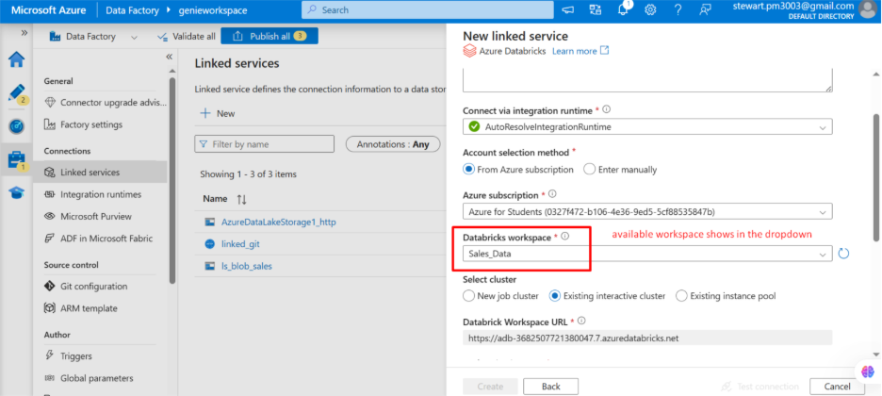

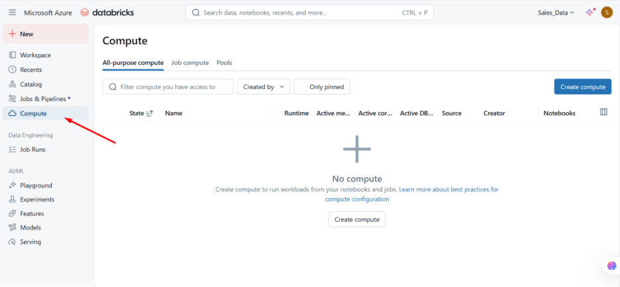

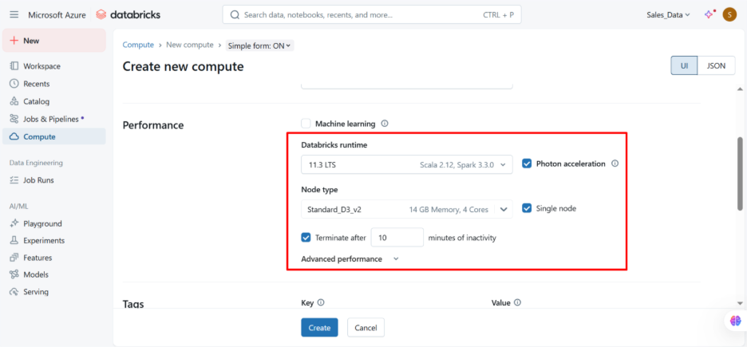

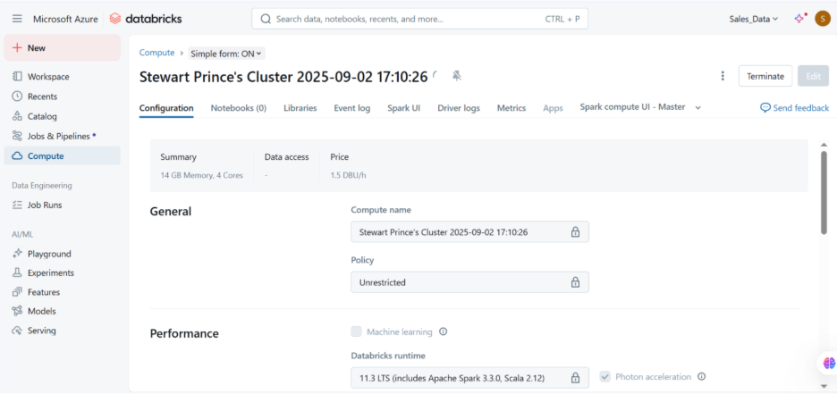

Cluster created

Connect linked service

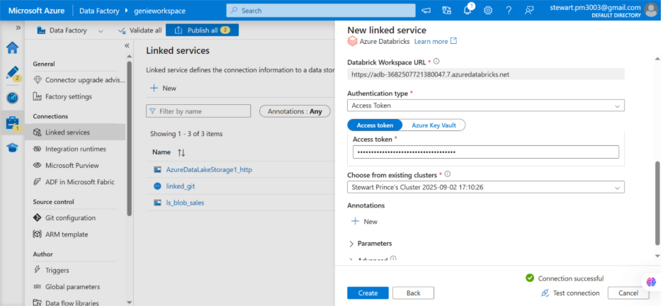

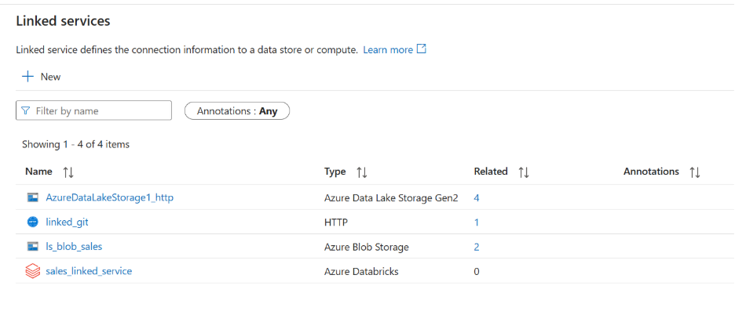

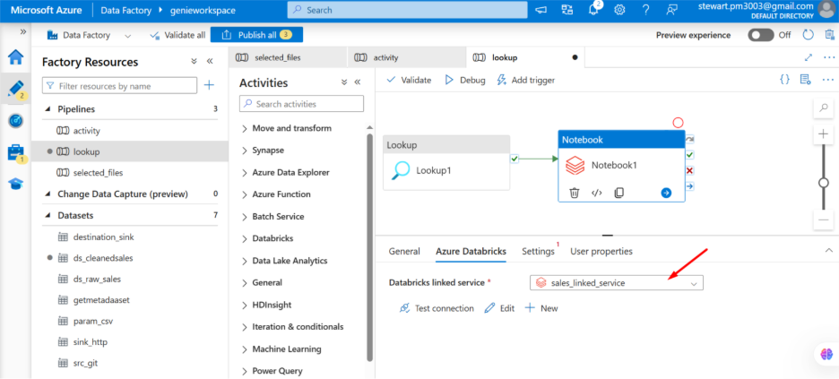

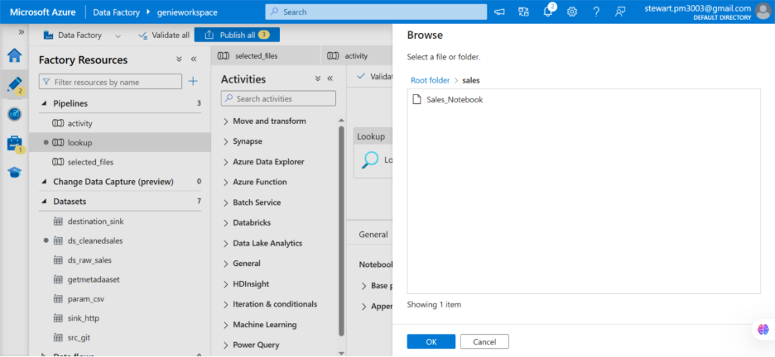

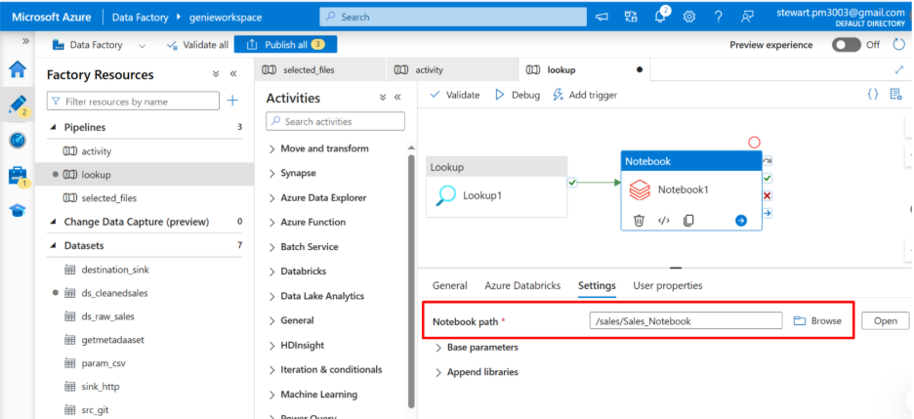

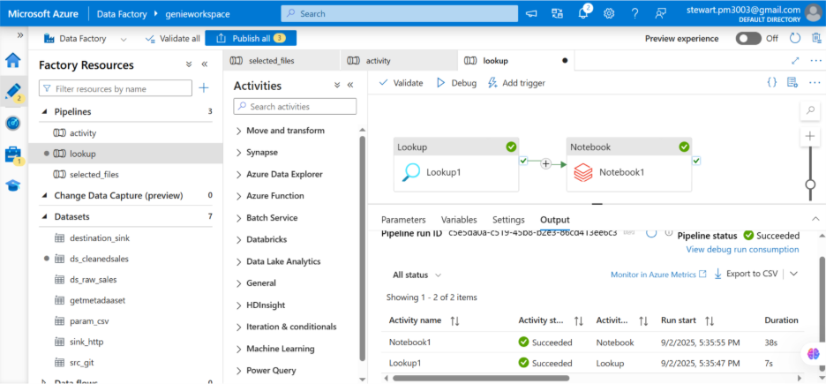

Filter activity

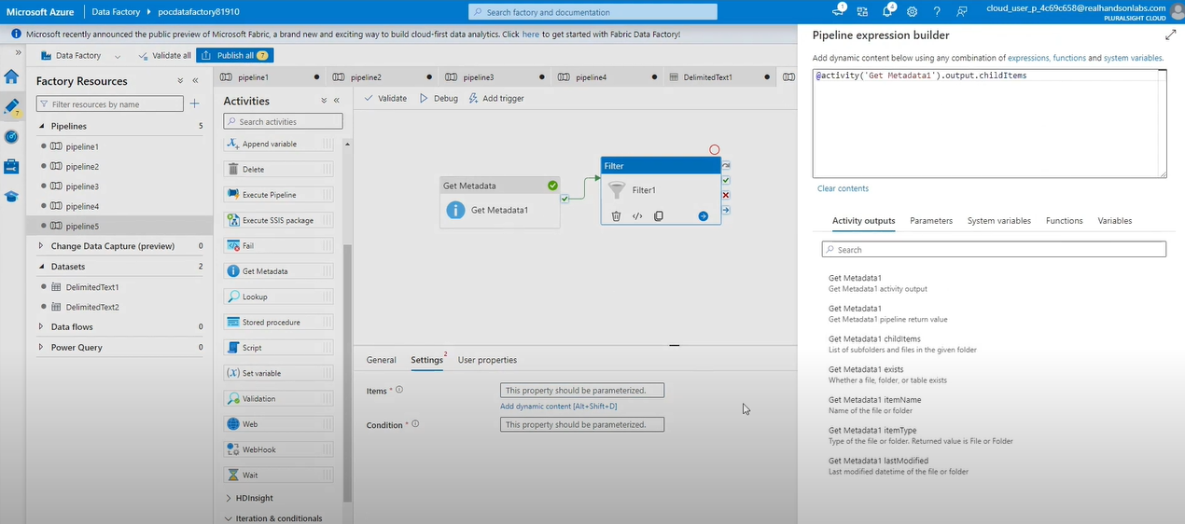

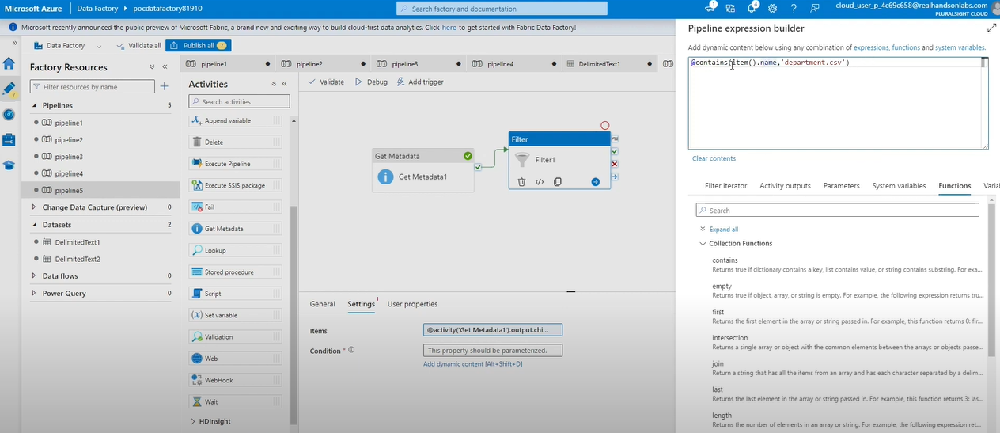

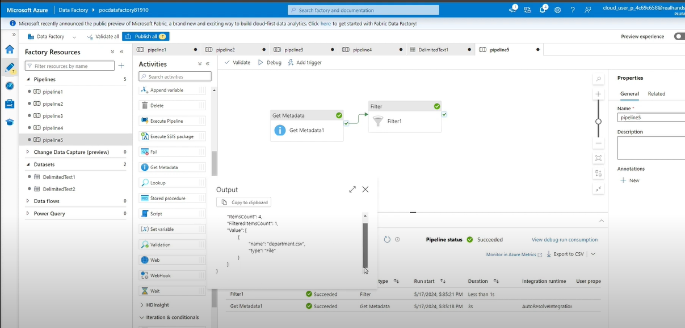

Azure Data Factory Pipeline Activities

* Move and transform

|  |  |  |
| --- | --- | --- |
| **Activity** | **What it does** | **Real-time scenario** |
| **Copy Data** | Moves data from a source to a sink (with optional schema mapping). | Copy CSV from Blob → Azure SQL Table. |
| **Data Flow** | Runs Mapping Data Flows (row-level transformations like join, aggregate, conditional split). | Cleanse customer data, handle SCD Type 2, load fact tables. |

2. **Azure Data Lake / Databricks**

| **Activity** | **What it does** | **Scenario** |
| --- | --- | --- |
| **Databricks Notebook / Jar / Python** | Runs Databricks jobs. | Run PySpark to flatten JSON or apply SCD logic. |
| **HDInsight Hive / Pig / MapReduce / Spark** | Run big data jobs on HDInsight cluster. | Legacy Hadoop workloads. |

3. **General Activities**

| **Activity** | **What it does** | **Scenario** |
| --- | --- | --- |
| **Lookup** | Reads a single row or dataset from a source for use in pipeline. | Get latest watermark value from SQL table. |
| **Get Metadata** | Fetches file/table properties (size, modified date, schema). | Check if file exists before processing. |
| **Delete** | Deletes files/folders from storage. | Clean up old files after load. |
| **Web** | Calls REST APIs (fire and forget). | Trigger an API that refreshes Power BI dataset. |
| **Webhook** | Calls API and waits for callback. | Trigger ML job and wait until training finishes. |
| **Stored Procedure** | Calls SQL stored procedure. | Run merge procedure after staging load. |
| **Execute Pipeline** | Runs another pipeline. | Modularize pipelines (ingest pipeline → transform pipeline). |
| **Append Variable** | Adds a value to an array variable. | Collect list of file names during iteration. |
| **Set Variable** | Assigns value to a variable. | Store dynamic file path for use later. |
| **Validation** | Checks existence/availability of data before continuing. | Ensure file is present before Copy Activity. |
| **Wait** | Pauses pipeline for set time. | Add 10 min delay before retrying API. |

4. **Iteration & Conditionals**

| **Activity** | **What it does** | **Scenario** |
| --- | --- | --- |
| **If Condition** | Branch logic (if-else). | If file size > 1GB, process in Databricks, else Copy directly. |
| **Switch** | Case-based branching. | Route data load to bronze, silver, or gold container. |
| **ForEach** | Loops over a collection of items. | Process each file in a folder one by one. |
| **Until** | Loops until condition = true. | Keep checking for a file until it arrives. |

Create sql database

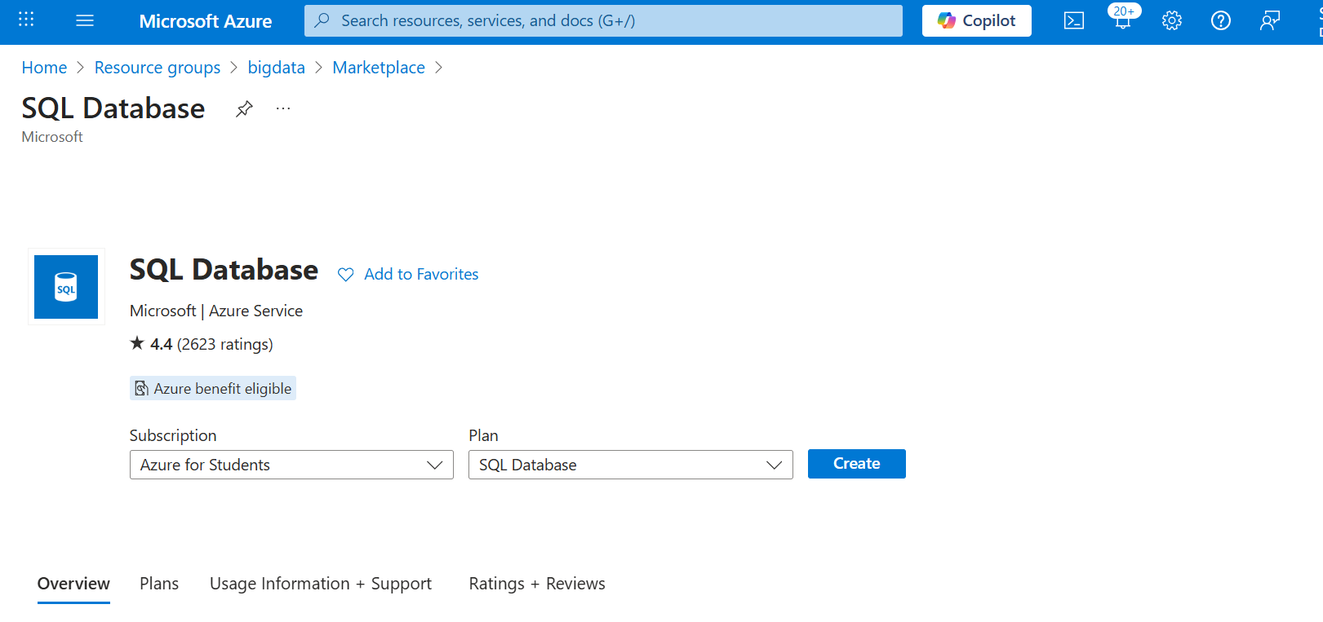

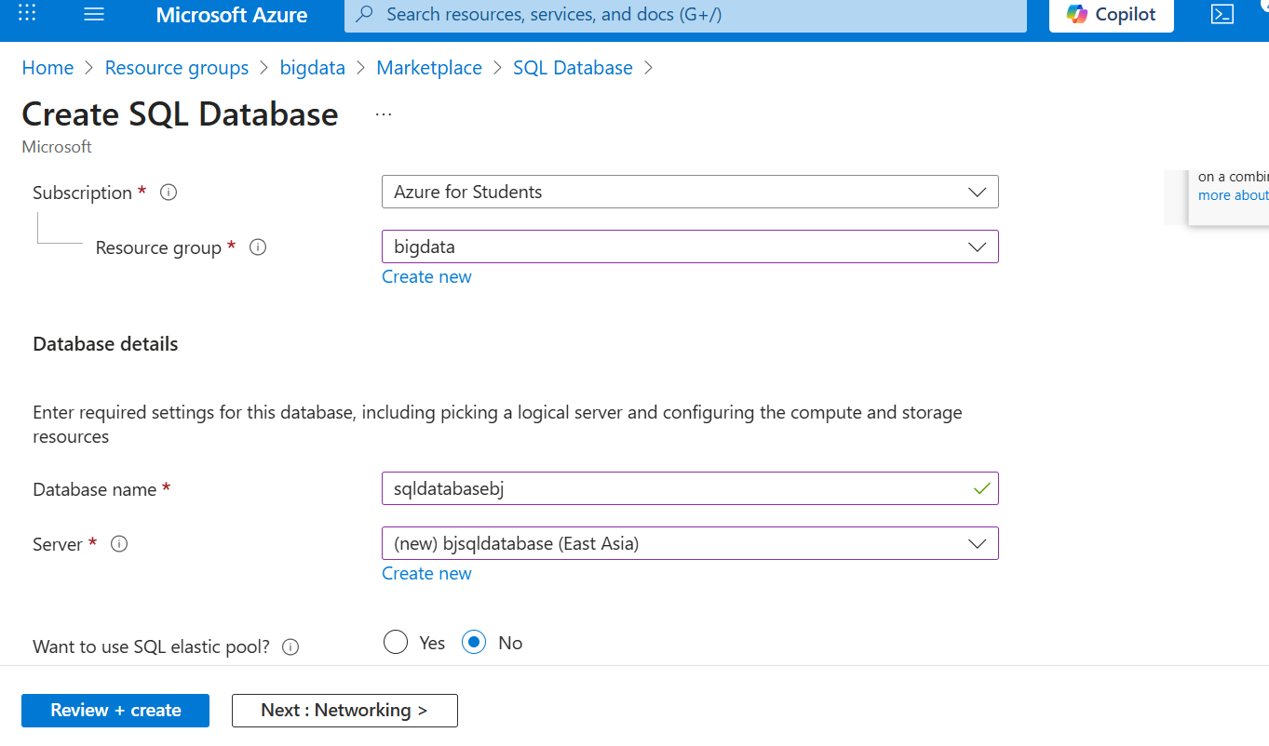

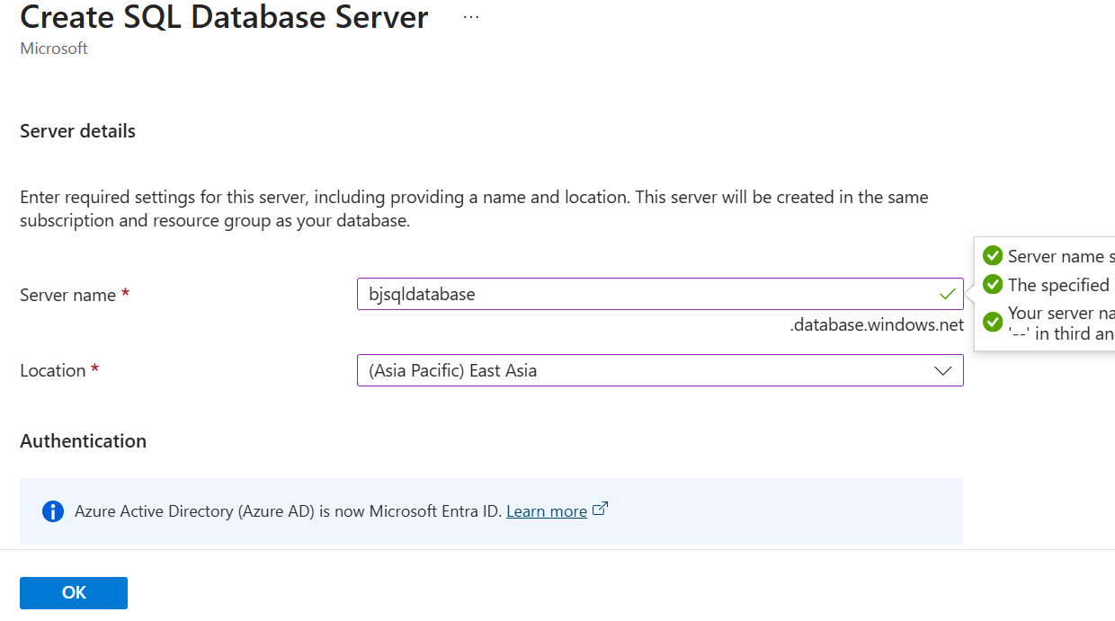

bjSQL@5@7

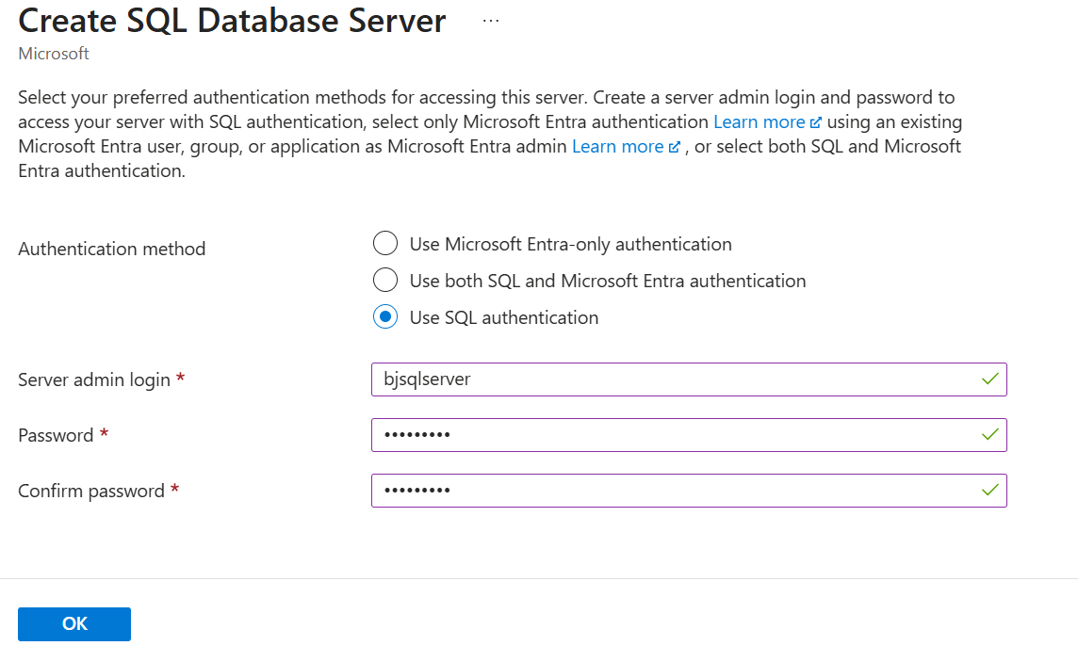

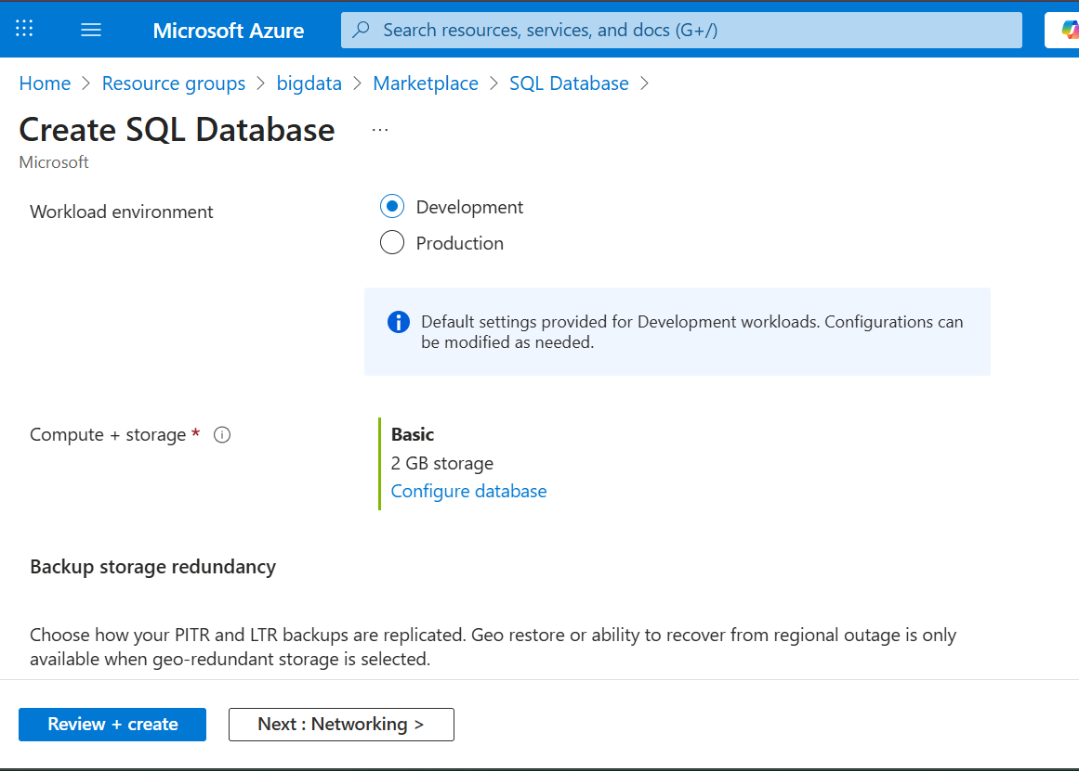

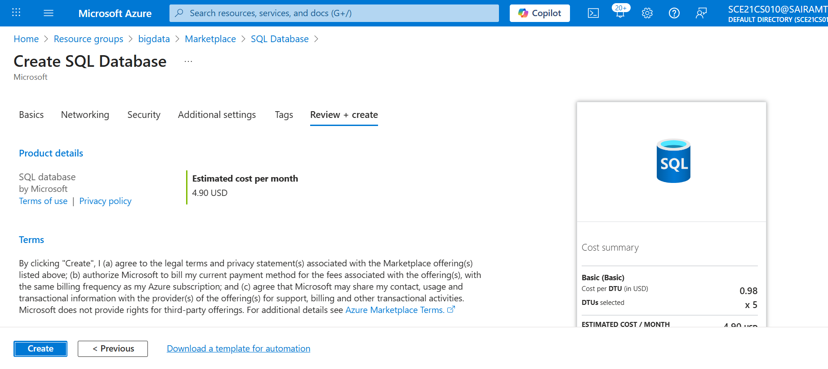

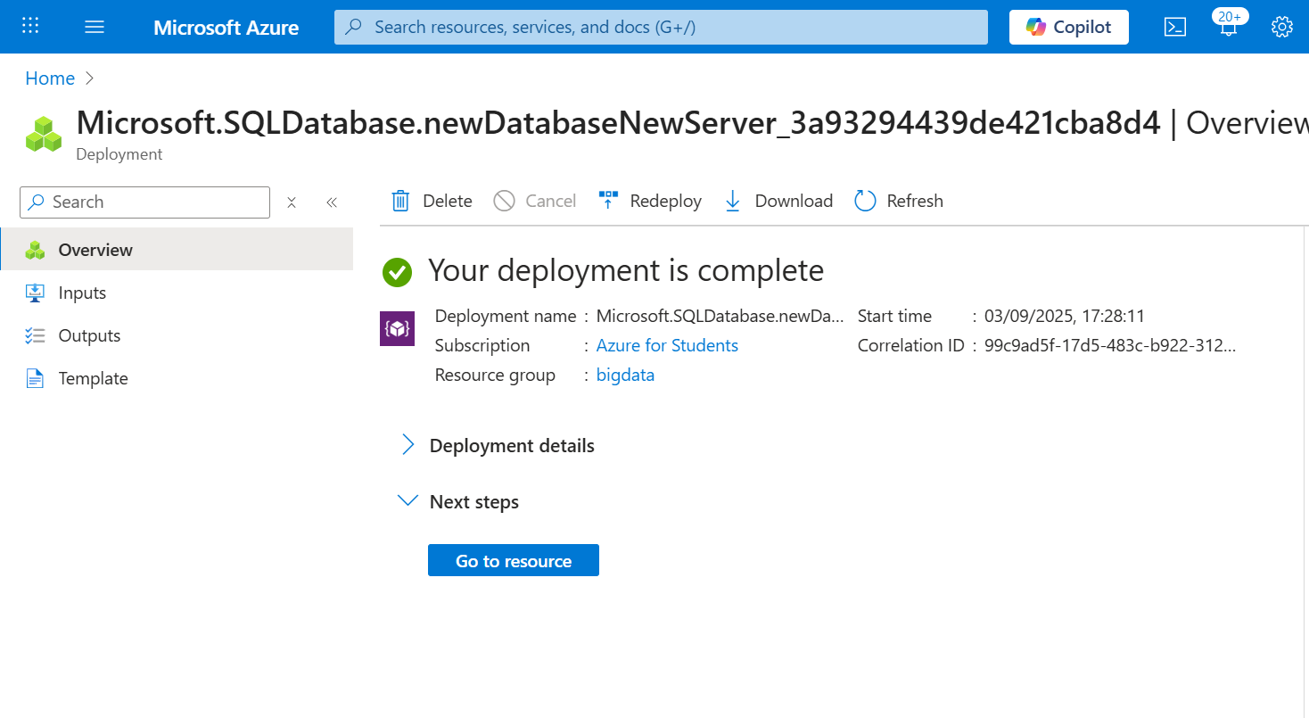

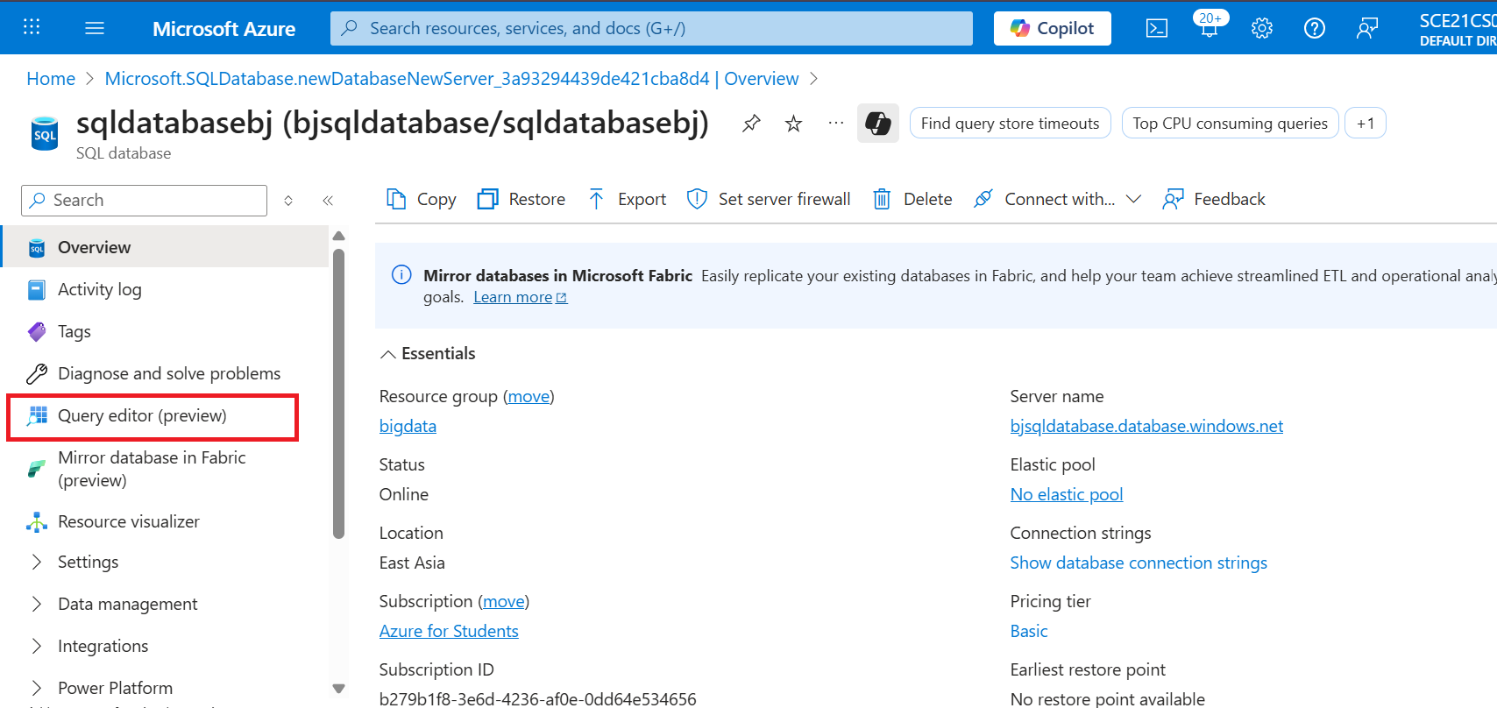

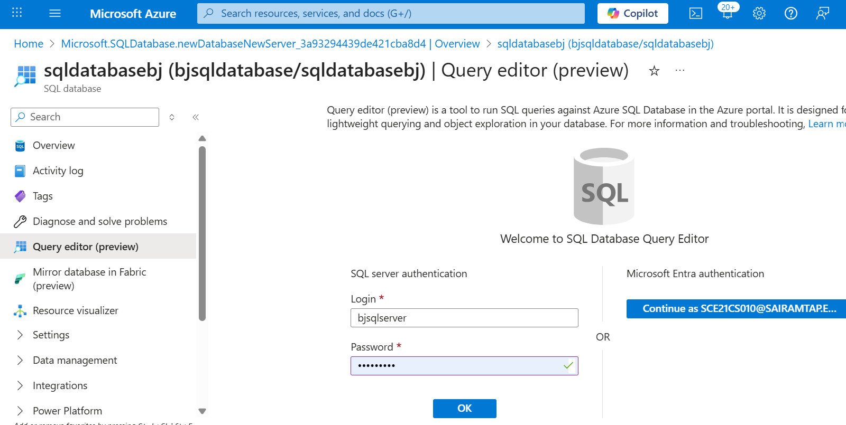

Scenario

* 1. We have data available in blob or ADLS as csv format
  2. We need to copy data from storage to sql database (table format)

Source is created

Sink

(table created)

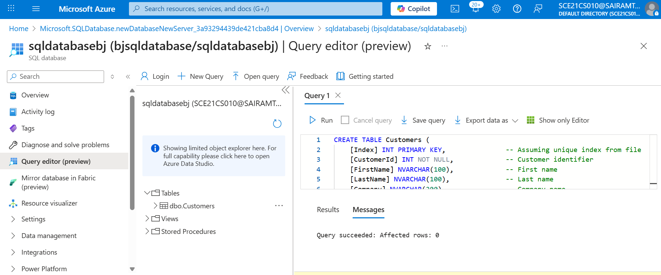

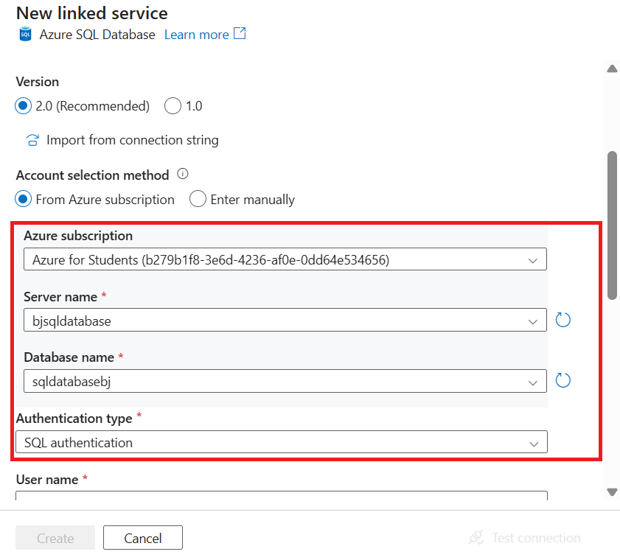

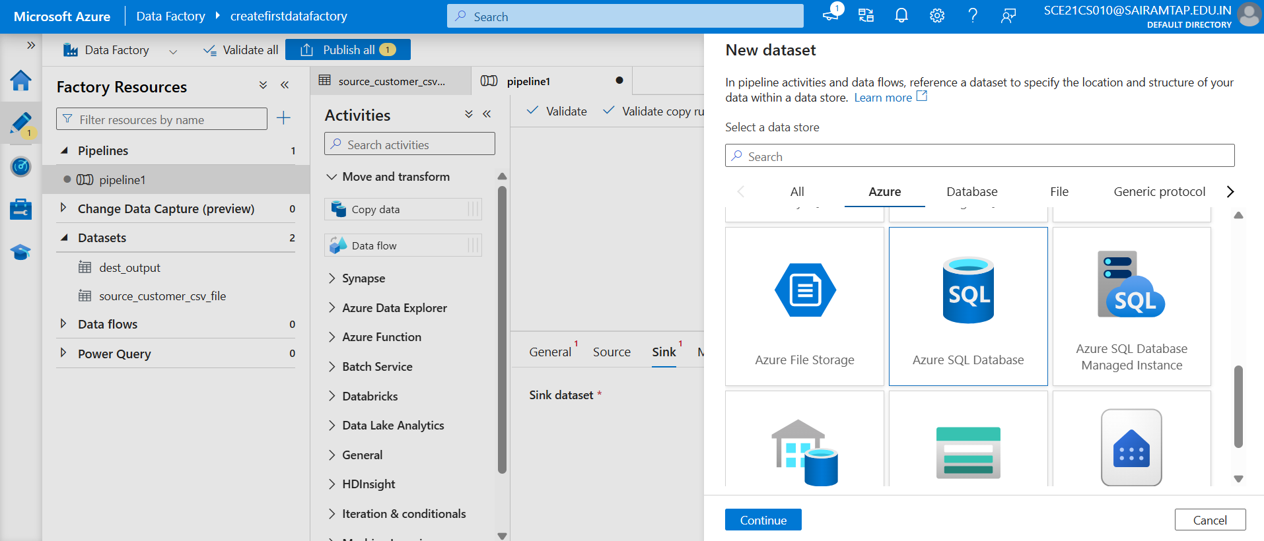

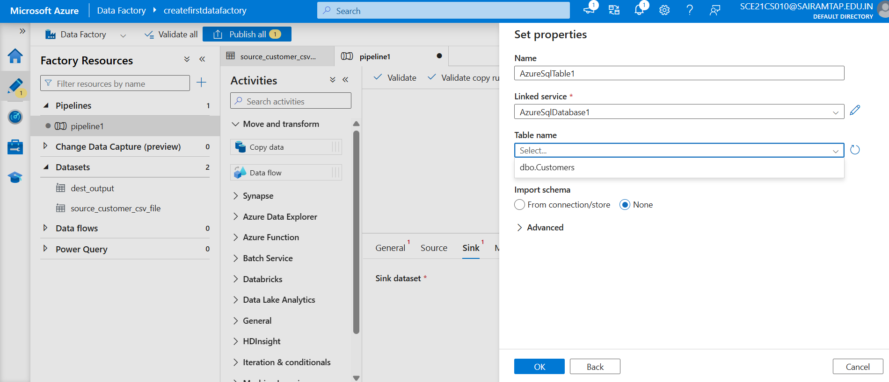

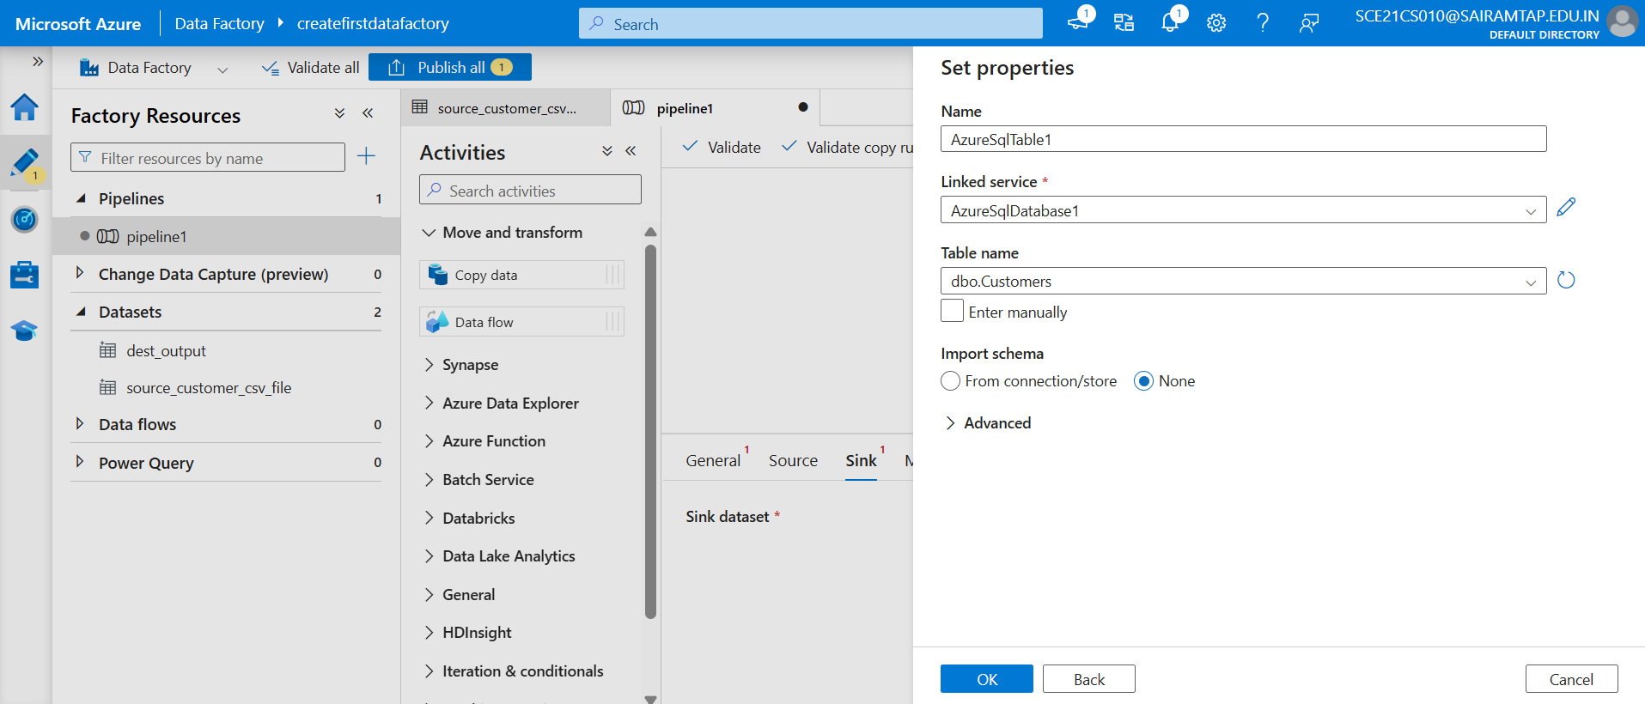

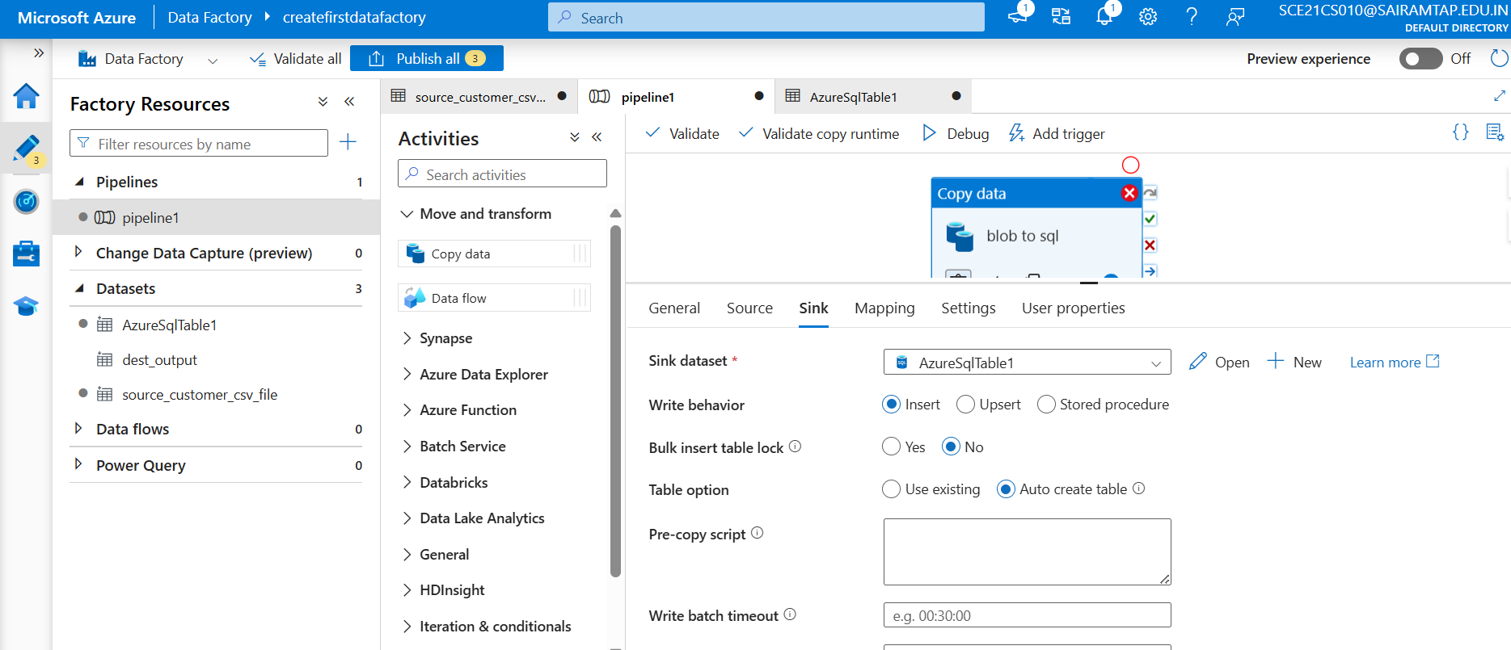

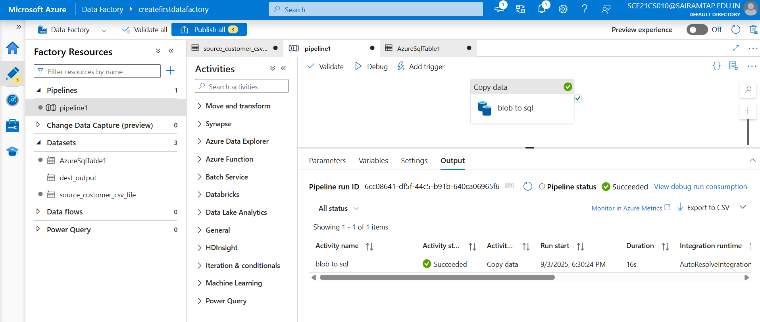

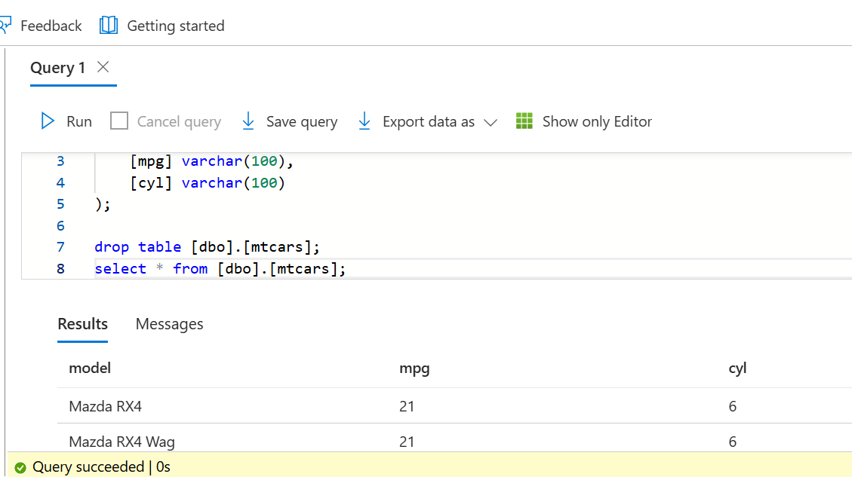

**1) Azure DevOps**

Azure DevOps is Microsoft’s cloud-based platform that provides tools for collaboration, version control, build, testing, and deployment of applications.  
It is widely used for managing the end-to-end software development lifecycle (SDLC).

**Key Components:**

* Azure Repos → Git repositories for source code management.
* Azure Pipelines → Continuous Integration & Continuous Deployment (CI/CD).
* Azure Boards → Agile planning (work items, user stories, sprint planning, Kanban boards).
* Azure Artifacts → Package management (NuGet, npm, Maven, etc.).
* Azure Test Plans → Testing and quality assurance.

**2) CI/CD Integration**

CI/CD stands for Continuous Integration and Continuous Deployment/Delivery.  
It is a DevOps practice that automates building, testing, and deploying applications to ensure faster and more reliable delivery.

**Breakdown:**

* **CI (Continuous Integration):**
* Developers push code frequently to a shared repo (e.g., Azure Repos, GitHub).
* Code is automatically built and tested using pipelines.
* Ensures issues are caught early.
* **CD (Continuous Delivery/Deployment):**
  + Automates the release of validated code to different environments (Dev, QA, UAT, Prod).
  + Continuous Delivery → requires manual approval before production.
  + Continuous Deployment → fully automated deployment into production.

**Azure DevOps CI/CD Example Flow:**

1. Developer pushes code to Azure Repos (Git).
2. Pipeline (CI) triggers → builds app, runs unit tests.
3. Release pipeline (CD) → deploys to staging → approval → production.
4. Monitoring & feedback loop via dashboards/logs.

**In short:**

* Azure DevOps = Platform with tools for DevOps.
* CI/CD Integration = The practice of automating build/test/deployment pipelines, often implemented in Azure Pipelines.

**Key Features and Services – Global Data Centers**

* **Global Presence** – Azure has **data centers across the world** (regions).
* **Regions** – A geographical area containing one or more data centers (e.g., East US, Central India).
* **Availability Zones (AZs)** – Physically separate data centers within a region to provide **high availability** and **fault tolerance**.
* **Paired Regions** – Each region is paired with another (for disaster recovery).
* **Global Network** – Low-latency, high-speed connectivity between regions.
* **Compliance & Security** – Meets local laws (GDPR, HIPAA, etc.) by placing data in the right region.

**In short:** Azure’s global data centers ensure **availability, redundancy, disaster recovery, and compliance** worldwide.

**2) Key Features and Services – Azure Subscription and Resource Groups**

* **Azure Subscription**:
  + Acts as a **container for resources** (VMs, databases, storage, etc.).
  + Defines **billing boundary** (you get billed per subscription).
  + Can have multiple subscriptions for **separation of environments** (Dev, Test, Prod).
  + Controls **access management** via Azure RBAC.
* **Resource Group (RG)**:
  + A **logical container** inside a subscription.
  + Used to group related resources (VM, Storage, Database for one app).
  + Supports **lifecycle management** (deploy, update, delete as a unit).
  + Helps in **organization, access control, and cost tracking**.

1. You have a pipeline that ingests files from an on-premises SQL Server every hour. Sometimes the files arrive late. How would you design the pipeline to handle late-arriving files without failing? – Event triggers

You are using **Copy Activity** to move JSON files from Blob to SQL Database, but some rows fail because of schema drift (extra columns added in source). How will you handle these error rows?

1. How to provide filename to the target file based on date function

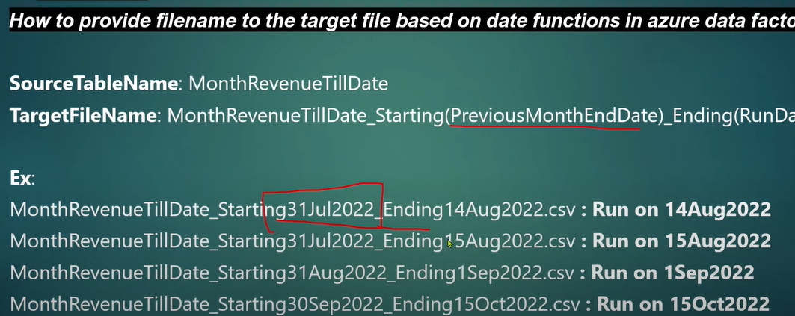

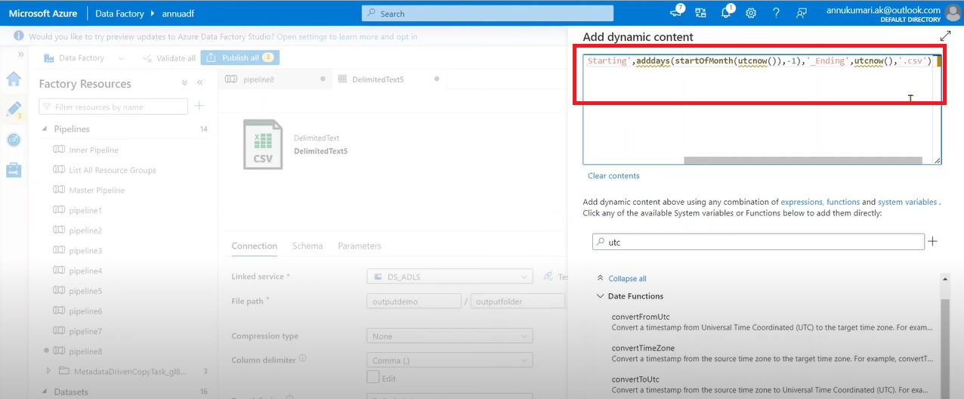



**@concat(‘monthStart’, adddays(‘startofMonth’, (utcnow()),’Ending’, utcnow())**

1. **How to copy all the file present in folder to another folder using ADF**

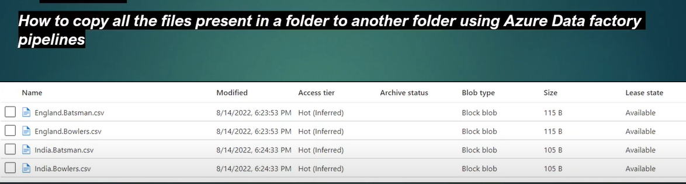

**Method – 1**

* **Configure Source Dataset Create a dataset for your source (e.g., Azure Blob Storage, ADLS). Use the Wildcard File Path option in the source settings to specify multiple files or folders. For example: Folder Path: demo/source/ Wildcard File Name: *.csv This will select all .csv files in the specified folder.**

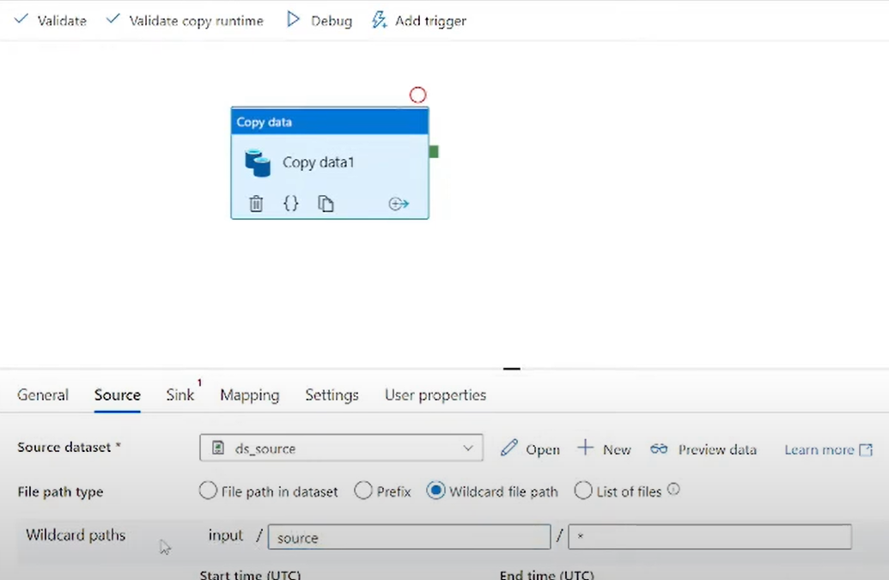

**Method – 2 (dynamic copying)**

* **Use ForEach Activity for Dynamic Copying If you need to copy files from multiple folders dynamically: Use a get metadata Activity to fetch folder/file paths. Pass the output of the get metadata (child item) to a ForEach Activity. Inside the ForEach loop, configure the Copy Activity with dynamic parameters for source and sink paths: Source Path: @item().SourcePath Sink Path: @item().DestinationPath**

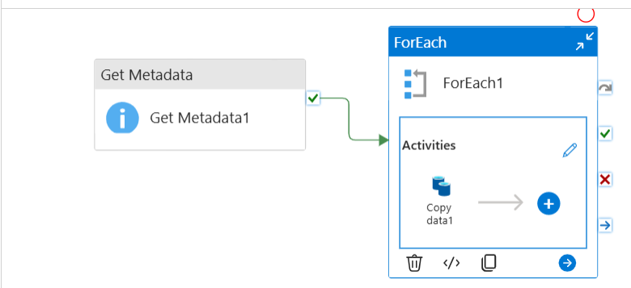

1. **How to copy files of specific format from one ADLS folder to another using ADF pipeline**

Step-1: get all file information using **Get Metadata activity** and the output to the **filter activity**

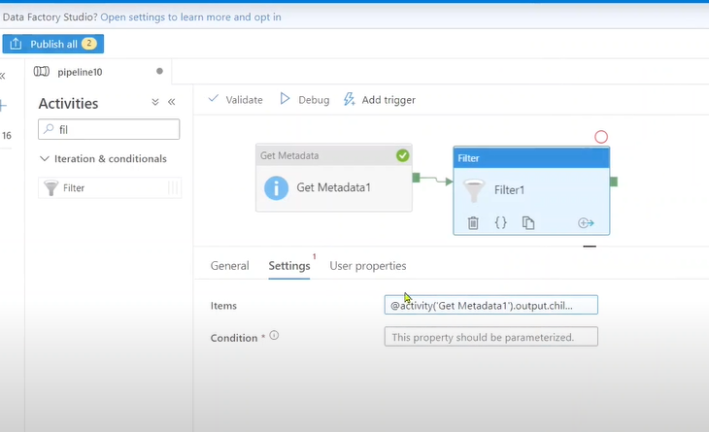

**We can give dynamic file type also**

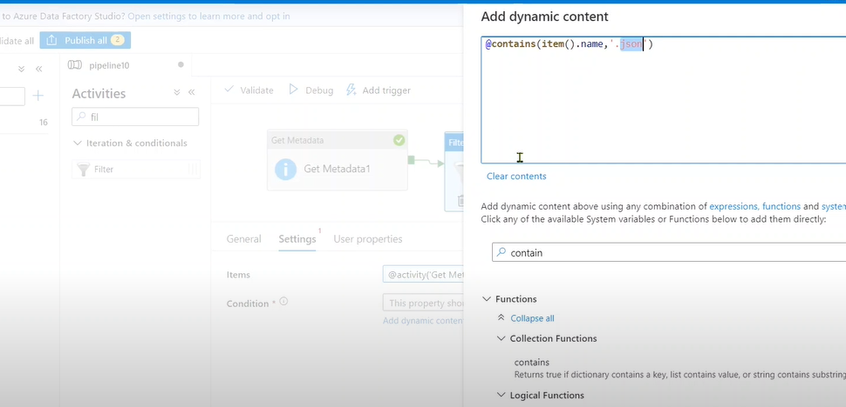

1. **How to load all the ADLS foldername and count of files inside each folder into SQL table.**

Not given any file path

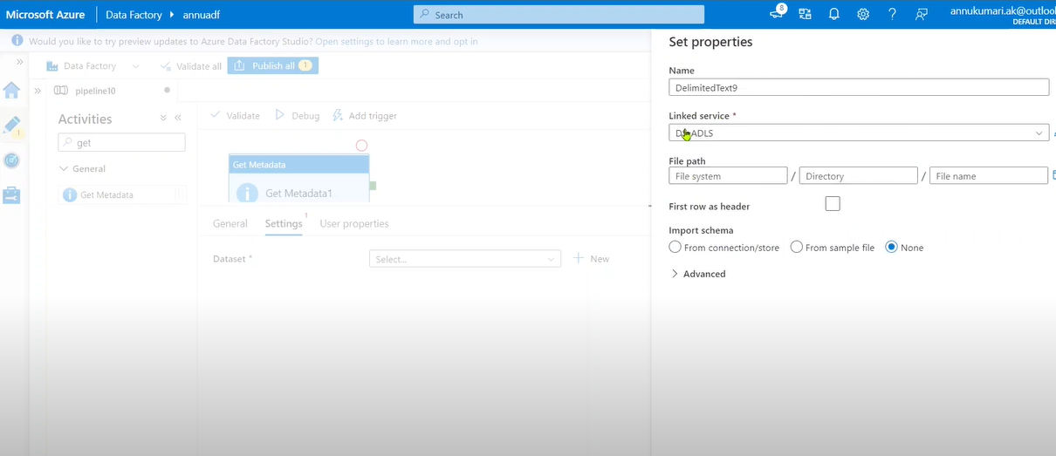

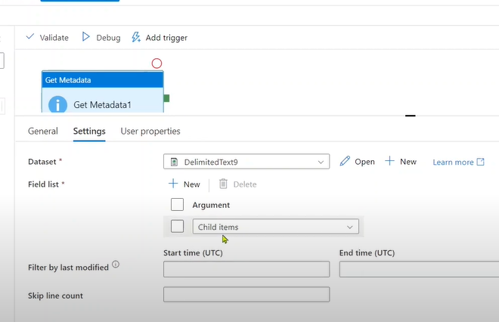

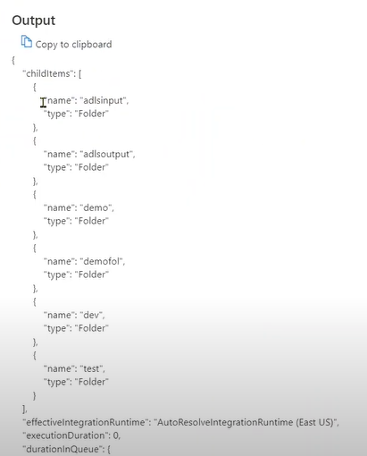

**The ouput of get metadata 1 is given to For each activity**

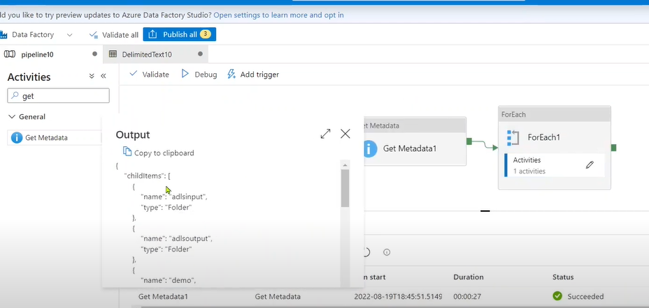

**Inside that another get metadata is called**

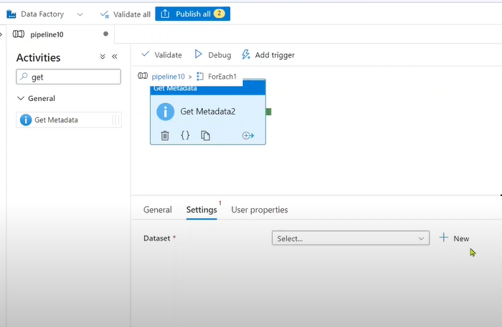

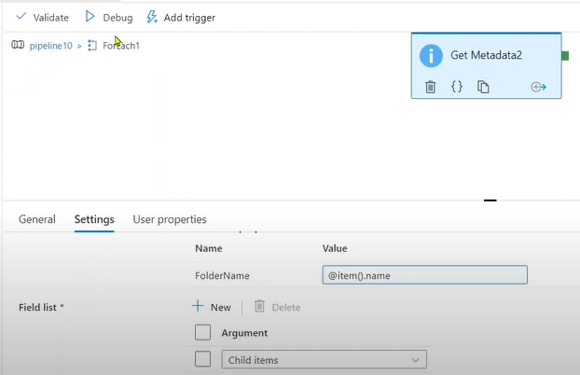

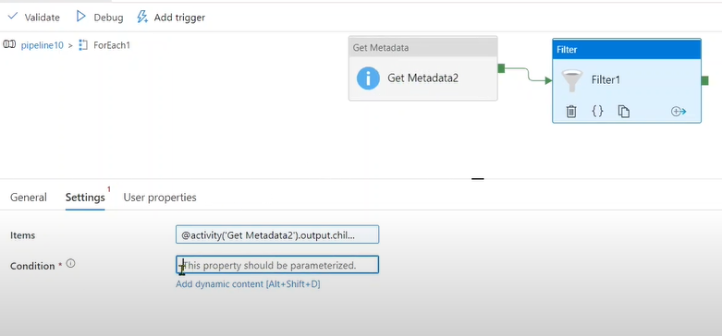

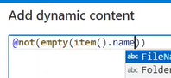

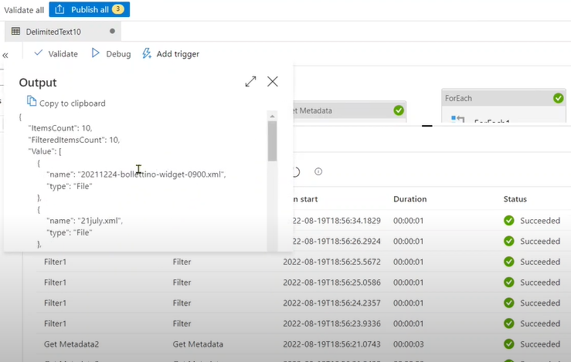

1. **How to retrieve folder having valid date in the FolderName**

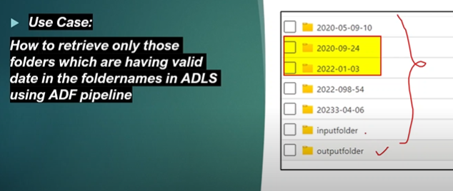

1. Use Get Metadata on the parent container.
   * Field list → Child items.
2. In a ForEach loop over @activity('Get Metadata1').output.childItems.
3. Inside ForEach add If Condition with an expression that checks if the folder name is a valid date.

If your folders are yyyyMMdd: @not(empty(tryParseDateTime(item().name, 'yyyyMMdd')))

If your folders are yyyy-MM-dd: @not(empty(tryParseDateTime(item().name, 'yyyy-MM-dd')))

1. **How to get the list of empty and non-empty ADLS folder.**

**Get metadata 🡪 for each 🡪 get metadata (directory) 🡪 IF (True) 🡪 append variable(file name) IF (false) 🡪 append variable(file name)**

